CAPABILITY STATEMENT | 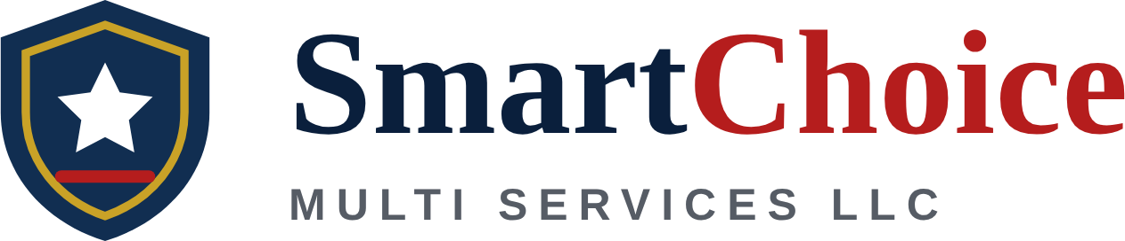  Service-Disabled Veteran-Owned Small Business (SDVOSB)

Core Competencies  - Rotary-Wing Powertrain & Rotor-System Maintenance – Repair, inspection, and troubleshooting of helicopter powertrain, drive-train, and rotor systems; non-destructive inspection (NDI); scheduled and unscheduled maintenance; component removal and replacement.  - Aircraft Engine & Airframe Maintenance – Engine and airframe maintenance and inspections for fixed- and rotary-wing aircraft, transient aircraft services, and technical documentation and maintenance records.  - Ground Support Equipment (GSE) – Maintenance, troubleshooting, and inspection of aviation ground support equipment in garrison and deployed environments.  - Aviation Quality, Safety & Training – Quality and production control, aviation safety compliance, maintenance shop supervision, and training of maintenance technicians.  - Cyber Threat Intelligence – Threat actor research and TTP analysis (MITRE ATT&CK), threat assessments, OSINT, link analysis, and executive briefings using Microsoft Sentinel, Splunk, Google Threat Intelligence, Mandiant Advantage, and Recorded Future.  Differentiators  - SBA-Certified SDVOSB – Eligible for SDVOSB set-aside and sole-source awards.  - 18+ Years of Aviation Maintenance – U.S. military, Kenya Air Force, and Kenya Airways experience, including deployed support at Kandahar Airfield, Afghanistan.  - Supervisor-Level Expertise – Proven shop supervision, quality and production control, and training of junior mechanics on rotary-wing powertrain and rotor systems.  - Multinational & Deployed Experience – Military, airline, and contractor aviation maintenance across the U.S., East Africa, and Afghanistan.  - Aviation + Cyber Combination – Hands-on aircraft maintenance paired with Intelligence Community cyber threat analysis, suited to aviation-sector cybersecurity.  Key Personnel Experience  - Aircraft Powertrain Repairer & Shop Supervisor — U.S. military aviation maintenance (2017–2023). Repair and inspection of powertrain and rotor systems including NDI; supervised and trained junior mechanics; quality and production control.  - Aircraft Handler — KBR-UK, Kandahar Airfield, Afghanistan (2013). Transient aircraft services for fixed- and rotary-wing aircraft; ground support equipment maintenance.  - Aircraft Technician / Safety Officer — Kenya Airways; Kenya Air Force (2003–2015). Engine and airframe maintenance, inspections, and safety compliance; supervision of technical staff.  - Cyber Analyst — Prescient Edge / Defense Intelligence Agency (Mar 2026–Present). Intelligence-driven threat assessments using GTI, Microsoft Sentinel, Splunk, and open-source intelligence; threat actor profiling; executive-level briefings.  - Technical Cyber Threat Analyst — Skye Tech Solutions / National Geospatial-Intelligence Agency (Feb 2023–Feb 2026). Cyber threat intelligence using Mandiant Advantage and Recorded Future; link analysis; structured analytic products for leadership and mission stakeholders. |  | Company Data  Background  SmartChoice Multi Services LLC is a service-disabled veteran-owned small business in Alexandria, Virginia, founded and led by Raphael Kimanga. We bring 18+ years of aviation maintenance and leadership across military, airline, and deployed contract environments, complemented by Intelligence Community cyber threat intelligence experience, to deliver aviation maintenance, ground support equipment, and cyber services to government and commercial customers.  Contracting Readiness  - SBA-certified SDVOSB & VOSB (effective 03/06/2025; renewal due 03/06/2028)  - Registered in SAM.gov and SBA DSBS  - Open to subcontracting and teaming partnerships, as well as prime contracts  - Compliant with limitations on subcontracting (13 CFR 125.6)  UEI #: SFMFL4AM3EB7  CAGE/NCAGE: 0SQJ7  NAICS Codes  Primary: 488190 – Other Support Activities for Air Transportation (aircraft maintenance & repair)  Aviation & Equipment: 336411, 811310  Cyber & IT: 541519, 541512, 541511  PSC Codes  Aviation & Equipment Maint.: J015, J016, J017  Cyber & Intelligence: DJ01, DA01, R423  Accepts Credit Cards (Government Purchase Card)  Certifications: SBA SDVOSB, SBA VOSB  Contact:  Raphael Kimanga  Owner / Director  E: rkimanga@smartchoice24.org  T: 785-317-0739  Qualifications:  B.S., Upper Iowa University  CompTIA Security+ | CySA+  DCITA Digital Forensics (CIRC)

