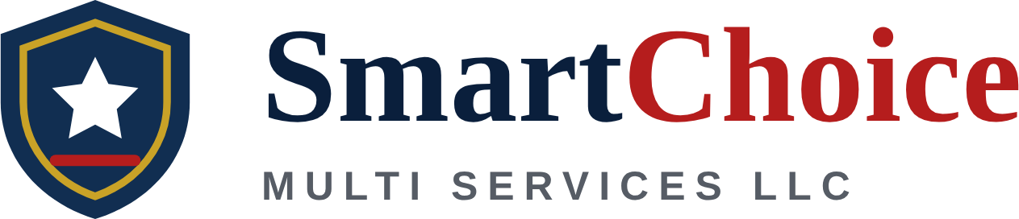
Capability Brief & Search Keywords
For SBA DSBS, SAM.gov, the company website, and LinkedIn. Contracting officers and prime contractors find small businesses by searching these profiles.
Capability Brief
Short version (one line): SDVOSB delivering rotary-wing aviation maintenance, ground support equipment services, and cyber threat intelligence, backed by 18+ years of military, airline, and deployed aviation experience.
Full version (DSBS Capabilities Narrative / SAM / website):
SmartChoice Multi Services LLC is an SBA-certified Service-Disabled Veteran-Owned Small Business (SDVOSB) in Alexandria, Virginia, providing aviation maintenance, ground support equipment, and cyber threat intelligence services to federal, defense, and commercial customers. Founder Raphael Kimanga brings 18+ years of aviation maintenance and leadership across the U.S. military, the Kenya Air Force, Kenya Airways, and deployed contract support at Kandahar Airfield, Afghanistan. Core strengths include rotary-wing powertrain and rotor-system repair, non-destructive inspection (NDI), engine and airframe maintenance, ground support equipment maintenance, quality and production control, aviation safety compliance, and technician training. The company also offers cyber threat intelligence services informed by the founder’s experience supporting Defense Intelligence Agency and National Geospatial-Intelligence Agency missions. SmartChoice is open to prime contracts, subcontracting, and teaming partnerships.
Keywords by Category
Rotary-Wing Maintenance | rotary-wing aircraft maintenance, helicopter maintenance, helicopter MRO, aircraft maintenance and repair, powertrain repair, drive train repair, rotor systems, rotor head inspection, transmission and gearbox repair, non-destructive inspection (NDI), scheduled maintenance, unscheduled maintenance, troubleshooting, component removal and replacement
Aircraft & Ground Support | fixed-wing aircraft maintenance, engine maintenance, airframe maintenance, aircraft inspections, transient aircraft services, aircraft handling, ground support equipment (GSE), GSE maintenance, aviation support services, maintenance records, technical documentation
Quality, Safety & Leadership | quality control (QC), quality assurance (QA), production control, aviation safety, safety compliance, maintenance supervision, shop supervisor, maintenance training, technician training, mentorship
Deployed & International | OCONUS, deployed operations, contingency operations, Afghanistan, Kandahar Airfield, East Africa, Kenya, AFRICOM, partner nation support, multinational operations
Cyber Threat Intelligence | cyber threat intelligence (CTI), threat intelligence, threat assessment, threat actor profiling, TTP analysis, MITRE ATT&CK, open-source intelligence (OSINT), link analysis, structured analytic techniques, intelligence analysis, executive briefings, Microsoft Sentinel, Splunk, SIEM, Google Threat Intelligence, Mandiant Advantage, Recorded Future, digital forensics, Intelligence Community (IC) support
Business & Contracting | service-disabled veteran-owned small business, SDVOSB, veteran-owned small business, VOSB, SBA VetCert, SDVOSB set-aside, SDVOSB sole source, subcontracting, teaming partner, small business, Alexandria Virginia, Northern Virginia, DMV

Copy-and-Paste List (DSBS Keywords Field)
Paste into the Keywords field of the SBA DSBS profile. Trim from the end if the field limits length.
rotary-wing aircraft maintenance, helicopter maintenance, helicopter MRO, aircraft maintenance and repair, powertrain repair, drive train repair, rotor systems, rotor head inspection, transmission and gearbox repair, non-destructive inspection (NDI), scheduled maintenance, unscheduled maintenance, troubleshooting, component removal and replacement, fixed-wing aircraft maintenance, engine maintenance, airframe maintenance, aircraft inspections, transient aircraft services, aircraft handling, ground support equipment (GSE), GSE maintenance, aviation support services, maintenance records, technical documentation, quality control (QC), quality assurance (QA), production control, aviation safety, safety compliance, maintenance supervision, shop supervisor, maintenance training, technician training, mentorship, OCONUS, deployed operations, contingency operations, Afghanistan, Kandahar Airfield, East Africa, Kenya, AFRICOM, partner nation support, multinational operations, cyber threat intelligence (CTI), threat intelligence, threat assessment, threat actor profiling, TTP analysis, MITRE ATT&CK, open-source intelligence (OSINT), link analysis, structured analytic techniques, intelligence analysis, executive briefings, Microsoft Sentinel, Splunk, SIEM, Google Threat Intelligence, Mandiant Advantage, Recorded Future, digital forensics, Intelligence Community (IC) support, service-disabled veteran-owned small business, SDVOSB, veteran-owned small business, VOSB, SBA VetCert, SDVOSB set-aside, SDVOSB sole source, subcontracting, teaming partner, small business, Alexandria Virginia, Northern Virginia, DMV
Codes Quick Reference (for DSBS / SAM profile)
NAICS (primary) | 488190 – Other Support Activities for Air Transportation
NAICS (secondary) | 336411, 811310, 541519, 541512, 541511
PSC | J015, J016, J017, DJ01, DA01, R423
UEI / CAGE | SFMFL4AM3EB7 / 0SQJ7

