Board paper

Quarterly business review
Q3 2026 · regional results



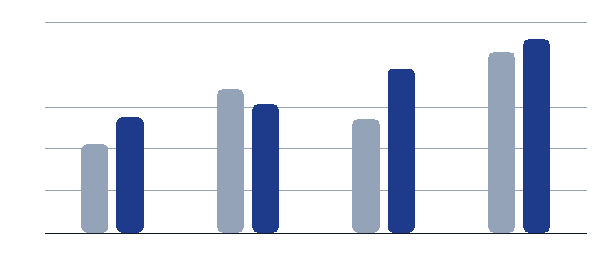
Figure 1. Revenue by region, indexed to the strongest quarter.

Prepared for the board. Figures are unaudited and in euro.

Regional results

«Region»
Led by «Head»

Revenue  «Revenue»  Year to date | Growth  «Growth»  Against Q2 | Deals  «Deals»  Closed

Summary
«Summary»

Numbers
Revenue | «Revenue»
Growth | «Growth»
Deals closed | «Deals»
Open pipeline | «Pipeline»

Priority for next quarter
«Priority»

What we will do
- Agree the plan with the regional head.
- Review the pipeline every second week.
- Report the outcome at the next board meeting.

Method

How we measure
Revenue is recognised in the month of delivery. Growth compares the quarter with the one before it.
Pipeline counts every open opportunity that has a named owner and a date.

Prepared by    EdgeDoc Analytics · 4 November 2026 | Distribution  Board members and regional heads.  Do not forward outside the company.

