Board paper

Quarterly business review
Q3 2026 · regional results



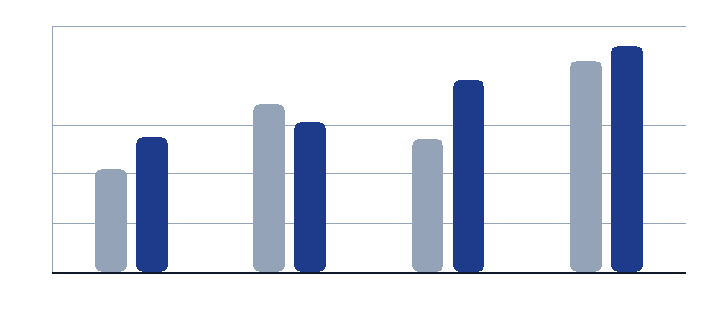
Figure 1. Revenue by region, indexed to the strongest quarter.

Prepared for the board. Figures are unaudited and in euro.

Regional results

Asia Pacific
Led by Wei Chen

Revenue  €2,540,000  Year to date | Growth  26.8%  Against Q2 | Deals  131  Closed

Summary
The lease is signed and the team starts with six people. This is the fastest-growing region on the smallest base.

Numbers
Revenue | €2,540,000
Growth | 26.8%
Deals closed | 131
Open pipeline | 3,800,000

Priority for next quarter
Open the Singapore office

What we will do
- Agree the plan with the regional head.
- Review the pipeline every second week.
- Report the outcome at the next board meeting.

Method

How we measure
Revenue is recognised in the month of delivery. Growth compares the quarter with the one before it.
Pipeline counts every open opportunity that has a named owner and a date.

Prepared by    EdgeDoc Analytics · 4 November 2026 | Distribution  Board members and regional heads.  Do not forward outside the company.

Board paper

Quarterly business review
Q3 2026 · regional results

Figure 1. Revenue by region, indexed to the strongest quarter.

Prepared for the board. Figures are unaudited and in euro.

Regional results

Latin America
Led by Sofia Alvarez

Revenue  €1,780,000  Year to date | Growth  6.3%  Against Q2 | Deals  94  Closed

Summary
Two large accounts moved to longer payment terms. Growth held while collections improved in the second half of the quarter.

Numbers
Revenue | €1,780,000
Growth | 6.3%
Deals closed | 94
Open pipeline | 2,050,000

Priority for next quarter
Stabilise collections

What we will do
- Agree the plan with the regional head.
- Review the pipeline every second week.
- Report the outcome at the next board meeting.

Method

How we measure
Revenue is recognised in the month of delivery. Growth compares the quarter with the one before it.
Pipeline counts every open opportunity that has a named owner and a date.

Prepared by  EdgeDoc Analytics · 4 November 2026 | Distribution  Board members and regional heads.  Do not forward outside the company.

Board paper

Quarterly business review
Q3 2026 · regional results

Figure 1. Revenue by region, indexed to the strongest quarter.

Prepared for the board. Figures are unaudited and in euro.

Regional results

North America
Led by Grace Lee

Revenue  €7,960,000  Year to date | Growth  19.2%  Against Q2 | Deals  402  Closed

Summary
Two roles are open and pipeline covers the target twice over. The region leads on new logos and on expansion revenue.

Numbers
Revenue | €7,960,000
Growth | 19.2%
Deals closed | 402
Open pipeline | 9,300,000

Priority for next quarter
Hire two enterprise sellers

What we will do
- Agree the plan with the regional head.
- Review the pipeline every second week.
- Report the outcome at the next board meeting.

Method

How we measure
Revenue is recognised in the month of delivery. Growth compares the quarter with the one before it.
Pipeline counts every open opportunity that has a named owner and a date.

Prepared by  EdgeDoc Analytics · 4 November 2026 | Distribution  Board members and regional heads.  Do not forward outside the company.

Board paper

Quarterly business review
Q3 2026 · regional results

Figure 1. Revenue by region, indexed to the strongest quarter.

Prepared for the board. Figures are unaudited and in euro.

Regional results

Northern Europe
Led by Elena Fischer

Revenue  €4,820,000  Year to date | Growth  12.4%  Against Q2 | Deals  214  Closed

Summary
Retention is the strongest in the group. Two renewals move to multi-year terms. The region grew on the back of two framework renewals and a stronger mid-market mix.

Numbers
Revenue | €4,820,000
Growth | 12.4%
Deals closed | 214
Open pipeline | 6,100,000

Priority for next quarter
Renew the three framework contracts

What we will do
- Agree the plan with the regional head.
- Review the pipeline every second week.
- Report the outcome at the next board meeting.

Method

How we measure
Revenue is recognised in the month of delivery. Growth compares the quarter with the one before it.
Pipeline counts every open opportunity that has a named owner and a date.

Prepared by  EdgeDoc Analytics · 4 November 2026 | Distribution  Board members and regional heads.  Do not forward outside the company.

Board paper

Quarterly business review
Q3 2026 · regional results

Figure 1. Revenue by region, indexed to the strongest quarter.

Prepared for the board. Figures are unaudited and in euro.

Regional results

Southern Europe
Led by Marco Rossi

Revenue  €3,410,000  Year to date | Growth  8.1%  Against Q2 | Deals  186  Closed

Summary
The pilot converts in the first week of the next quarter. Growth came from the Milan pilot and from a higher average deal size.

Numbers
Revenue | €3,410,000
Growth | 8.1%
Deals closed | 186
Open pipeline | 4,450,000

Priority for next quarter
Close the Milan pilot

What we will do
- Agree the plan with the regional head.
- Review the pipeline every second week.
- Report the outcome at the next board meeting.

Method

How we measure
Revenue is recognised in the month of delivery. Growth compares the quarter with the one before it.
Pipeline counts every open opportunity that has a named owner and a date.

Prepared by  EdgeDoc Analytics · 4 November 2026 | Distribution  Board members and regional heads.  Do not forward outside the company.

