Monte-Carlo:

Solution:

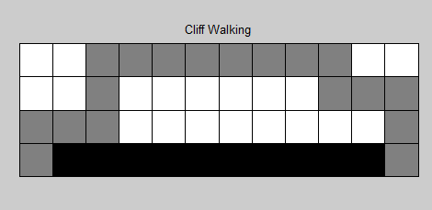

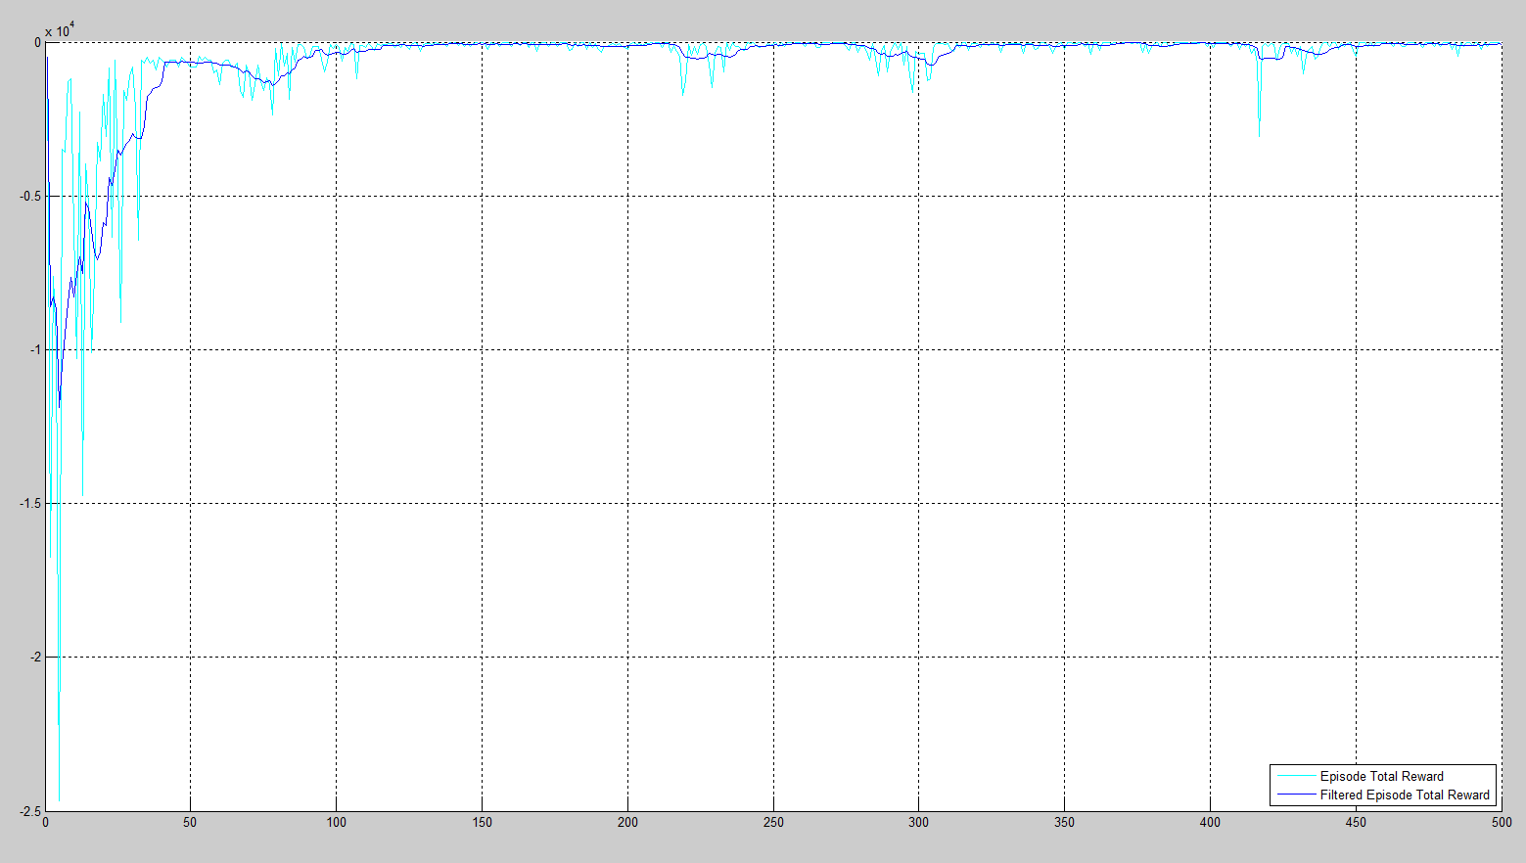

Iteration 1: Episode Length 500 Epsilon = 0.300000

Iteration 2: Episode Length 500 Epsilon = 0.300000

Iteration 3: Episode Length 500 Epsilon = 0.300000

Iteration 4: Episode Length 500 Epsilon = 0.300000

Iteration 5: Episode Length 500 Epsilon = 0.300000

Iteration 6: Episode Length 500 Epsilon = 0.300000

Iteration 7: Episode Length 500 Epsilon = 0.300000

Iteration 8: Episode Length 500 Epsilon = 0.300000

Iteration 9: Episode Length 500 Epsilon = 0.300000

Iteration 10: Episode Length 500 Epsilon = 0.300000

Iteration 11: Episode Length 500 Epsilon = 0.300000

Iteration 12: Episode Length 500 Epsilon = 0.300000

Iteration 13: Episode Length 500 Epsilon = 0.300000

Iteration 14: Episode Length 500 Epsilon = 0.300000

Iteration 15: Episode Length 500 Epsilon = 0.300000

Iteration 16: Episode Length 500 Epsilon = 0.300000

Iteration 17: Episode Length 500 Epsilon = 0.300000

Iteration 18: Episode Length 486 Epsilon = 0.300000

Iteration 19: Episode Length 500 Epsilon = 0.300000

Iteration 20: Episode Length 500 Epsilon = 0.300000

Iteration 21: Episode Length 500 Epsilon = 0.300000

Iteration 22: Episode Length 252 Epsilon = 0.300000

Iteration 23: Episode Length 500 Epsilon = 0.300000

Iteration 24: Episode Length 500 Epsilon = 0.300000

Iteration 25: Episode Length 500 Epsilon = 0.300000

Iteration 26: Episode Length 404 Epsilon = 0.300000

Iteration 27: Episode Length 500 Epsilon = 0.300000

Iteration 28: Episode Length 500 Epsilon = 0.300000

Iteration 29: Episode Length 500 Epsilon = 0.300000

Iteration 30: Episode Length 500 Epsilon = 0.300000

Iteration 31: Episode Length 500 Epsilon = 0.300000

Iteration 32: Episode Length 500 Epsilon = 0.300000

Iteration 33: Episode Length 500 Epsilon = 0.300000

Iteration 34: Episode Length 500 Epsilon = 0.300000

Iteration 35: Episode Length 500 Epsilon = 0.300000

Iteration 36: Episode Length 500 Epsilon = 0.300000

Iteration 37: Episode Length 500 Epsilon = 0.300000

Iteration 38: Episode Length 500 Epsilon = 0.300000

Iteration 39: Episode Length 500 Epsilon = 0.300000

Iteration 40: Episode Length 500 Epsilon = 0.300000

Iteration 41: Episode Length 500 Epsilon = 0.300000

Iteration 42: Episode Length 500 Epsilon = 0.300000

Iteration 43: Episode Length 500 Epsilon = 0.300000

Iteration 44: Episode Length 500 Epsilon = 0.300000

Iteration 45: Episode Length 500 Epsilon = 0.300000

Iteration 46: Episode Length 500 Epsilon = 0.300000

Iteration 47: Episode Length 500 Epsilon = 0.300000

Iteration 48: Episode Length 500 Epsilon = 0.300000

Iteration 49: Episode Length 500 Epsilon = 0.300000

Iteration 50: Episode Length 500 Epsilon = 0.300000

Iteration 51: Episode Length 500 Epsilon = 0.300000

Iteration 52: Episode Length 500 Epsilon = 0.300000

Iteration 53: Episode Length 470 Epsilon = 0.300000

Iteration 54: Episode Length 500 Epsilon = 0.300000

Iteration 55: Episode Length 500 Epsilon = 0.300000

Iteration 56: Episode Length 378 Epsilon = 0.300000

Iteration 57: Episode Length 500 Epsilon = 0.300000

Iteration 58: Episode Length 500 Epsilon = 0.300000

Iteration 59: Episode Length 500 Epsilon = 0.300000

Iteration 60: Episode Length 500 Epsilon = 0.300000

Iteration 61: Episode Length 500 Epsilon = 0.300000

Iteration 62: Episode Length 500 Epsilon = 0.300000

Iteration 63: Episode Length 500 Epsilon = 0.300000

Iteration 64: Episode Length 500 Epsilon = 0.300000

Iteration 65: Episode Length 500 Epsilon = 0.300000

Iteration 66: Episode Length 500 Epsilon = 0.300000

Iteration 67: Episode Length 500 Epsilon = 0.300000

Iteration 68: Episode Length 500 Epsilon = 0.300000

Iteration 69: Episode Length 266 Epsilon = 0.300000

Iteration 70: Episode Length 500 Epsilon = 0.300000

Iteration 71: Episode Length 500 Epsilon = 0.300000

Iteration 72: Episode Length 500 Epsilon = 0.300000

Iteration 73: Episode Length 438 Epsilon = 0.300000

Iteration 74: Episode Length 484 Epsilon = 0.300000

Iteration 75: Episode Length 500 Epsilon = 0.300000

Iteration 76: Episode Length 285 Epsilon = 0.300000

Iteration 77: Episode Length 500 Epsilon = 0.300000

Iteration 78: Episode Length 500 Epsilon = 0.300000

Iteration 79: Episode Length 116 Epsilon = 0.300000

Iteration 80: Episode Length 500 Epsilon = 0.300000

Iteration 81: Episode Length 51 Epsilon = 0.300000

Iteration 82: Episode Length 174 Epsilon = 0.300000

Iteration 83: Episode Length 68 Epsilon = 0.300000

Iteration 84: Episode Length 459 Epsilon = 0.300000

Iteration 85: Episode Length 72 Epsilon = 0.300000

Iteration 86: Episode Length 368 Epsilon = 0.300000

Iteration 87: Episode Length 70 Epsilon = 0.300000

Iteration 88: Episode Length 82 Epsilon = 0.300000

Iteration 89: Episode Length 166 Epsilon = 0.300000

Iteration 90: Episode Length 330 Epsilon = 0.300000

Iteration 91: Episode Length 265 Epsilon = 0.300000

Iteration 92: Episode Length 146 Epsilon = 0.300000

Iteration 93: Episode Length 130 Epsilon = 0.300000

Iteration 94: Episode Length 128 Epsilon = 0.300000

Iteration 95: Episode Length 356 Epsilon = 0.300000

Iteration 96: Episode Length 361 Epsilon = 0.300000

Iteration 97: Episode Length 258 Epsilon = 0.300000

Iteration 98: Episode Length 83 Epsilon = 0.300000

Iteration 99: Episode Length 97 Epsilon = 0.300000

Iteration 100: Episode Length 74 Epsilon = 0.300000

Iteration 101: Episode Length 90 Epsilon = 0.300000

Iteration 102: Episode Length 228 Epsilon = 0.300000

Iteration 103: Episode Length 168 Epsilon = 0.300000

Iteration 104: Episode Length 105 Epsilon = 0.300000

Iteration 105: Episode Length 52 Epsilon = 0.300000

Iteration 106: Episode Length 93 Epsilon = 0.300000

Iteration 107: Episode Length 500 Epsilon = 0.300000

Iteration 108: Episode Length 123 Epsilon = 0.300000

Iteration 109: Episode Length 110 Epsilon = 0.300000

Iteration 110: Episode Length 166 Epsilon = 0.300000

Iteration 111: Episode Length 59 Epsilon = 0.300000

Iteration 112: Episode Length 60 Epsilon = 0.300000

Iteration 113: Episode Length 65 Epsilon = 0.300000

Iteration 114: Episode Length 37 Epsilon = 0.300000

Iteration 115: Episode Length 100 Epsilon = 0.300000

Iteration 116: Episode Length 71 Epsilon = 0.300000

Iteration 117: Episode Length 87 Epsilon = 0.300000

Iteration 118: Episode Length 39 Epsilon = 0.300000

Iteration 119: Episode Length 61 Epsilon = 0.300000

Iteration 120: Episode Length 82 Epsilon = 0.300000

Iteration 121: Episode Length 46 Epsilon = 0.300000

Iteration 122: Episode Length 64 Epsilon = 0.300000

Iteration 123: Episode Length 53 Epsilon = 0.300000

Iteration 124: Episode Length 60 Epsilon = 0.300000

Iteration 125: Episode Length 155 Epsilon = 0.300000

Iteration 126: Episode Length 71 Epsilon = 0.300000

Iteration 127: Episode Length 25 Epsilon = 0.300000

Iteration 128: Episode Length 50 Epsilon = 0.300000

Iteration 129: Episode Length 91 Epsilon = 0.300000

Iteration 130: Episode Length 84 Epsilon = 0.300000

Iteration 131: Episode Length 36 Epsilon = 0.300000

Iteration 132: Episode Length 60 Epsilon = 0.300000

Iteration 133: Episode Length 91 Epsilon = 0.300000

Iteration 134: Episode Length 24 Epsilon = 0.300000

Iteration 135: Episode Length 39 Epsilon = 0.300000

Iteration 136: Episode Length 69 Epsilon = 0.300000

Iteration 137: Episode Length 61 Epsilon = 0.300000

Iteration 138: Episode Length 36 Epsilon = 0.300000

Iteration 139: Episode Length 27 Epsilon = 0.300000

Iteration 140: Episode Length 53 Epsilon = 0.300000

Iteration 141: Episode Length 28 Epsilon = 0.300000

Iteration 142: Episode Length 20 Epsilon = 0.300000

Iteration 143: Episode Length 19 Epsilon = 0.300000

Iteration 144: Episode Length 29 Epsilon = 0.300000

Iteration 145: Episode Length 46 Epsilon = 0.300000

Iteration 146: Episode Length 33 Epsilon = 0.300000

Iteration 147: Episode Length 34 Epsilon = 0.300000

Iteration 148: Episode Length 31 Epsilon = 0.300000

Iteration 149: Episode Length 35 Epsilon = 0.300000

Iteration 150: Episode Length 31 Epsilon = 0.300000

Iteration 151: Episode Length 34 Epsilon = 0.300000

Iteration 152: Episode Length 25 Epsilon = 0.300000

Iteration 153: Episode Length 25 Epsilon = 0.300000

Iteration 154: Episode Length 48 Epsilon = 0.300000

Iteration 155: Episode Length 33 Epsilon = 0.300000

Iteration 156: Episode Length 52 Epsilon = 0.300000

Iteration 157: Episode Length 23 Epsilon = 0.300000

Iteration 158: Episode Length 24 Epsilon = 0.300000

Iteration 159: Episode Length 22 Epsilon = 0.300000

Iteration 160: Episode Length 41 Epsilon = 0.300000

Iteration 161: Episode Length 17 Epsilon = 0.300000

Iteration 162: Episode Length 48 Epsilon = 0.300000

Iteration 163: Episode Length 20 Epsilon = 0.300000

Iteration 164: Episode Length 21 Epsilon = 0.300000

Iteration 165: Episode Length 20 Epsilon = 0.300000

Iteration 166: Episode Length 71 Epsilon = 0.300000

Iteration 167: Episode Length 22 Epsilon = 0.300000

Iteration 168: Episode Length 23 Epsilon = 0.300000

Iteration 169: Episode Length 91 Epsilon = 0.300000

Iteration 170: Episode Length 35 Epsilon = 0.300000

Iteration 171: Episode Length 30 Epsilon = 0.300000

Iteration 172: Episode Length 27 Epsilon = 0.300000

Iteration 173: Episode Length 36 Epsilon = 0.300000

Iteration 174: Episode Length 21 Epsilon = 0.300000

Iteration 175: Episode Length 22 Epsilon = 0.300000

Iteration 176: Episode Length 48 Epsilon = 0.300000

Iteration 177: Episode Length 19 Epsilon = 0.300000

Iteration 178: Episode Length 25 Epsilon = 0.300000

Iteration 179: Episode Length 21 Epsilon = 0.300000

Iteration 180: Episode Length 59 Epsilon = 0.300000

Iteration 181: Episode Length 26 Epsilon = 0.300000

Iteration 182: Episode Length 20 Epsilon = 0.300000

Iteration 183: Episode Length 36 Epsilon = 0.300000

Iteration 184: Episode Length 21 Epsilon = 0.300000

Iteration 185: Episode Length 17 Epsilon = 0.300000

Iteration 186: Episode Length 33 Epsilon = 0.300000

Iteration 187: Episode Length 25 Epsilon = 0.300000

Iteration 188: Episode Length 61 Epsilon = 0.300000

Iteration 189: Episode Length 36 Epsilon = 0.300000

Iteration 190: Episode Length 37 Epsilon = 0.300000

Iteration 191: Episode Length 38 Epsilon = 0.300000

Iteration 192: Episode Length 53 Epsilon = 0.300000

Iteration 193: Episode Length 128 Epsilon = 0.300000

Iteration 194: Episode Length 83 Epsilon = 0.300000

Iteration 195: Episode Length 53 Epsilon = 0.300000

Iteration 196: Episode Length 114 Epsilon = 0.300000

Iteration 197: Episode Length 39 Epsilon = 0.300000

Iteration 198: Episode Length 53 Epsilon = 0.300000

Iteration 199: Episode Length 69 Epsilon = 0.300000

Iteration 200: Episode Length 54 Epsilon = 0.300000

Iteration 201: Episode Length 50 Epsilon = 0.300000

Iteration 202: Episode Length 30 Epsilon = 0.300000

Iteration 203: Episode Length 71 Epsilon = 0.300000

Iteration 204: Episode Length 33 Epsilon = 0.300000

Iteration 205: Episode Length 117 Epsilon = 0.300000

Iteration 206: Episode Length 37 Epsilon = 0.300000

Iteration 207: Episode Length 34 Epsilon = 0.300000

Iteration 208: Episode Length 29 Epsilon = 0.300000

Iteration 209: Episode Length 37 Epsilon = 0.300000

Iteration 210: Episode Length 19 Epsilon = 0.300000

Iteration 211: Episode Length 31 Epsilon = 0.300000

Iteration 212: Episode Length 74 Epsilon = 0.300000

Iteration 213: Episode Length 22 Epsilon = 0.300000

Iteration 214: Episode Length 31 Epsilon = 0.300000

Iteration 215: Episode Length 50 Epsilon = 0.300000

Iteration 216: Episode Length 102 Epsilon = 0.300000

Iteration 217: Episode Length 89 Epsilon = 0.300000

Iteration 218: Episode Length 366 Epsilon = 0.300000

Iteration 219: Episode Length 359 Epsilon = 0.300000

Iteration 220: Episode Length 255 Epsilon = 0.300000

Iteration 221: Episode Length 68 Epsilon = 0.300000

Iteration 222: Episode Length 136 Epsilon = 0.300000

Iteration 223: Episode Length 44 Epsilon = 0.300000

Iteration 224: Episode Length 104 Epsilon = 0.300000

Iteration 225: Episode Length 74 Epsilon = 0.300000

Iteration 226: Episode Length 55 Epsilon = 0.300000

Iteration 227: Episode Length 56 Epsilon = 0.300000

Iteration 228: Episode Length 214 Epsilon = 0.300000

Iteration 229: Episode Length 500 Epsilon = 0.300000

Iteration 230: Episode Length 79 Epsilon = 0.300000

Iteration 231: Episode Length 47 Epsilon = 0.300000

Iteration 232: Episode Length 90 Epsilon = 0.300000

Iteration 233: Episode Length 189 Epsilon = 0.300000

Iteration 234: Episode Length 28 Epsilon = 0.300000

Iteration 235: Episode Length 65 Epsilon = 0.300000

Iteration 236: Episode Length 26 Epsilon = 0.300000

Iteration 237: Episode Length 55 Epsilon = 0.300000

Iteration 238: Episode Length 37 Epsilon = 0.300000

Iteration 239: Episode Length 36 Epsilon = 0.300000

Iteration 240: Episode Length 66 Epsilon = 0.300000

Iteration 241: Episode Length 30 Epsilon = 0.300000

Iteration 242: Episode Length 55 Epsilon = 0.300000

Iteration 243: Episode Length 26 Epsilon = 0.300000

Iteration 244: Episode Length 28 Epsilon = 0.300000

Iteration 245: Episode Length 71 Epsilon = 0.300000

Iteration 246: Episode Length 30 Epsilon = 0.300000

Iteration 247: Episode Length 57 Epsilon = 0.300000

Iteration 248: Episode Length 57 Epsilon = 0.300000

Iteration 249: Episode Length 26 Epsilon = 0.300000

Iteration 250: Episode Length 39 Epsilon = 0.300000

Iteration 251: Episode Length 22 Epsilon = 0.300000

Iteration 252: Episode Length 38 Epsilon = 0.300000

Iteration 253: Episode Length 26 Epsilon = 0.300000

Iteration 254: Episode Length 34 Epsilon = 0.300000

Iteration 255: Episode Length 23 Epsilon = 0.300000

Iteration 256: Episode Length 21 Epsilon = 0.300000

Iteration 257: Episode Length 39 Epsilon = 0.300000

Iteration 258: Episode Length 27 Epsilon = 0.300000

Iteration 259: Episode Length 31 Epsilon = 0.300000

Iteration 260: Episode Length 43 Epsilon = 0.300000

Iteration 261: Episode Length 31 Epsilon = 0.300000

Iteration 262: Episode Length 22 Epsilon = 0.300000

Iteration 263: Episode Length 33 Epsilon = 0.300000

Iteration 264: Episode Length 29 Epsilon = 0.300000

Iteration 265: Episode Length 68 Epsilon = 0.300000

Iteration 266: Episode Length 61 Epsilon = 0.300000

Iteration 267: Episode Length 26 Epsilon = 0.300000

Iteration 268: Episode Length 26 Epsilon = 0.300000

Iteration 269: Episode Length 21 Epsilon = 0.300000

Iteration 270: Episode Length 55 Epsilon = 0.300000

Iteration 271: Episode Length 27 Epsilon = 0.300000

Iteration 272: Episode Length 29 Epsilon = 0.300000

Iteration 273: Episode Length 27 Epsilon = 0.300000

Iteration 274: Episode Length 21 Epsilon = 0.300000

Iteration 275: Episode Length 58 Epsilon = 0.300000

Iteration 276: Episode Length 58 Epsilon = 0.300000

Iteration 277: Episode Length 23 Epsilon = 0.300000

Iteration 278: Episode Length 24 Epsilon = 0.300000

Iteration 279: Episode Length 39 Epsilon = 0.300000

Iteration 280: Episode Length 47 Epsilon = 0.300000

Iteration 281: Episode Length 51 Epsilon = 0.300000

Iteration 282: Episode Length 96 Epsilon = 0.300000

Iteration 283: Episode Length 106 Epsilon = 0.300000

Iteration 284: Episode Length 45 Epsilon = 0.300000

Iteration 285: Episode Length 135 Epsilon = 0.300000

Iteration 286: Episode Length 500 Epsilon = 0.300000

Iteration 287: Episode Length 70 Epsilon = 0.300000

Iteration 288: Episode Length 109 Epsilon = 0.300000

Iteration 289: Episode Length 279 Epsilon = 0.300000

Iteration 290: Episode Length 34 Epsilon = 0.300000

Iteration 291: Episode Length 56 Epsilon = 0.300000

Iteration 292: Episode Length 29 Epsilon = 0.300000

Iteration 293: Episode Length 36 Epsilon = 0.300000

Iteration 294: Episode Length 23 Epsilon = 0.300000

Iteration 295: Episode Length 55 Epsilon = 0.300000

Iteration 296: Episode Length 49 Epsilon = 0.300000

Iteration 297: Episode Length 97 Epsilon = 0.300000

Iteration 298: Episode Length 245 Epsilon = 0.300000

Iteration 299: Episode Length 100 Epsilon = 0.300000

Iteration 300: Episode Length 112 Epsilon = 0.300000

Iteration 301: Episode Length 62 Epsilon = 0.300000

Iteration 302: Episode Length 79 Epsilon = 0.300000

Iteration 303: Episode Length 380 Epsilon = 0.300000

Iteration 304: Episode Length 500 Epsilon = 0.300000

Iteration 305: Episode Length 63 Epsilon = 0.300000

Iteration 306: Episode Length 46 Epsilon = 0.300000

Iteration 307: Episode Length 37 Epsilon = 0.300000

Iteration 308: Episode Length 42 Epsilon = 0.300000

Iteration 309: Episode Length 94 Epsilon = 0.300000

Iteration 310: Episode Length 38 Epsilon = 0.300000

Iteration 311: Episode Length 51 Epsilon = 0.300000

Iteration 312: Episode Length 104 Epsilon = 0.300000

Iteration 313: Episode Length 47 Epsilon = 0.300000

Iteration 314: Episode Length 73 Epsilon = 0.300000

Iteration 315: Episode Length 22 Epsilon = 0.300000

Iteration 316: Episode Length 24 Epsilon = 0.300000

Iteration 317: Episode Length 156 Epsilon = 0.300000

Iteration 318: Episode Length 48 Epsilon = 0.300000

Iteration 319: Episode Length 63 Epsilon = 0.300000

Iteration 320: Episode Length 47 Epsilon = 0.300000

Iteration 321: Episode Length 165 Epsilon = 0.300000

Iteration 322: Episode Length 51 Epsilon = 0.300000

Iteration 323: Episode Length 76 Epsilon = 0.300000

Iteration 324: Episode Length 100 Epsilon = 0.300000

Iteration 325: Episode Length 27 Epsilon = 0.300000

Iteration 326: Episode Length 72 Epsilon = 0.300000

Iteration 327: Episode Length 41 Epsilon = 0.300000

Iteration 328: Episode Length 131 Epsilon = 0.300000

Iteration 329: Episode Length 50 Epsilon = 0.300000

Iteration 330: Episode Length 69 Epsilon = 0.300000

Iteration 331: Episode Length 41 Epsilon = 0.300000

Iteration 332: Episode Length 35 Epsilon = 0.300000

Iteration 333: Episode Length 49 Epsilon = 0.300000

Iteration 334: Episode Length 33 Epsilon = 0.300000

Iteration 335: Episode Length 36 Epsilon = 0.300000

Iteration 336: Episode Length 169 Epsilon = 0.300000

Iteration 337: Episode Length 43 Epsilon = 0.300000

Iteration 338: Episode Length 63 Epsilon = 0.300000

Iteration 339: Episode Length 51 Epsilon = 0.300000

Iteration 340: Episode Length 53 Epsilon = 0.300000

Iteration 341: Episode Length 93 Epsilon = 0.300000

Iteration 342: Episode Length 27 Epsilon = 0.300000

Iteration 343: Episode Length 21 Epsilon = 0.300000

Iteration 344: Episode Length 66 Epsilon = 0.300000

Iteration 345: Episode Length 43 Epsilon = 0.300000

Iteration 346: Episode Length 180 Epsilon = 0.300000

Iteration 347: Episode Length 60 Epsilon = 0.300000

Iteration 348: Episode Length 35 Epsilon = 0.300000

Iteration 349: Episode Length 23 Epsilon = 0.300000

Iteration 350: Episode Length 53 Epsilon = 0.300000

Iteration 351: Episode Length 17 Epsilon = 0.300000

Iteration 352: Episode Length 21 Epsilon = 0.300000

Iteration 353: Episode Length 43 Epsilon = 0.300000

Iteration 354: Episode Length 35 Epsilon = 0.300000

Iteration 355: Episode Length 18 Epsilon = 0.300000

Iteration 356: Episode Length 37 Epsilon = 0.300000

Iteration 357: Episode Length 31 Epsilon = 0.300000

Iteration 358: Episode Length 29 Epsilon = 0.300000

Iteration 359: Episode Length 90 Epsilon = 0.300000

Iteration 360: Episode Length 22 Epsilon = 0.300000

Iteration 361: Episode Length 23 Epsilon = 0.300000

Iteration 362: Episode Length 66 Epsilon = 0.300000

Iteration 363: Episode Length 26 Epsilon = 0.300000

Iteration 364: Episode Length 25 Epsilon = 0.300000

Iteration 365: Episode Length 19 Epsilon = 0.300000

Iteration 366: Episode Length 39 Epsilon = 0.300000

Iteration 367: Episode Length 25 Epsilon = 0.300000

Iteration 368: Episode Length 33 Epsilon = 0.300000

Iteration 369: Episode Length 43 Epsilon = 0.300000

Iteration 370: Episode Length 19 Epsilon = 0.300000

Iteration 371: Episode Length 19 Epsilon = 0.300000

Iteration 372: Episode Length 27 Epsilon = 0.300000

Iteration 373: Episode Length 34 Epsilon = 0.300000

Iteration 374: Episode Length 17 Epsilon = 0.300000

Iteration 375: Episode Length 35 Epsilon = 0.300000

Iteration 376: Episode Length 29 Epsilon = 0.300000

Iteration 377: Episode Length 48 Epsilon = 0.300000

Iteration 378: Episode Length 44 Epsilon = 0.300000

Iteration 379: Episode Length 67 Epsilon = 0.300000

Iteration 380: Episode Length 42 Epsilon = 0.300000

Iteration 381: Episode Length 36 Epsilon = 0.300000

Iteration 382: Episode Length 22 Epsilon = 0.300000

Iteration 383: Episode Length 60 Epsilon = 0.300000

Iteration 384: Episode Length 21 Epsilon = 0.300000

Iteration 385: Episode Length 30 Epsilon = 0.300000

Iteration 386: Episode Length 40 Epsilon = 0.300000

Iteration 387: Episode Length 23 Epsilon = 0.300000

Iteration 388: Episode Length 22 Epsilon = 0.300000

Iteration 389: Episode Length 25 Epsilon = 0.300000

Iteration 390: Episode Length 18 Epsilon = 0.300000

Iteration 391: Episode Length 21 Epsilon = 0.300000

Iteration 392: Episode Length 27 Epsilon = 0.300000

Iteration 393: Episode Length 42 Epsilon = 0.300000

Iteration 394: Episode Length 28 Epsilon = 0.300000

Iteration 395: Episode Length 26 Epsilon = 0.300000

Iteration 396: Episode Length 32 Epsilon = 0.300000

Iteration 397: Episode Length 26 Epsilon = 0.300000

Iteration 398: Episode Length 29 Epsilon = 0.300000

Iteration 399: Episode Length 49 Epsilon = 0.300000

Iteration 400: Episode Length 25 Epsilon = 0.300000

Iteration 401: Episode Length 71 Epsilon = 0.300000

Iteration 402: Episode Length 21 Epsilon = 0.300000

Iteration 403: Episode Length 27 Epsilon = 0.300000

Iteration 404: Episode Length 21 Epsilon = 0.300000

Iteration 405: Episode Length 25 Epsilon = 0.300000

Iteration 406: Episode Length 37 Epsilon = 0.300000

Iteration 407: Episode Length 36 Epsilon = 0.300000

Iteration 408: Episode Length 41 Epsilon = 0.300000

Iteration 409: Episode Length 25 Epsilon = 0.300000

Iteration 410: Episode Length 27 Epsilon = 0.300000

Iteration 411: Episode Length 42 Epsilon = 0.300000

Iteration 412: Episode Length 52 Epsilon = 0.300000

Iteration 413: Episode Length 47 Epsilon = 0.300000

Iteration 414: Episode Length 73 Epsilon = 0.300000

Iteration 415: Episode Length 100 Epsilon = 0.300000

Iteration 416: Episode Length 371 Epsilon = 0.300000

Iteration 417: Episode Length 500 Epsilon = 0.300000

Iteration 418: Episode Length 35 Epsilon = 0.300000

Iteration 419: Episode Length 32 Epsilon = 0.300000

Iteration 420: Episode Length 39 Epsilon = 0.300000

Iteration 421: Episode Length 51 Epsilon = 0.300000

Iteration 422: Episode Length 66 Epsilon = 0.300000

Iteration 423: Episode Length 87 Epsilon = 0.300000

Iteration 424: Episode Length 81 Epsilon = 0.300000

Iteration 425: Episode Length 45 Epsilon = 0.300000

Iteration 426: Episode Length 39 Epsilon = 0.300000

Iteration 427: Episode Length 32 Epsilon = 0.300000

Iteration 428: Episode Length 83 Epsilon = 0.300000

Iteration 429: Episode Length 76 Epsilon = 0.300000

Iteration 430: Episode Length 67 Epsilon = 0.300000

Iteration 431: Episode Length 36 Epsilon = 0.300000

Iteration 432: Episode Length 137 Epsilon = 0.300000

Iteration 433: Episode Length 132 Epsilon = 0.300000

Iteration 434: Episode Length 39 Epsilon = 0.300000

Iteration 435: Episode Length 50 Epsilon = 0.300000

Iteration 436: Episode Length 175 Epsilon = 0.300000

Iteration 437: Episode Length 75 Epsilon = 0.300000

Iteration 438: Episode Length 46 Epsilon = 0.300000

Iteration 439: Episode Length 22 Epsilon = 0.300000

Iteration 440: Episode Length 30 Epsilon = 0.300000

Iteration 441: Episode Length 49 Epsilon = 0.300000

Iteration 442: Episode Length 27 Epsilon = 0.300000

Iteration 443: Episode Length 29 Epsilon = 0.300000

Iteration 444: Episode Length 38 Epsilon = 0.300000

Iteration 445: Episode Length 32 Epsilon = 0.300000

Iteration 446: Episode Length 35 Epsilon = 0.300000

Iteration 447: Episode Length 33 Epsilon = 0.300000

Iteration 448: Episode Length 27 Epsilon = 0.300000

Iteration 449: Episode Length 58 Epsilon = 0.300000

Iteration 450: Episode Length 57 Epsilon = 0.300000

Iteration 451: Episode Length 25 Epsilon = 0.300000

Iteration 452: Episode Length 29 Epsilon = 0.300000

Iteration 453: Episode Length 24 Epsilon = 0.300000

Iteration 454: Episode Length 43 Epsilon = 0.300000

Iteration 455: Episode Length 18 Epsilon = 0.300000

Iteration 456: Episode Length 30 Epsilon = 0.300000

Iteration 457: Episode Length 21 Epsilon = 0.300000

Iteration 458: Episode Length 29 Epsilon = 0.300000

Iteration 459: Episode Length 19 Epsilon = 0.300000

Iteration 460: Episode Length 23 Epsilon = 0.300000

Iteration 461: Episode Length 32 Epsilon = 0.300000

Iteration 462: Episode Length 22 Epsilon = 0.300000

Iteration 463: Episode Length 44 Epsilon = 0.300000

Iteration 464: Episode Length 30 Epsilon = 0.300000

Iteration 465: Episode Length 42 Epsilon = 0.300000

Iteration 466: Episode Length 35 Epsilon = 0.300000

Iteration 467: Episode Length 55 Epsilon = 0.300000

Iteration 468: Episode Length 31 Epsilon = 0.300000

Iteration 469: Episode Length 21 Epsilon = 0.300000

Iteration 470: Episode Length 28 Epsilon = 0.300000

Iteration 471: Episode Length 73 Epsilon = 0.300000

Iteration 472: Episode Length 34 Epsilon = 0.300000

Iteration 473: Episode Length 77 Epsilon = 0.300000

Iteration 474: Episode Length 28 Epsilon = 0.300000

Iteration 475: Episode Length 19 Epsilon = 0.300000

Iteration 476: Episode Length 25 Epsilon = 0.300000

Iteration 477: Episode Length 35 Epsilon = 0.300000

Iteration 478: Episode Length 31 Epsilon = 0.300000

Iteration 479: Episode Length 30 Epsilon = 0.300000

Iteration 480: Episode Length 18 Epsilon = 0.300000

Iteration 481: Episode Length 23 Epsilon = 0.300000

Iteration 482: Episode Length 23 Epsilon = 0.300000

Iteration 483: Episode Length 43 Epsilon = 0.300000

Iteration 484: Episode Length 21 Epsilon = 0.300000

Iteration 485: Episode Length 52 Epsilon = 0.300000

Iteration 486: Episode Length 21 Epsilon = 0.300000

Iteration 487: Episode Length 41 Epsilon = 0.300000

Iteration 488: Episode Length 21 Epsilon = 0.300000

Iteration 489: Episode Length 23 Epsilon = 0.300000

Iteration 490: Episode Length 24 Epsilon = 0.300000

Iteration 491: Episode Length 21 Epsilon = 0.300000

Iteration 492: Episode Length 32 Epsilon = 0.300000

Iteration 493: Episode Length 56 Epsilon = 0.300000

Iteration 494: Episode Length 19 Epsilon = 0.300000

Iteration 495: Episode Length 33 Epsilon = 0.300000

Iteration 496: Episode Length 26 Epsilon = 0.300000

Iteration 497: Episode Length 26 Epsilon = 0.300000

Iteration 498: Episode Length 30 Epsilon = 0.300000

Iteration 499: Episode Length 20 Epsilon = 0.300000

Iteration 500: Episode Length 19 Epsilon = 0.300000

Q-Learning:

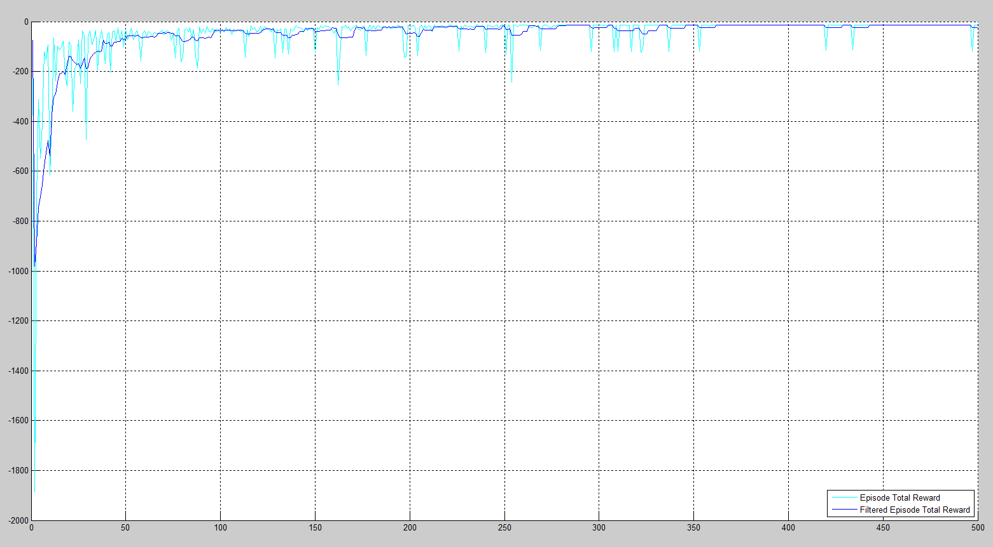

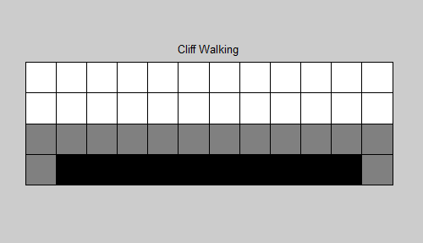

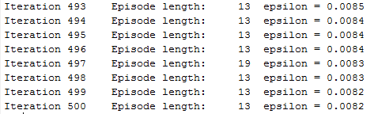

Solution:

