Index

**1.** **Downloading and configuring the application** 2

*1.1* *Downloading the application* 2

*1.2* *Create a folder and put the executable (or jar).* 3

*1.3* *Set the IP FTP* 3

*1.4* *Set Mainframe User* 4

**2.** **Using the application - Viewing copybook** 5

*2.1* *Downloading mainframe file* 5

*2.2* *Reading a copybook that already exist.* 6

**3.** **Using the application - Splitting strings** 7

**4.** **Using the application - Reading files** 9

*4.1* *Downloading mainframe file* 9

*4.2* *Loading a file that already exist* 10

# **Downloading and configuring the application**

## *Downloading the application*

- Download the JInSync file as follows (the JInSync.jar file can also be used)

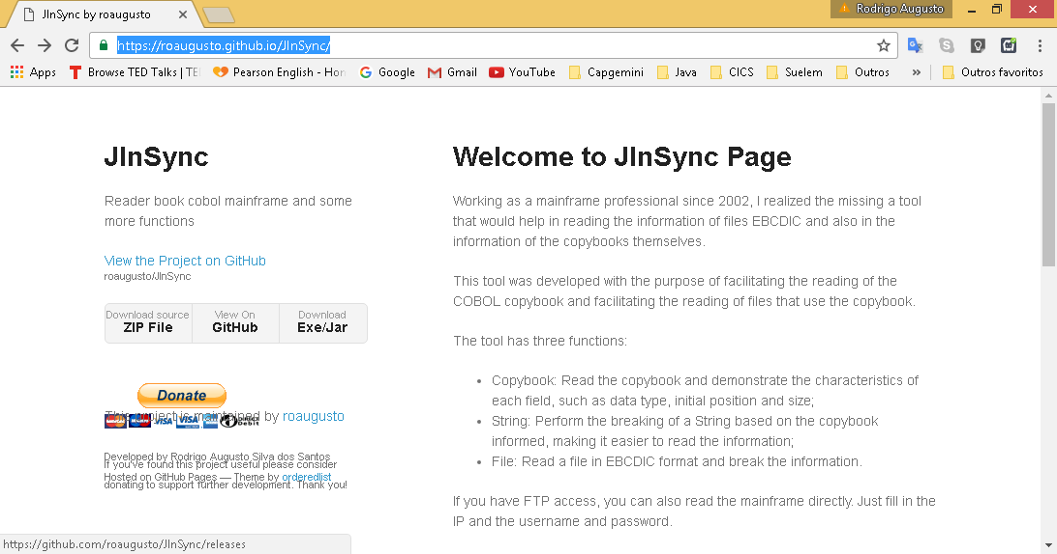

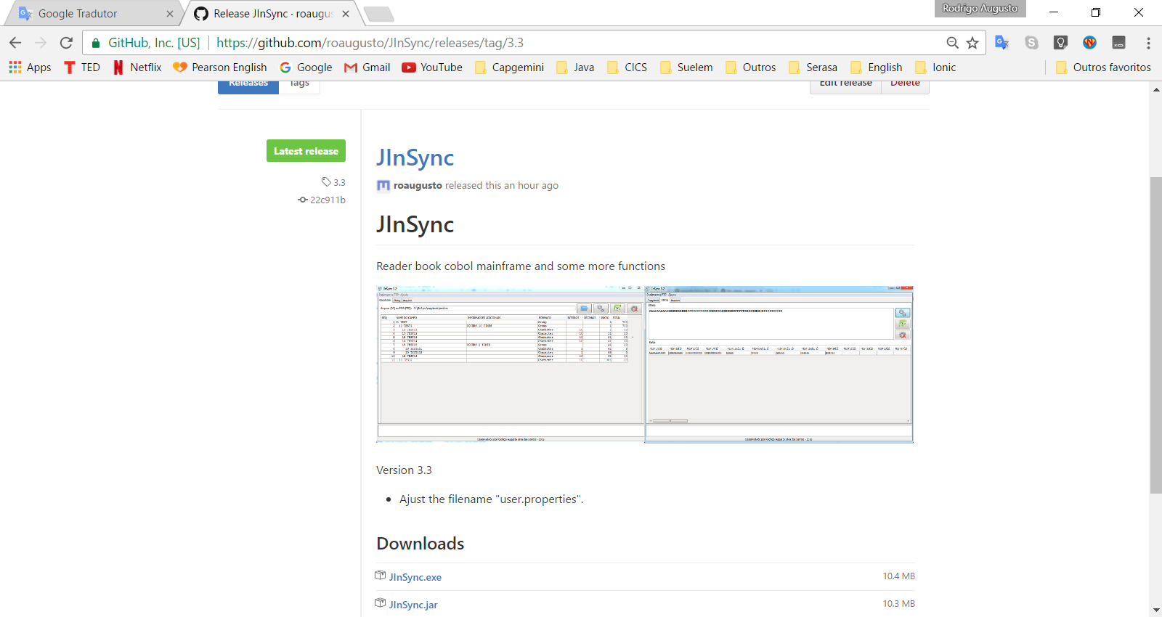

## *Create a folder and put the executable (or jar).*

- In this case, I'll use the C:\JInSync\

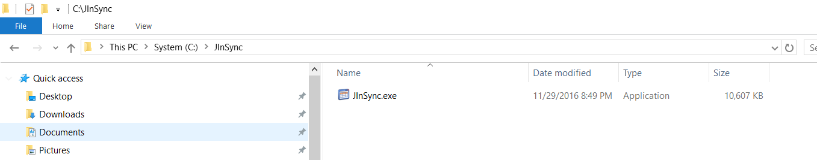

## *Set the IP FTP*

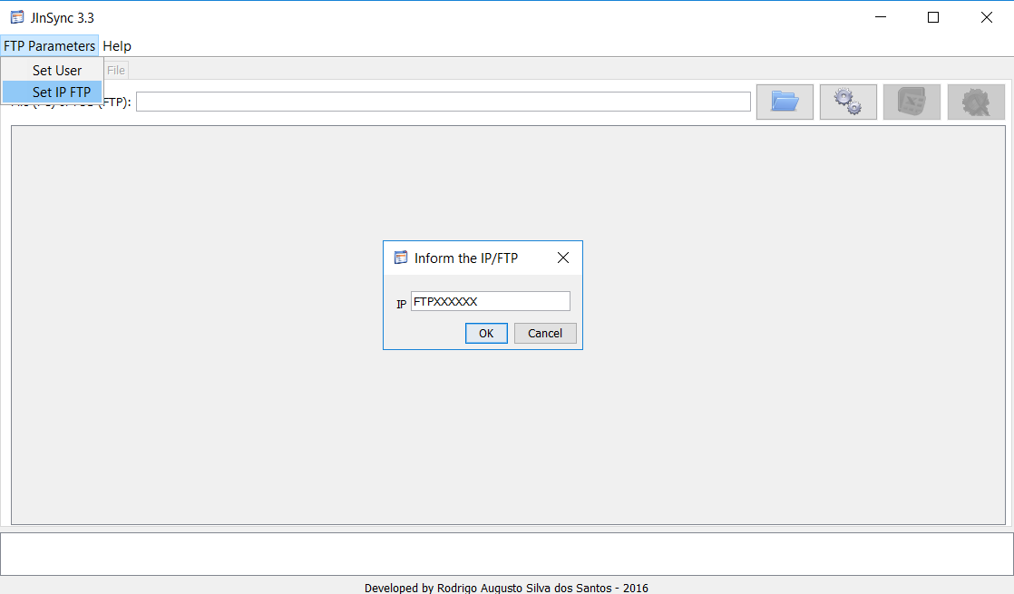

The ftp will be save in C:\JInSync\config\ftp.properties

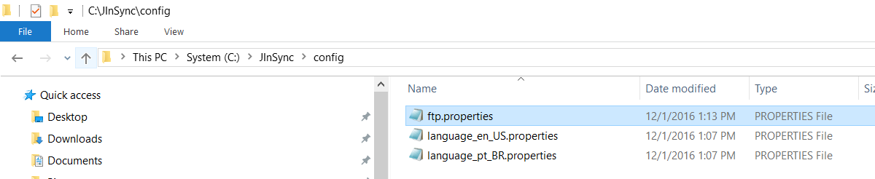

## *Set Mainframe User*

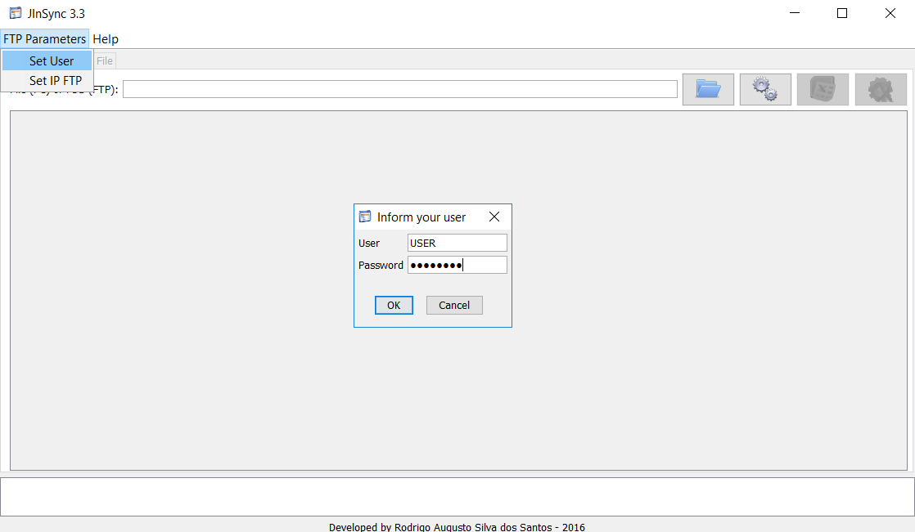

The user will be save in C:\JInSync\config\user.properties

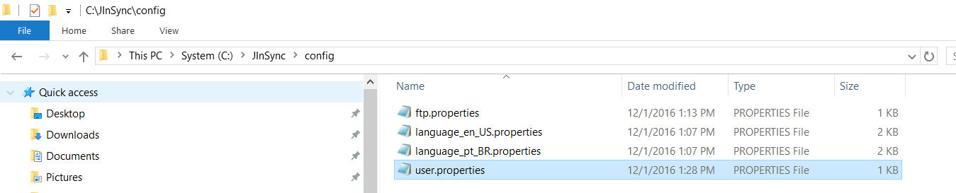

Password is encrypted

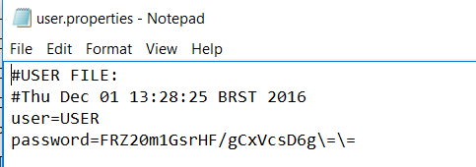

# **Using the application - Viewing copybook**



## *Downloading mainframe file*

- Inform the mainframe component (copybook) and click in “Engine”

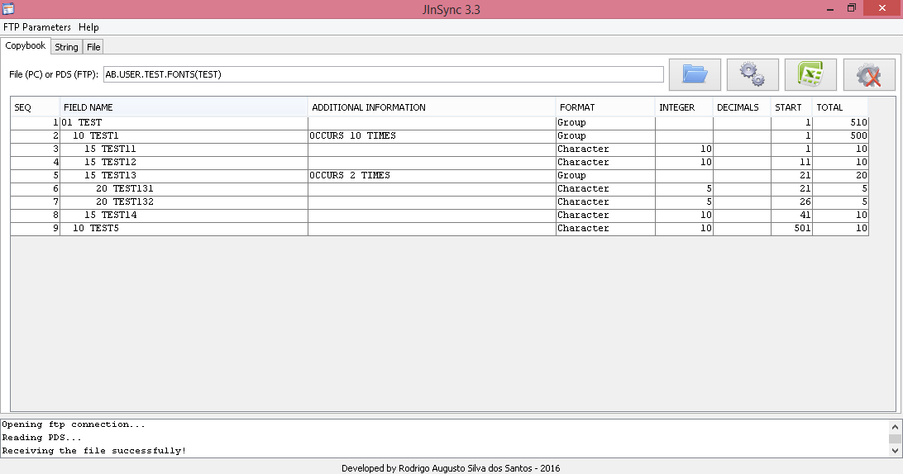

The copybook will be save in C:\JInSync\copybook

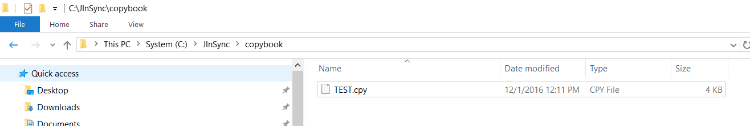

## *Reading a copybook that already exist.*

- Search the copybook in your computer and and click in “Engine”

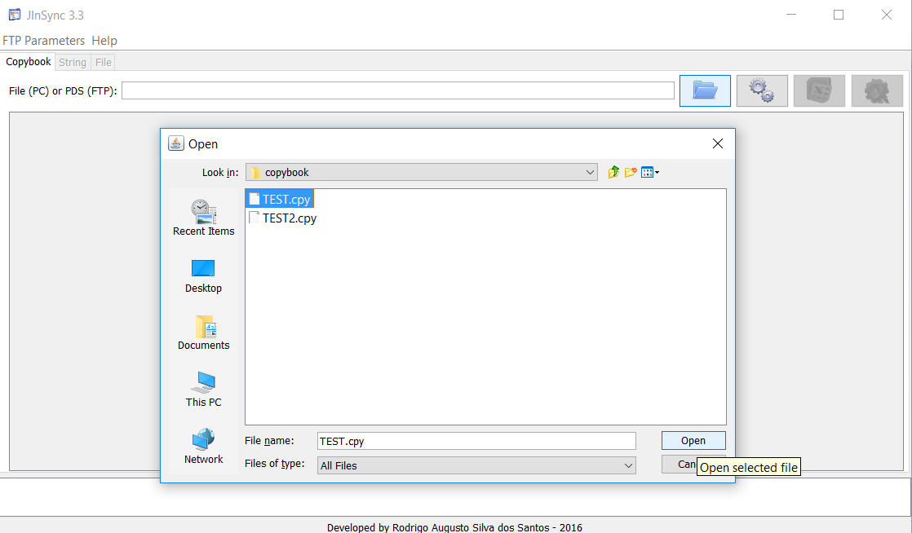

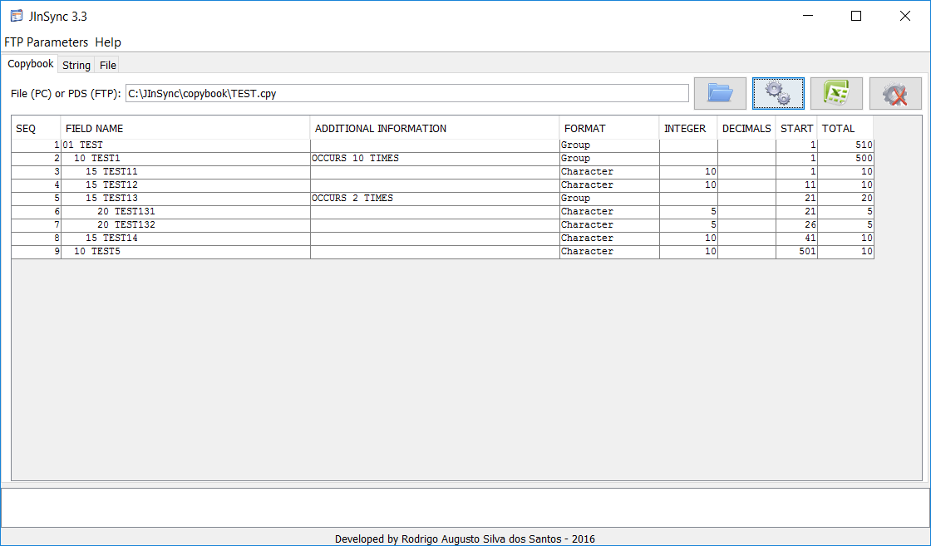

# **Using the application - Splitting strings**

- Load the copybook



- In the String tab, put the string that you want split.

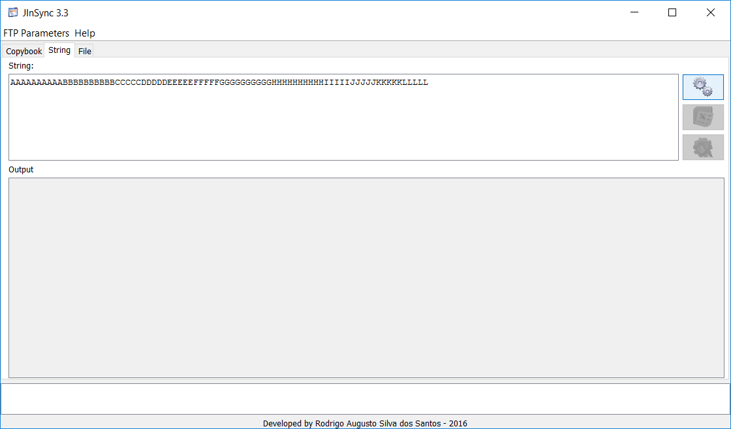

- For export to Excel, click in the button with the "Excel" icon.

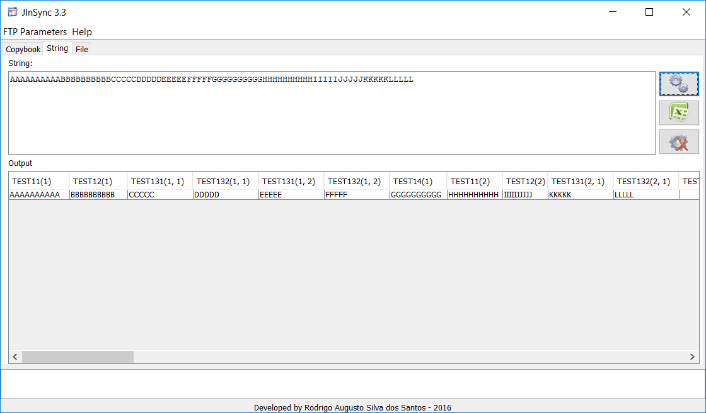

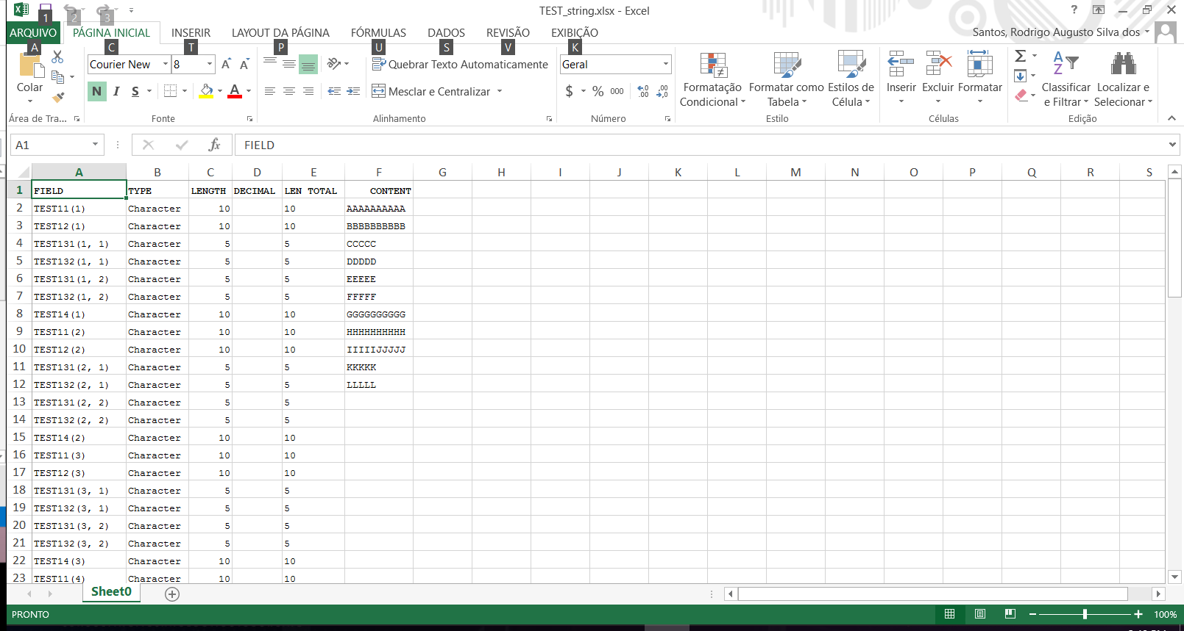

# **Using the application - Reading files**



## *Downloading mainframe file*

- Load copybook

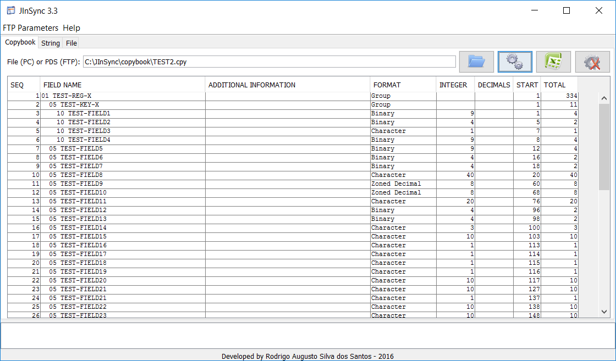

- In the File tab, put the mainframe file that you want load and click in “Engine”

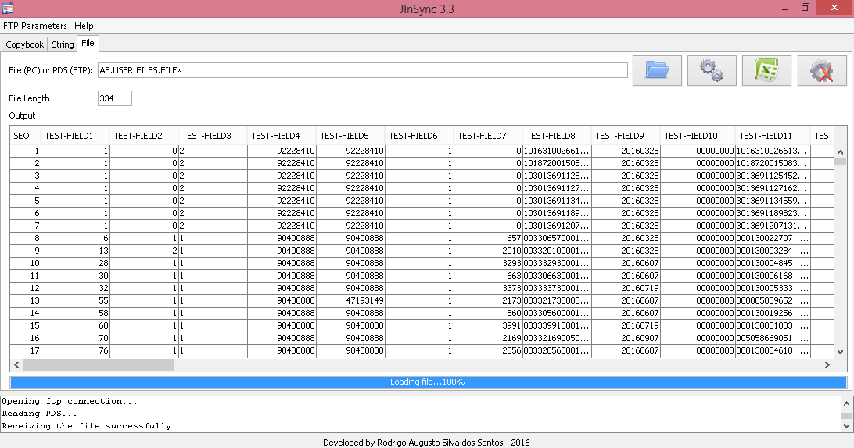

The file will be save in C:\JInSync\file

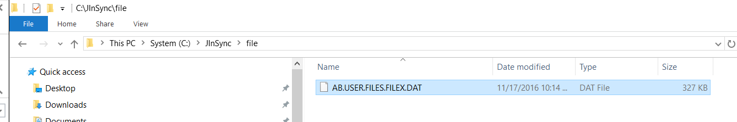

## *Loading a file that already exist*

- Find the file in you compute e click in “Engine”

