* Meeting 01 (21/01/202 17:30 – 17:57)

Agile B Meeting Notes

* Purpose of the webapp

Create a dynamic website for a company that aims to deliver food, display food items, and allow users to post feedback. The website will have different pages that display menus, FAQ, delivery, and different type of costs.

* Features:
* Menus divided into tabs e.g. What’s new, drinks, burgers, and sides.
* Basket area that shows current order and total price.
* Note system e.g., food allergies and edit order.
* Search feature that investigates menus
* Login-system that tracks user orders for future purchases.
* Food hygiene rates
* Opening times
* Social media interaction
* Review system
* Order in advance.
* Taiga roles

Scrum Master: rm731@kent.ac.uk

Product Owner: mm53@kent.ac.uk

Team member 1:

Team member 2:

Team member 3:

* Meeting 02 (20-01-2021 9:00-9:)

New Features:

* Allowing/blocking users from ordering depending on or basket/amount
* Post code estimation
* Meeting 03 (25/01: 17:30- 19:40)
* Finished Scrum product backlog and Product.

Meeting 15/02/2021

Account Creation Page

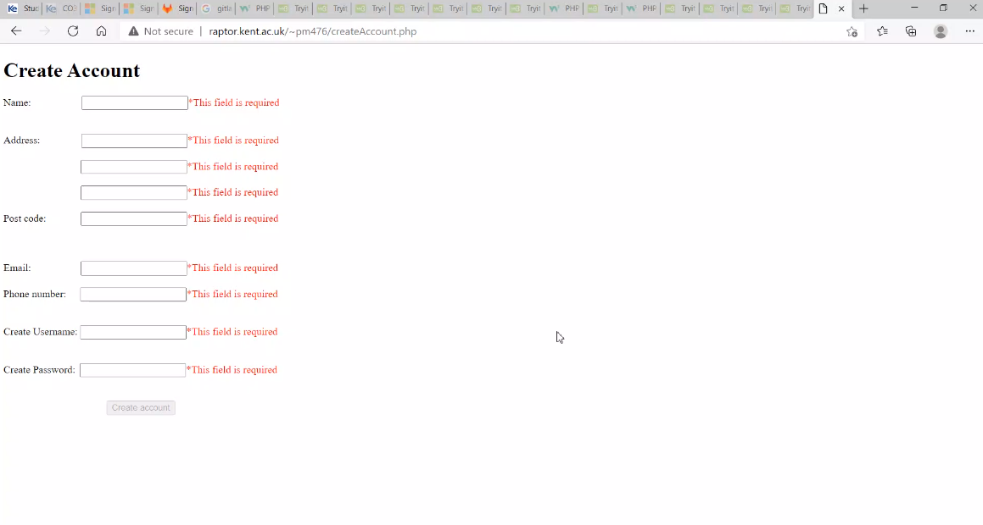

Home Page

