**A**

**PROJECT REPORT**

**ON**

“Student Record System”



Submitted by: Shikhar gupta

Inter

Rapid code technologies Pvt. Ltd.

Submitted to:

**Head of Department Project Guide**

**(Mr. Vinay tondon) (Mr .Ritesham Shastri)**

Managing director

Rapid code technologies Pvt. Ltd.

**Department of Computer Application**

College: Aligarh College of Engineering and Technology

Session:2019-20

Year:1

ACKNOWLEDGEMENT

I am grateful to all my lecturer who have contributed in inspiring and clarifying my thought over the years; Mr Ritesham Shastri at rapid code.

I wish to acknowledge my supervisor at Rapid code technologies Pvt. Ltd, Mr. Ritesham Shastri, who was instrumental in bringing this thesis to light.

Thanks also to the entire staff of Rapid Code, for making me feel so welcome at Rapid Code from day one. Your hospitality is very much appreciated.

I highly recognize Mr. Ritesham Shastri for mentoring me and contributing to my total transformation of my entire life. Finally, Honor and glory to the highest God for having enabled me successfully accomplishes.

About this Document

This document presents the briefing of the Project Student Record System. The purpose of the report is to present requirements, analysis, development procedure, SDLC for the Project Student record system as project Report to illustrate the successful completion as per the given guidelines & International standardization.

**Note:** It is important that this document be reviewed continuously to keep the information relevant and up-to-date. This document is subject to further elaboration. Rapidcode Technologies [P] Ltd. IN reserve the right to make corrections, modifications, enhancements, improvements, and other changes to its products and services at any time and to discontinue any product or service without prior notice**.**

CERTIFICATE

It is our pleasure to write about Mr. Shikhar gupta [students of ACET, Aligarh BCA. who got selected to work with Rapidcode Technologies Pvt. Ltd. in the capacity of -Trainee in Technology Unit Department for tenure of 1.5 months . The present report is partial fulfillment of the training as per academic rules of minimum 45 Days. (Duration 27 June 2016- 12 Aug 2018)

Please note that the company believes in Re- Engineering as a confidence process and therefore designations and responsibilities and locations are subject to modifications in line with the re-engineering process

The management will view his performance continuously during the period of his training and if his performance will be found satisfactory and outstanding, management can decide to retain him as a fixed role of the organization. We hope the same co-operation in future.

During training period, some soft features viz. sincere, reliable, trustworthy, sociable, pleasant, and open to challenges have expected.

Sincerely,

Mr. Ritesham Shastri

Managing Director

UNDERTAKING

My work titled **Student Record System** as part of the Summer Internship (June – July, 2019) under the guidance of Mr. Ritesham Shastri.

If my work has been inspired by anyone else’s work, then all such work(s) has been appropriately referred by me and due acknowledgements have been made.

Any academic misconduct and dishonesty found in regard to above or otherwise shall be solely and entirely my responsibility and my faculty advisor shall not be responsible. In such a situation, I understand that a strict disciplinary action can be undertaken against me by the concerned authorities.

Name: Shikhar Gupta,

Date: 12 Aug, 2019

Signature:

Table of content

1-Introduction -----------------------------------------------------------------------7

2-Objective ---------------------------------------------------------------------------8

3-Fleaxiblity --------------------------------------------------------------------------9

4-System Requirement ----------------------------------------------------------10

5-Purpose --------------------------------------------------------------------------11

6-Scope -----------------------------------------------------------------------------12

7-Flow of Data --------------------------------------------------------------------14

8-Output of Generate Record -------------------------------------------------15

9-Output of Add Record --------------------------------------------------------16

INTRODUCTION

During the past several decades’ personnel function has been transformed from a relatively obscure record keeping Student to central and top level management function. There are many factors that have influenced this transformation like technological advances, professionalism, and general recognition of human beings as most important resources.

A computer based management system is designed to handle all the primary information required to Generate Record, Modify Record, List Record, Delete Record,

Add Record. Separate database is maintained to handle all the details required for the correct statement generation.

This project intends to introduce more user friendliness in the various activities such as record updating, maintenance, and searching. The searching of record has been made quite simple as all the details of the customer can be obtained by simply keying in the identification or Roll Number of that Student. Similarly, record maintenance and updating can also be accomplished by using the Student Number with all the details being automatically generated. These details are also being promptly automatically updated in the master file thus keeping the record absolutely up-to-date.

The entire information has maintained in the database or Files and whoever wants to retrieve can’t retrieve, only authorization user can retrieve the necessary information which can be easily be accessible from the file.

OBJECTIVE

A computer based Record system is designed to handle all the primary information required to calculate the Record of student including modify Record, Delete Record, List Record, Generate Record. Separate database is maintained to handle all the details required for the correct their Record and can able to generate.

This project intends to introduce more user friendliness in the various activities such as record maintenance, and searching. The searching of record has been made quite simple as all the details of the Student can be obtained by simply keying in the identification or Roll Number of that Student. Similarly, record maintenance and updating can also be accomplished by using the Roll Number with all the details being automatically generated. These details are also being promptly automatically updated in the master file thus keeping the record absolutely up-to-date.

The main objective of our project is providing the different typed of Student’ facility, the main objective of this system is to find out the actual customer service. Etc.

This system is very easy to use, so that any user can use without getting pre-knowledge about this. It’s very much user friendly and meet almost all daily working process requirements. This system is completely CUI based and can’t be use by mouse but cab be used by keyboard.

FESAIBLITY ANALYSIS

Depending on the results of the initial investigation, the survey is expanded to a more detailed feasibility study. A feasibility study is a test of a system proposal. According to its workability, impact on the organization, ability to meet user’s needs and effective use of the resources its main task done during the feasibility study are: -

TECHNICAL FEASIBILITY: -

The proposed system is technically feasible as it can be developed easily with the help of available technology. The proposed system requires LINUX – red hat enterprises using VM –ware as Interface for Programming & FILE handling for storing/maintaining database.

OPERATIONAL FEASIBILITY: -

Automation makes our life easy. The proposed system is highly user friendly and is much easily able to interact with the system. Therefore, the users will readily accept the system as data entry and making queries can be easily done.

SYSTEM REQUIREMENT

Hardware specifications: -

Hardware is a set of physical components, which performs the functions of applying appropriate, predefined instructions. In other words, one can say that electronic and mechanical parts of computer constitute hardware.

This package is designed on a powerful programming language C. It is a powerful CUI. It can run on almost all the popular microcomputers. The following are the minimum hardware specifications to run this package: -

Personal Computer: -

It minimum contains P-IV processor

Processor with 512 MB RAM

Software Requirements**: -**

The software is a set of procedures of coded information or a program which when fed into the computer hardware, enables the computer to perform the various tasks. Software is like a current inside the wire, which cannot be seen but its effect can be felt.

1. Operating System-UNIX/LINUX

2. Application Software: - VM Ware

3. Editor: - vi editor

PURPOSE

The objective of **Student Record System** is to allow the administrator of any organization to edit and find out the personal details of a student and allows the student to keep up to date his Roll no . It’ll also facilitate keeping all the records of students, such as their id, name, phone number etc. So all the information about an student will be available in a few seconds.

Overall, it’ll make Student Information Management an easier job for the administrator and the student of any organization.

The main purpose of this SRS document is to illustrate the requirements of the project **Student Record System** and is intended to help any organization to maintain and manage its student’s personal data.

**Scope**

Without a **Student Record System**, managing and maintaining the details of the student is a tedious job for any organization.

Student Information system will store all the details of the students including their background information, personal details and all the information related to their resume.

**Login module**: Login module will help in authentication of user accounts Users who have valid login id and password can only login into their respective accounts.

**Search module**: Suppose there are hundreds of students and from this we have to search a particular student and we know the roll no of Student. In manual system it is a tedious task though we know the name of the student, but using this module we can easily search the student by specifying the name of the student in the search criteria. Thus this module will help the administrator in searching the student with various criteria easily.

**Registration Module and Account Management**: This module will help the student get registered from anywhere. This module will really simplify the task of on paper registration. Also after successful registration the user can update information and change their information as and when required.

**User Management**: This module will help the administrator in enabling/disabling a user account and updating user information as required.

Purpose of project is to maintain details of the students such as storing information about:

* Student id
* Student password
* Student name
* Student Phone Number
* Student Roll no
* Student Father name
* Student Mother name
* Gender

FLOW OF DATA

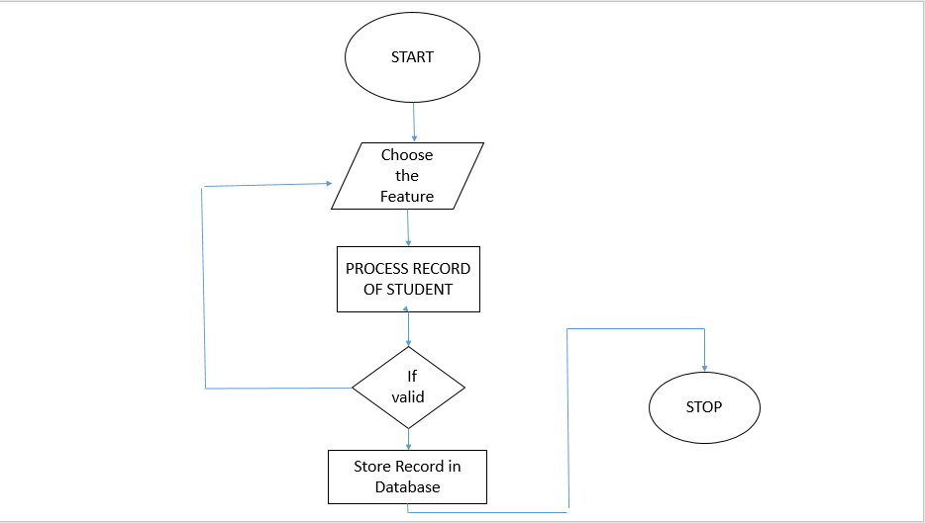

OUTPUT OF GENERATE RECORD

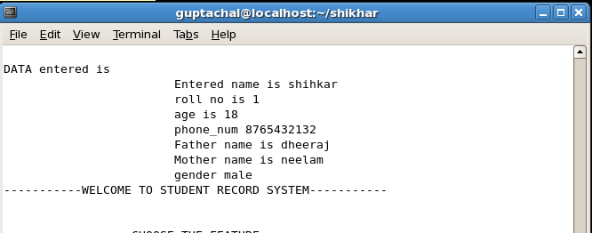

OUTPUT OF ADD RECORD

