Gas optimization in smart Contract

Minimize on-chain Data (already used)
When you design a dApp, you need to decide what code or data to put on-chain and off-chain. The less you put on-chain, the less your gas costs. What can be put off-chain is metadata, file, settings, and all non-critical pieces.
No metadata, file, settings, non-critical pieces discovered
Turn On Solidity Optimization(already used)

When you compile Solidity smart contracts, you can specify an optimization flag to tell the Solidity compiler to produce highly optimized bytecode. This bytecode will consume less gas than if you don’t use the optimization flag.
This was already initiated (fig.1)
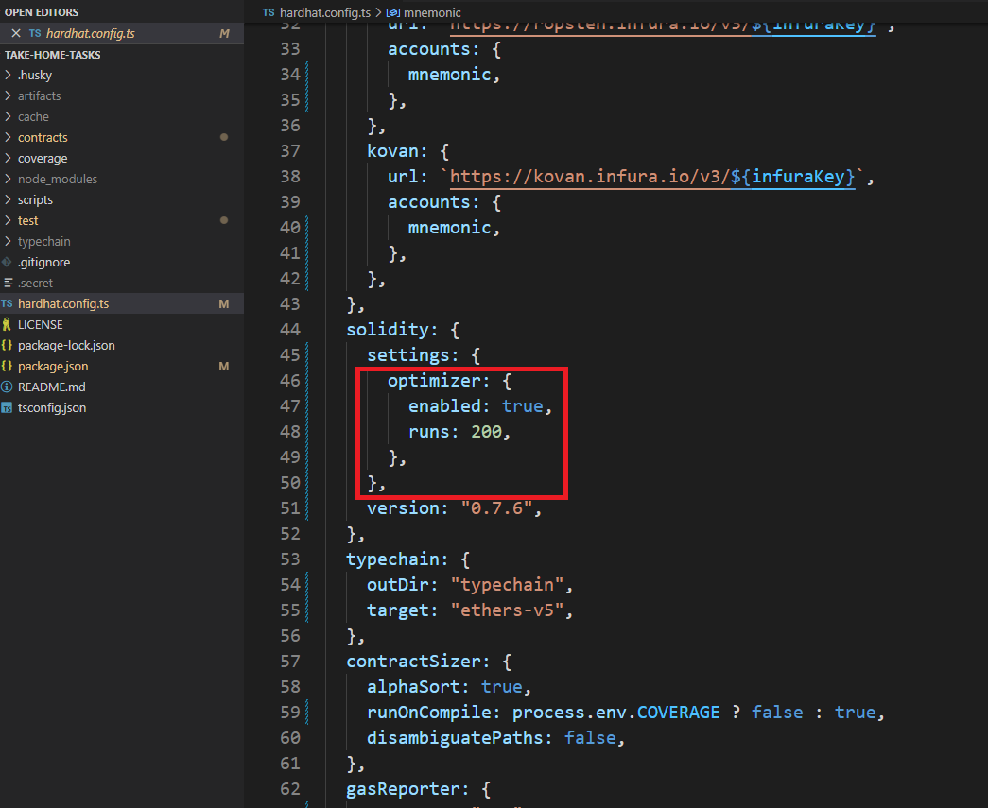
Fig1 – optimizer in hardhat.config.ts
Change Order of Variable Declaration(already used)

Order of Variable Declaration affects the consuming of gas.
In solidity, it stores data in 256bit memory slots. Data over 256bit can be spread over more than a slot. If data is smaller than single slot, we can optimize it and pack it together with other small data.
//Good :)
uint128 a;
uint128 b; It uses only 2 slots, ‘a’ and ‘b’ can be stored in one slot
uint256 c;

// Bad :(
uint128 a;
uint256 b; We have to use 3 slots in this case.
uint128 c;
Fortunately, in your both contract uses UINT256 or Address which can’t be stored in a single slot. So It doesn’t need – It is one of the optimization – already done!
I have checked your sol files (fig.2,3)
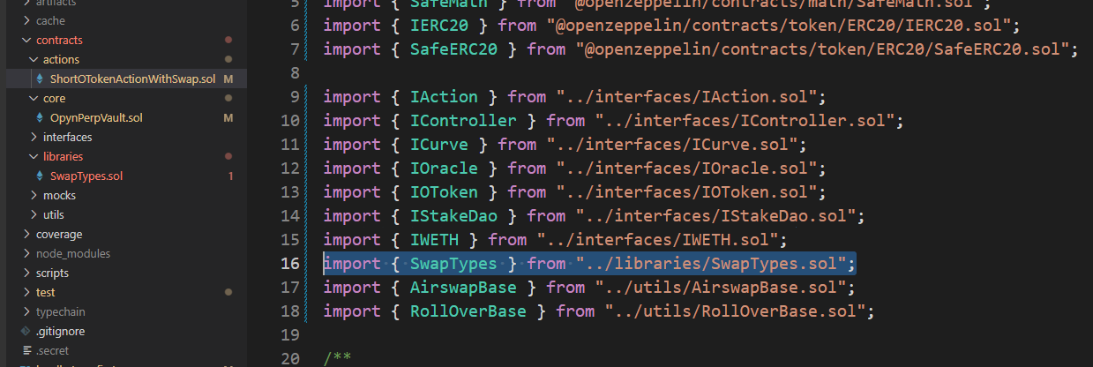
Fig.2
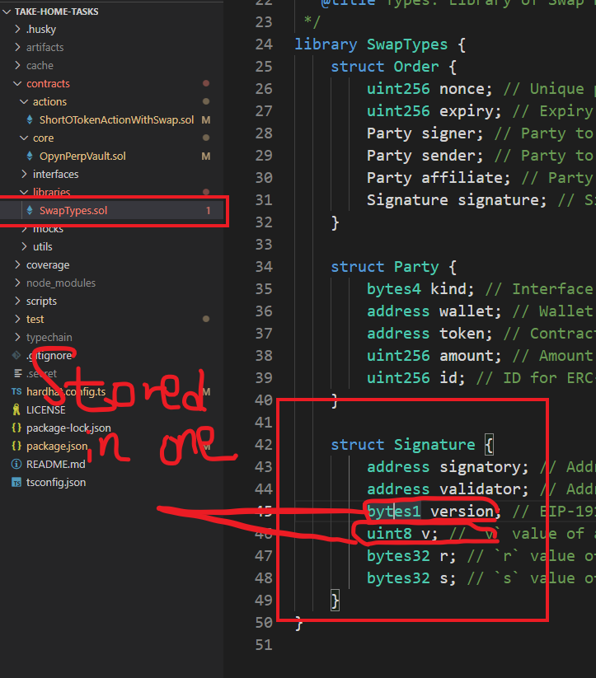
Fig.3

Write Literal Values instead of Computed One
If you know already know the value of some data at compile time, write directly this value. Don’t use Solidity functions to derive the value of the data at compile time. This might be less convenient to do this, but it avoids wasting gas.
//Good
bytes32 constant hash = 'uiHk78Uidaf....';

//Bad
bytes32 constant hash = keccack256(abi.encodePacked('MyDataToHash'));

In your project, there aren’t anykeccack256() functions used and no constant used.
Use Assembly Code
When you compile a Solidity smart contract, it is transformed into a series of EVM (Ethereum virtual machine) opcodes. We call this the bytecode. Solidity generally does a good job at writing optimized bytecode. But sometime, you can do better than Solidity by writing yourself the bytecode.
Actually, nobody writes directly EVM bytecode. But what you can do is to use (Solidity) assembly, a low-level smart contract language. With assembly, you write code very close to the opcode level. It’s not very easy to write code at such a low level, but the benefit is that you can manually optimize the opcode and outperform Solidity bytecode in some cases.
In your project this solution is used like this figure.
Here, you did use assembly as possible as they can. (Fig.4)

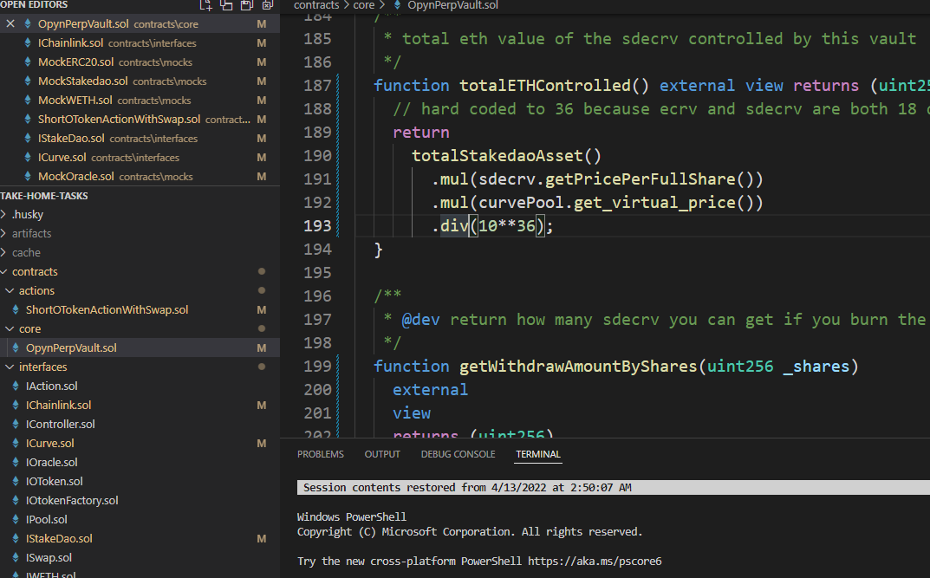
Fig.4

Use require instead of assert(already used)
Assert is a big gas eater
And Not initialize the variable – it’s expensive
require(balance >= amount); no need.
//This check is redundant because the safemath subtract function used below already includes this check.balance = balance.sub(amount);

Our suggestion
First, We suggest that we should change the whole architecture of project.

Retail customer
WithDraw
Deposit
Vault
WithDraw
Deposit
CurvePool

WithDrawwaw
Deposit
Passive ETH strategy

If users perform deposit and withdraw 10 times and 30 transactions caused.
This is existing architecture, I want to change it. Use database, you can see how to below next page.

Retail customer
Clients interact wit DB and after several operation performed , then send transaction to vault.
For example, if clients deposit and with draw 10 times, in the pre-version, 30 transactions needed,
But if we use db as above,
We just need 6 transactions, because we only deposit and withdraw after 10 actions finished. Here actions count 10 is optional

WithDraw
Deposit
10 actions performed but no transaction causes.
Works only after actions overflow the count- user settings-10
DB
Passive ETH strategy
CurvePool
Vault
WithDraw
Deposit

Deposit
WithDraw
Deposit
WithDrawwaw

Second, there are several ways to optimize.
-Don’t initialize the value with declaration.
Declaration value with initialize consumes gas more.
Initialize it after declaration and in such a constructor.
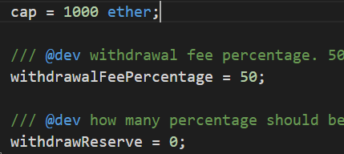
-you can reset optimizer from 1-1337 and set the ideal value.
settings: {
optimizer: {
enabled: true,
runs: 1,
},
},

- Not use constants
Replace constant with its literal or numerical value.
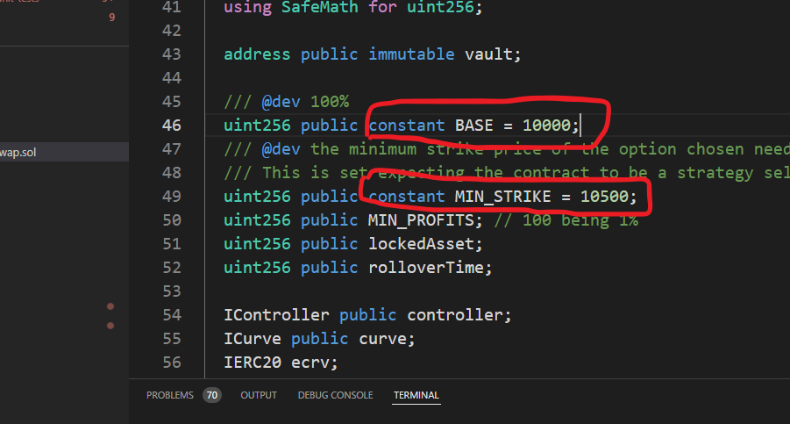
Fig.5
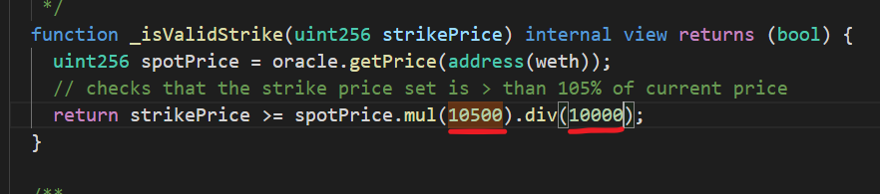
Fig.6
- Remove all the events and emits.
Events consume a lot of gas. I think there are too many events.
In my opinion, reduce count of events as much as possible, deal with only one event – that has event_type and group of data so you can reduce fee.
- 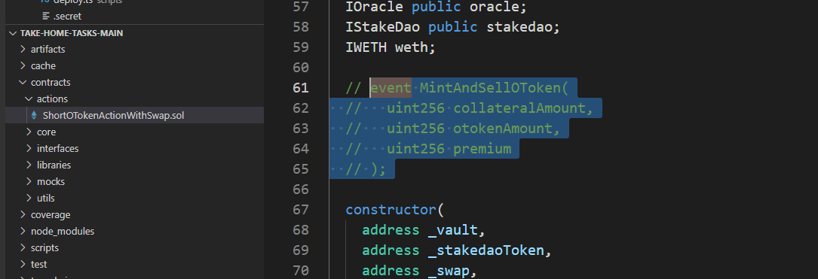
Fig.7
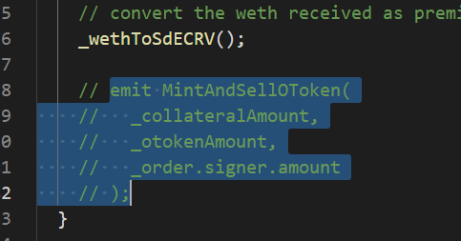
Fig.8
I did the same operation in both sol file.
And the result is below-Fig.10.
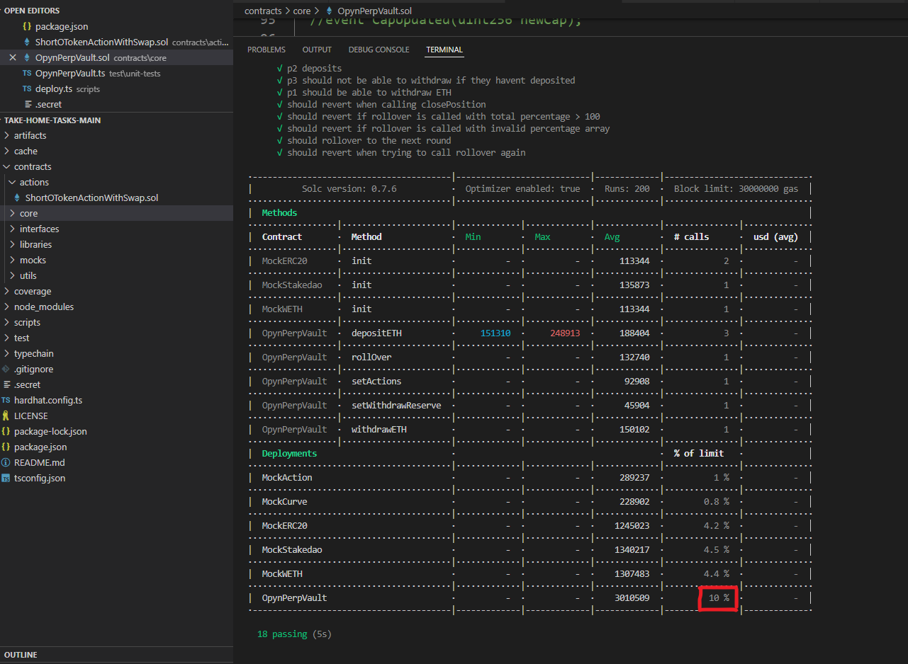
Fig.9-result-optimizer-run = 200

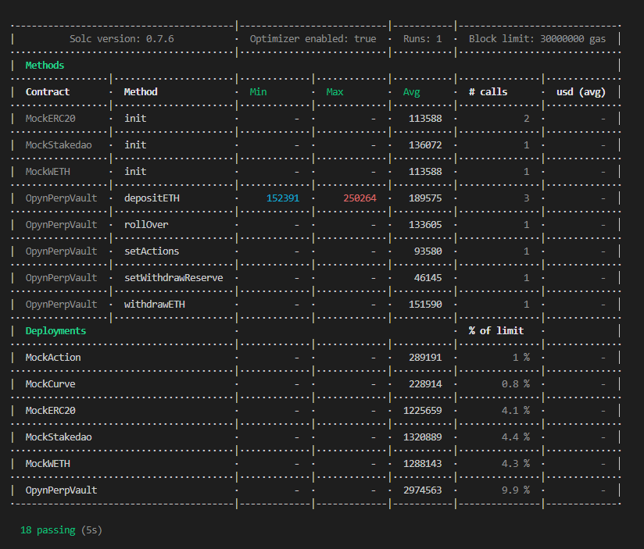
Fig.10-result. (result-optimizer-run = 1)

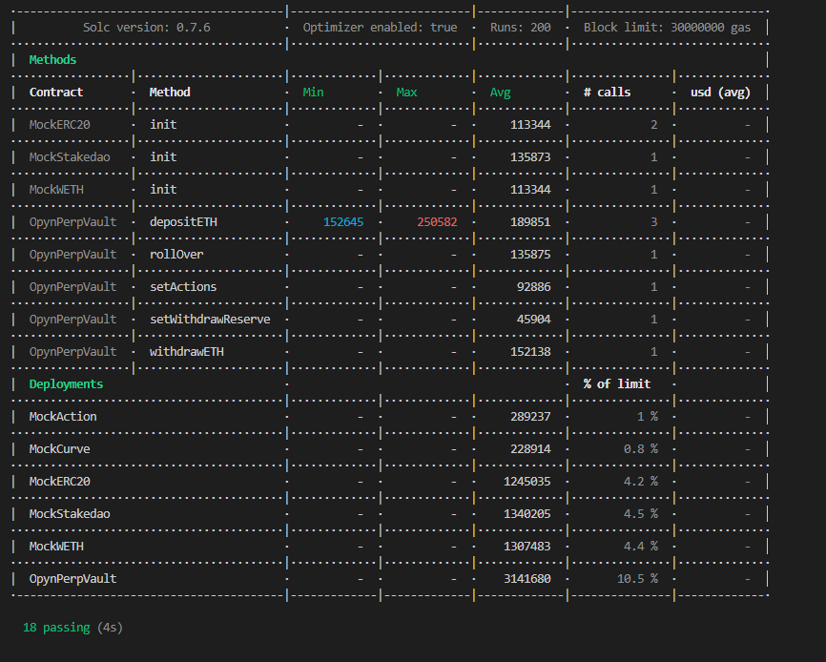

Old result.
I reduce it to 9.9%

