Lab Exercise: Exploring Android Virtual and Physical
Devices
Title: Simulating and Comparing Android Virtual Devices (AVD) and Physical Devices

Part 1: Setting up an Android Virtual Device
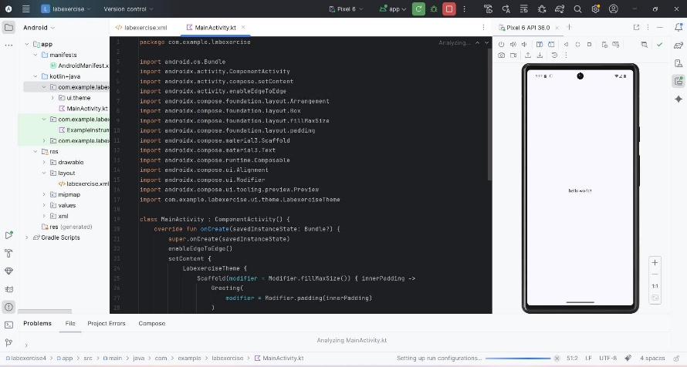


Part 2: Testing an App on AVD

Part 3: Testing on a Physical Device (if available)

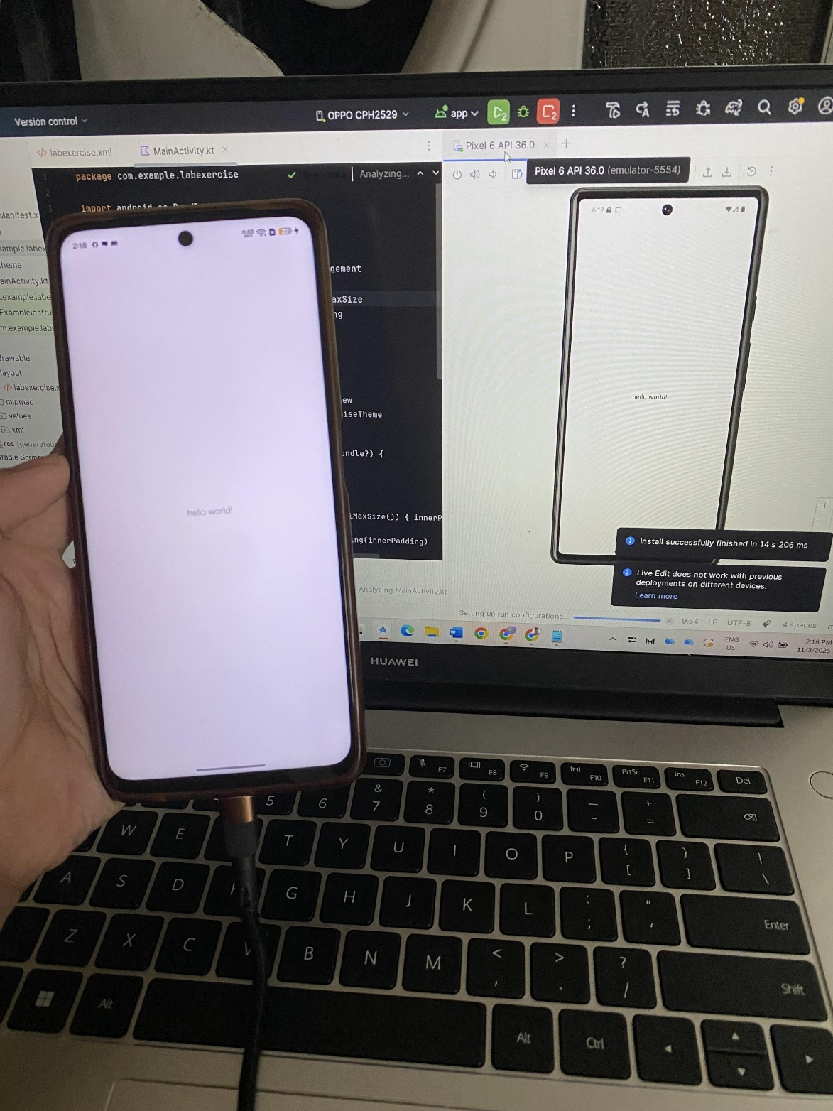

Post-Lab Activity:
Answer the following questions in your lab report:
1.What differences did you observe between the AVD and physical device performance?
-AVDs are slower and less accurate while the physical devices are faster and more realistic.
2. Which platform was easier to configure and use for testing?
-AVDs are easier to set up quickly while the physical devices need more hardware setup.
3. What are the advantages and limitations of AVDs?
-Advantages: Cheap, easy to reset, scalable. Limitations: Slower, uses lots of computer resource, not perfect for real hardware.
4. When would you prefer to use a physical device instead of an AVD?
-For testing real speed, battery, sensors, cameras, or actual user feel.

