🧪 Laboratory Exercise: XML Resources and Debugging in Android Studio
Lab Title:
Exploring XML Resources and Debugging Techniques in Android Development

Part I: XML Resource Implementation
Activity 1 – Create a Simple Android Layout Using XML
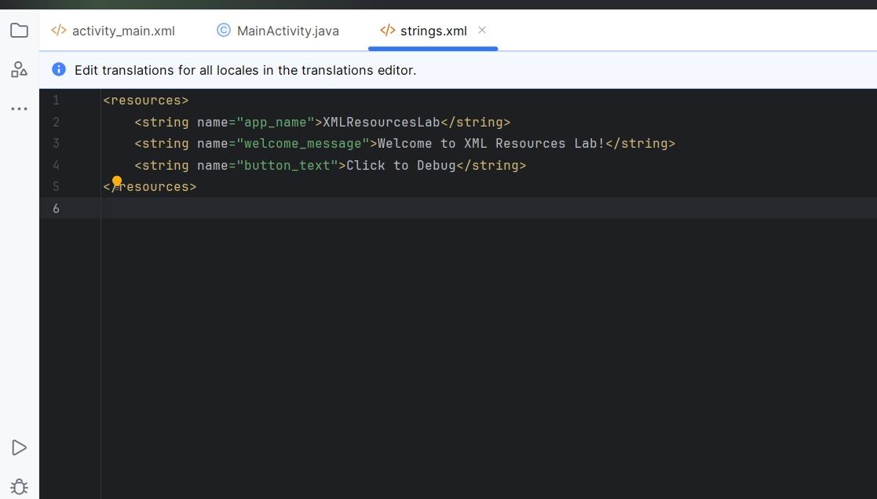

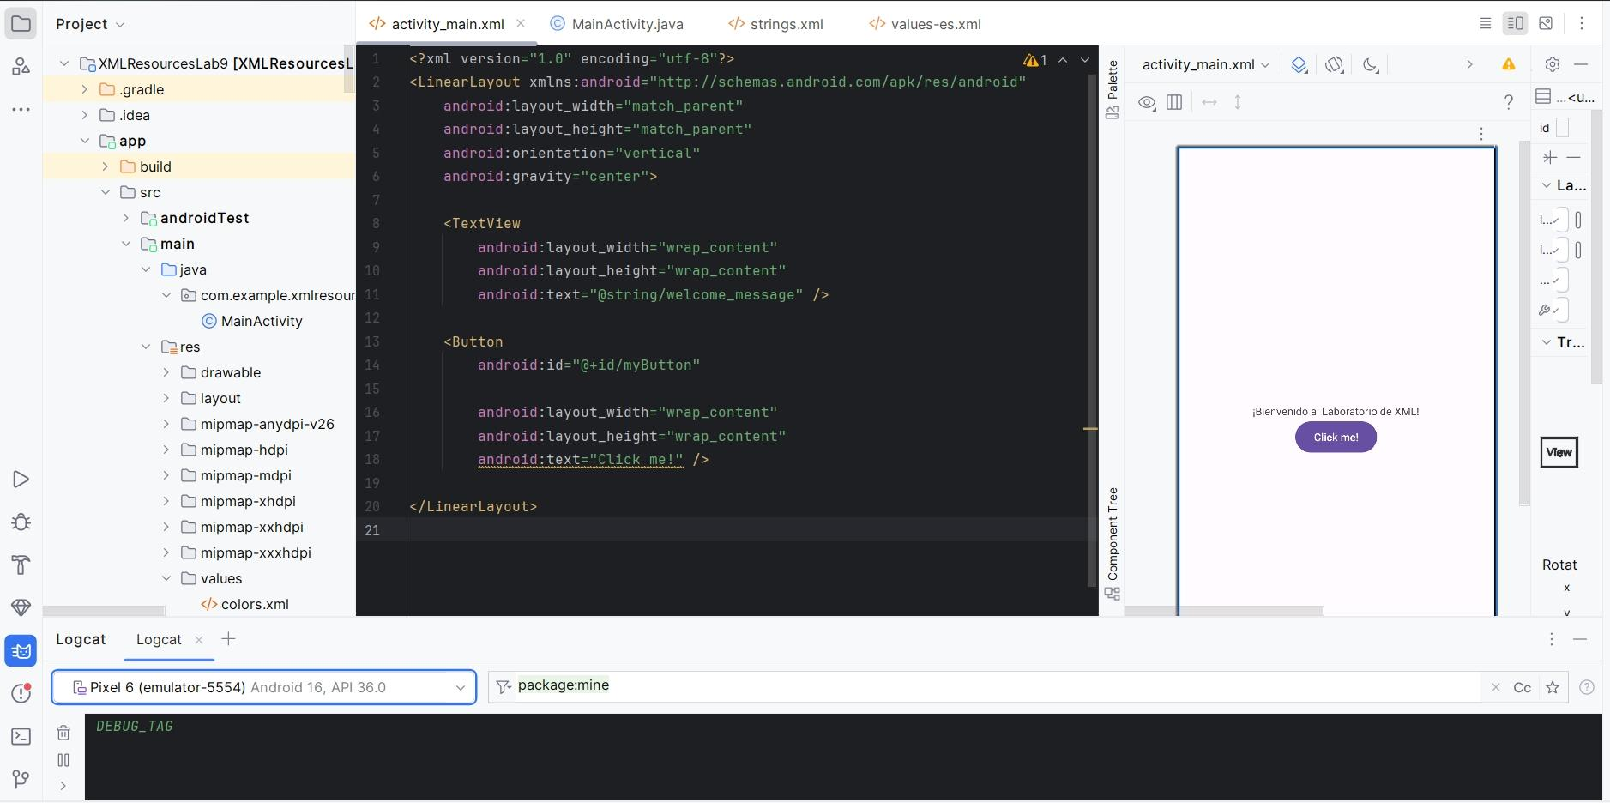
3. Modify MainActivity.java:
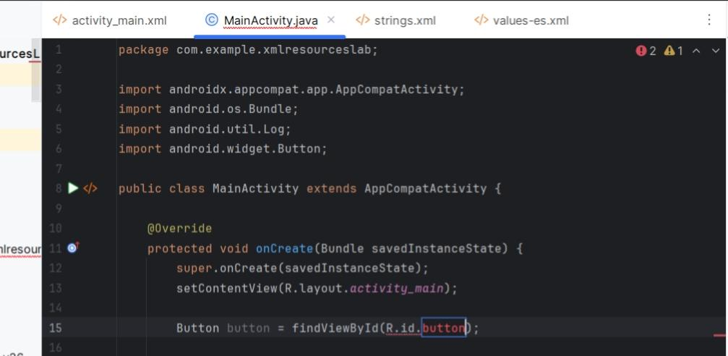

Guide Questions:
- What are the benefits of using XML for UI design in Android?
- XML keeps the layout separate from logic, Easier to edit and visualize UI ,Cleaner structure and faster changes Reusable components

- How does the separation of concerns improve code maintenance?
- UI code XML and logic code Java or Kotlin are kept apart
Makes the app easier to update, test, and fix
You can change the UI without touching Java code
- What would happen if the XML tag is misclosed or misspelled?
- The app will fail to buildR resources won't generate You get errors like "cannot find symbol R"

Part II: Debugging and Logcat
Activity 2 – Exploring Debugging Tools
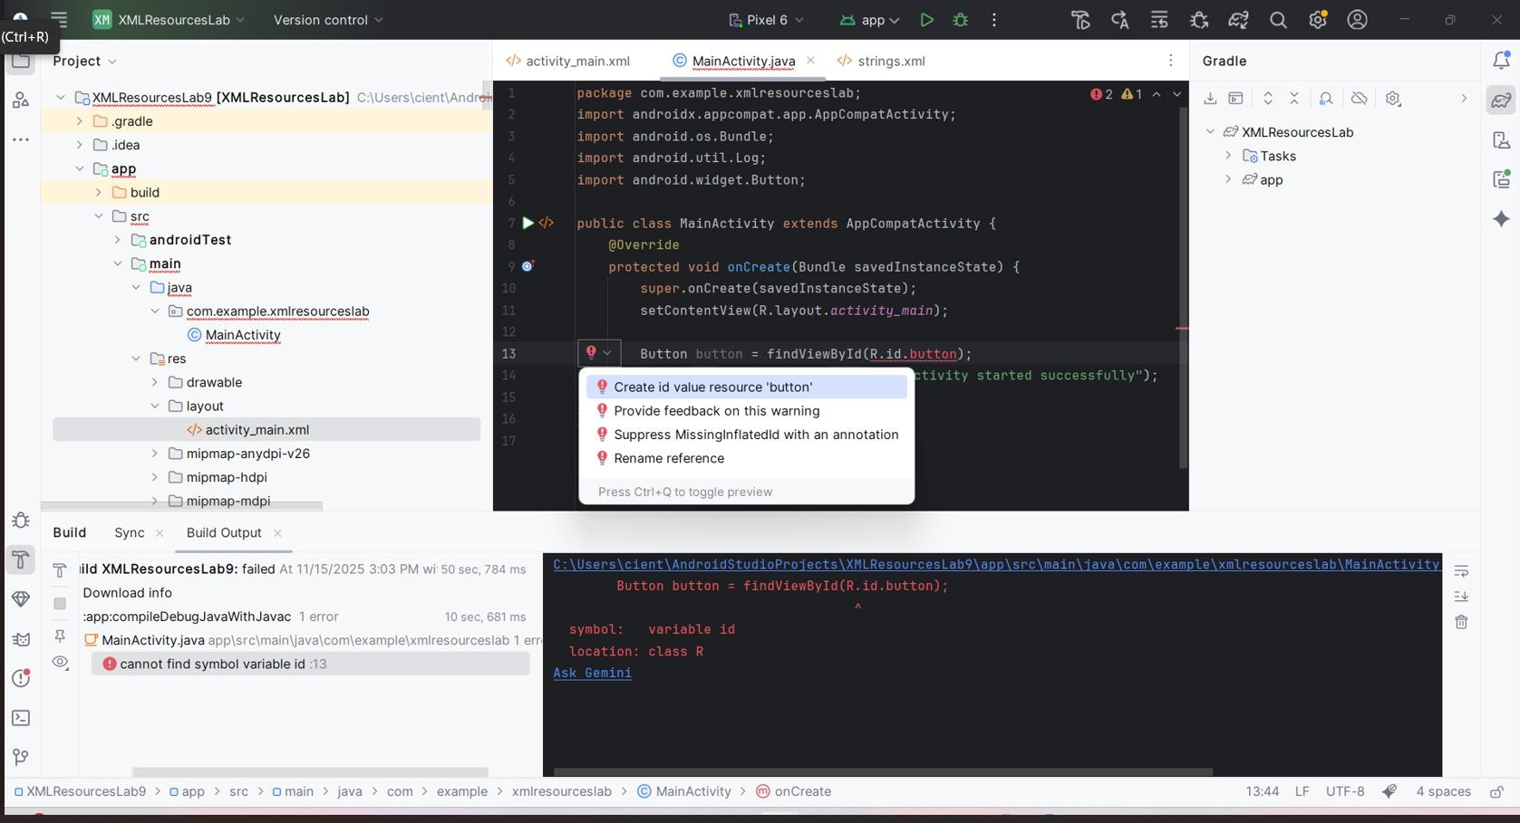

Activity 3 – Logcat
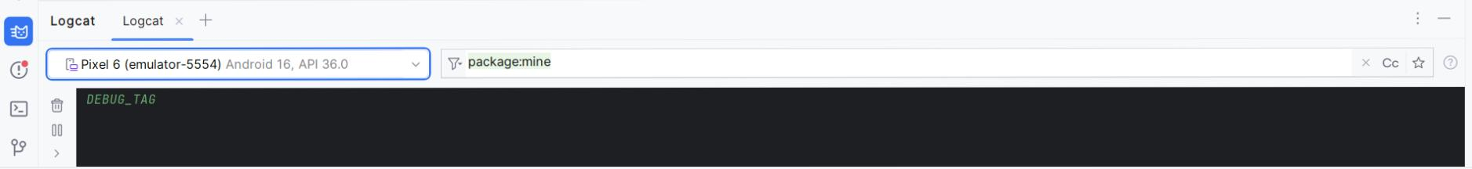
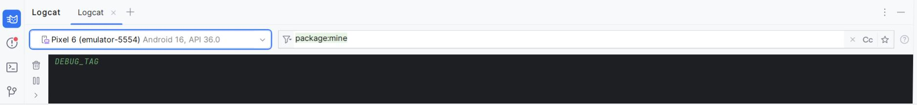

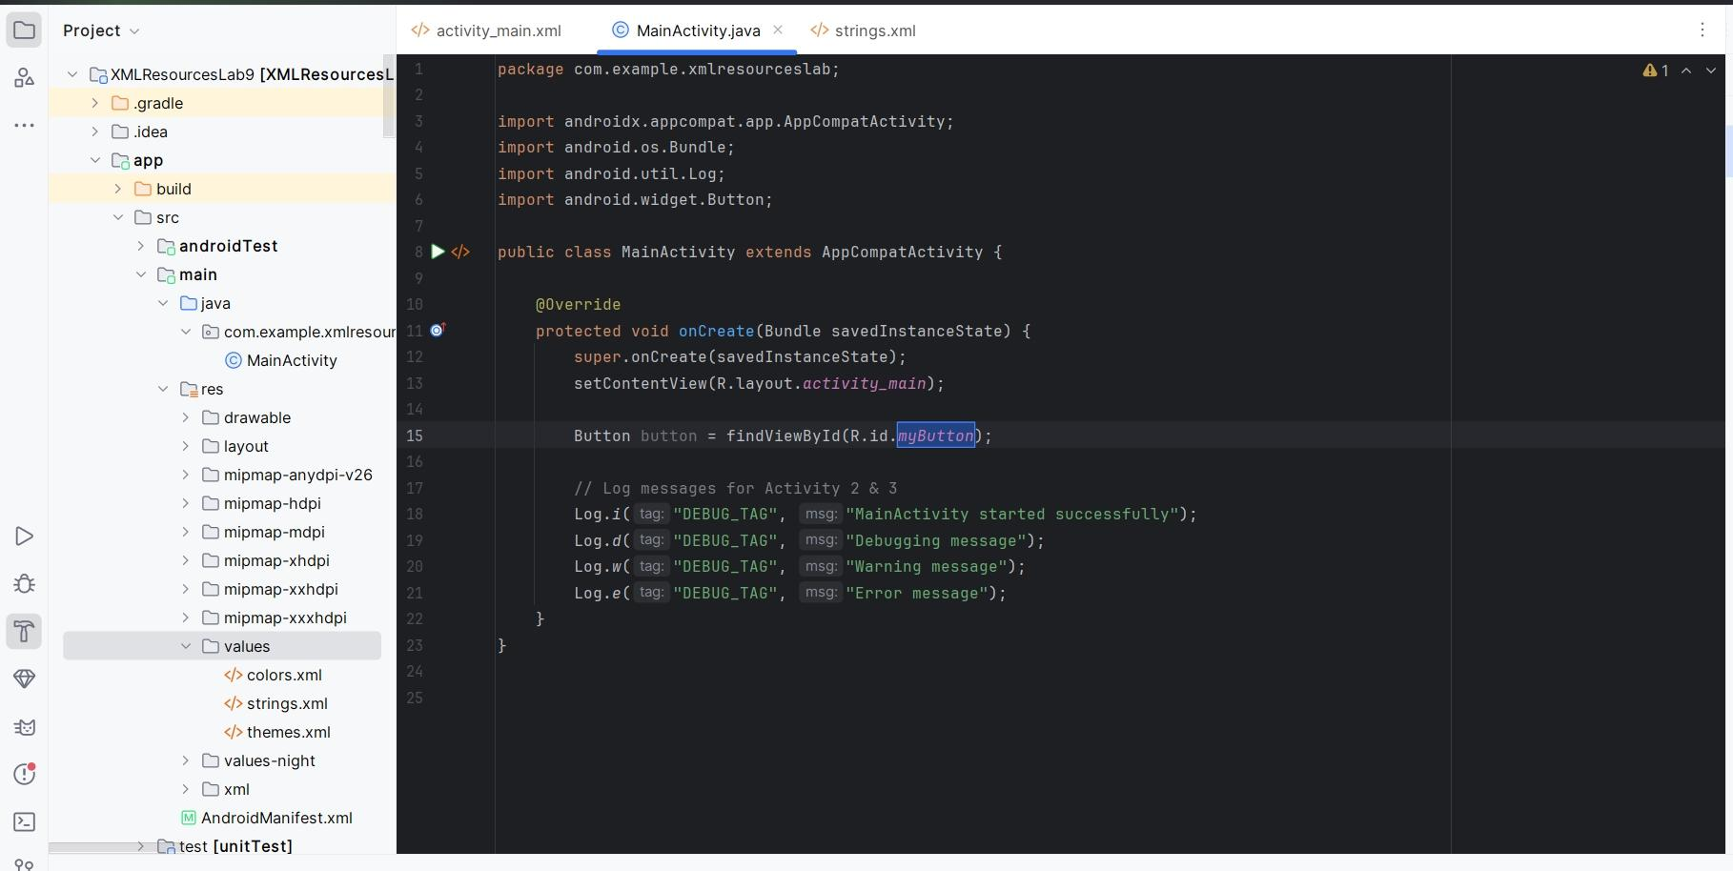

Guide Questions:
- What is the difference between Log.d(), Log.i(), and Log.e()?
- Method Meaning Used For Log.d() Debug Developer/testing info Log.i() Info General messages Log.e() Error Serious problems or failures

- How can you filter logs in Logcat to make debugging easier?
- Type your tag (example: DEBUG_TAG) in the search bar Filter by log level (Debug, Info, Warning, Error) Select only your app's process
- Why are breakpoints useful during development?
- Pause the code at a specific line,Check variable values,Understand code flow step-by-step, and Helps find and fix bugs faster

Part III: Localization and Reusability
Activity 4 – Adding Localization Support Steps:
Guide Questions:
- How does Android decide which resource file to load?
- device language next loads matching folder (e.g., values-es) if no match next uses default values folder

- What advantages does localization provide for global users?
- Supports users from different languages, Improves accessibility, Makes apps usable worldwide

