HANDS-ON AI FOR KIDS
CHAPTER 1

Hands-On AI for Kids
An AI powered adventure with Newton, Byte & SparX

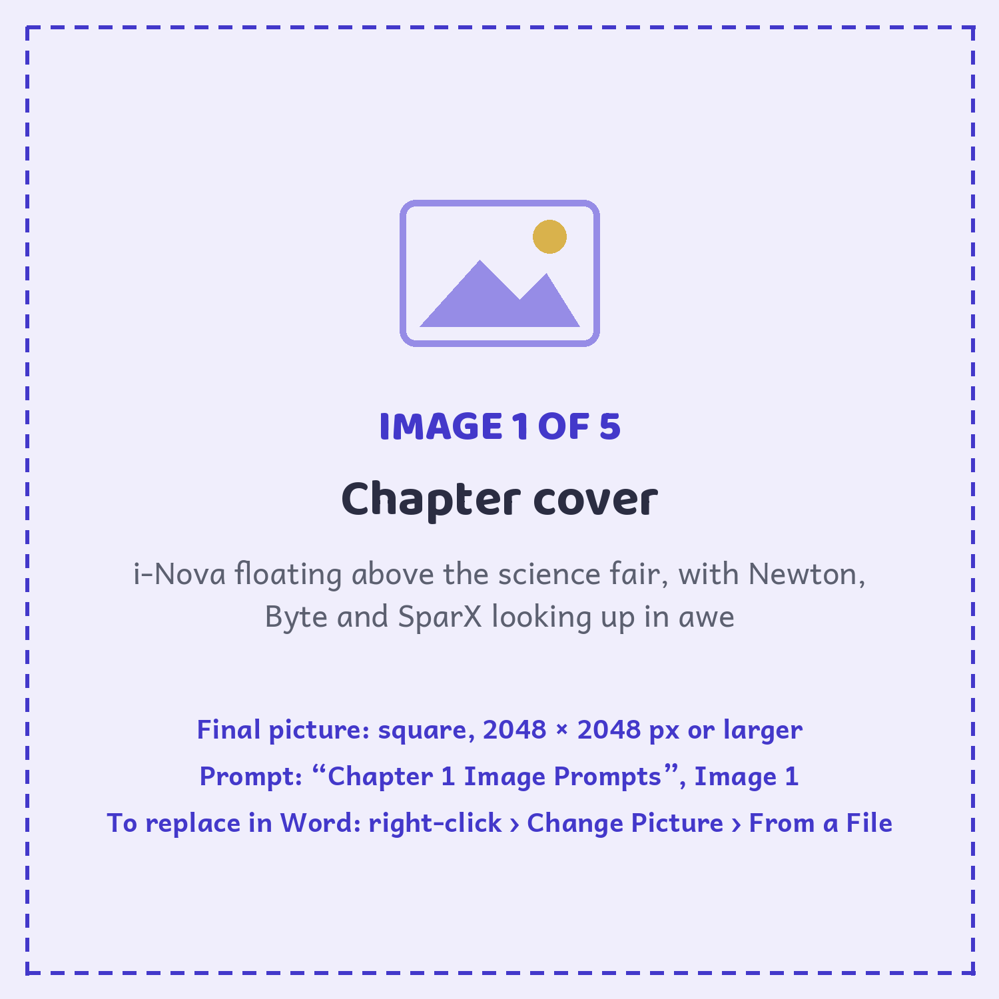
Newton, Byte and SparX meet i-Nova, the Ever-learning AI, at a lively science fair.

Dear Young Reader,
The world you’re growing up in is full of AI and you have been chosen.... AI World needs a new explorer, and we think it should be you.
Inside this book, machines can see, listen, talk and learn. But they can’t do it alone. They need humans to teach them, test them, and make sure they use their powers wisely.
Newton, Byte and SparX will be your guides. Along the way, you’ll tackle puzzles, try hands-on challenges, and uncover the big ideas behind the technology that’s changing our world.
You don’t need to be a computer genius. You just need a curious mind, and the courage to ask “Why?”
Ready? Turn the page. AI World is waiting.........
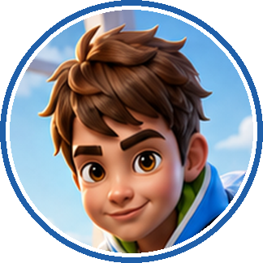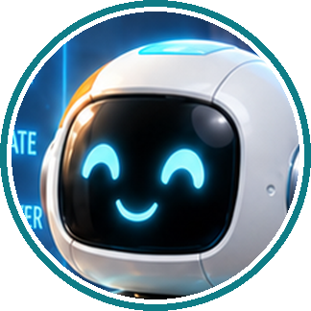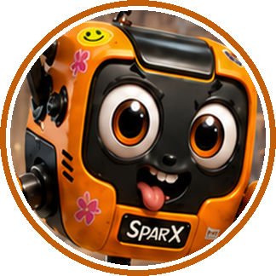

THREE THINGS YOU SHOULD KNOW FIRST
- You already use AI. Your phone unlocking. Your music app. The bus tracker. All of it.
- AI is not magic and it has no brain. It spots patterns in examples that people gave it.
- It gets things wrong. Sometimes hilariously. Working out WHY is the fun part.

This book will not teach you which buttons to press. It teaches you how these machines actually think — so when one gives you a confident answer that happens to be completely wrong, you will spot it.
ONE LAST THING
You are allowed to get it wrong. SparX gets everything wrong and he is having the time of his life.

CHAPTER 1
Contents

GETTING STARTED
So... What Is This Book? 2
Meet Your Adventure Crew 5
THE STORY · PART ONE (SECTIONS 1–4)
Section 1 · The Science Fair Surprise 6
Section 2 · What Is AI 10
Your Turn 1 — activity and summary 14
Section 3 · How AI Learns 16
Your Turn 2 — activity and summary 20
Section 4 · How to Talk to AI 22
Your Turn 3 — activity and summary 26
WHEN YOU GET TO THE END
Everything You Learned 27
AI Crossword 28
Pattern Detective — a no-screen game 30
Amazing AI Facts and the People Behind Them 31
Answer Key — Crossword Answers 32
Glossary — Acronyms & Key Words 33
Parents’ Corner 34
START HERE

Meet Your Adventure Crew

You will always know who is speaking. Each character has their own colour and their own stripe down the side of the page.
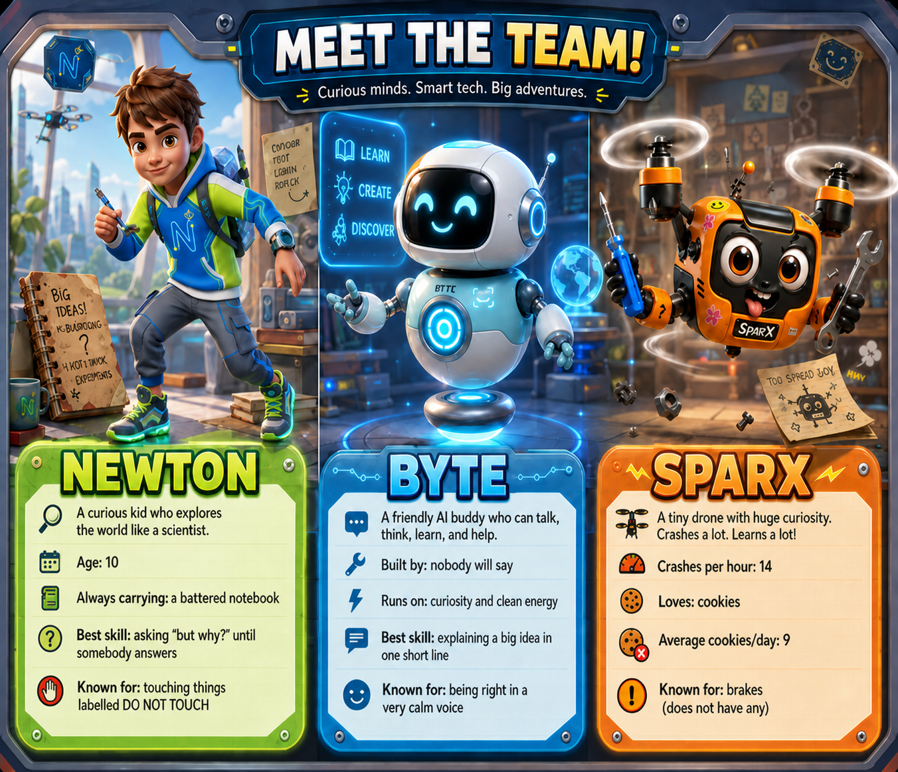

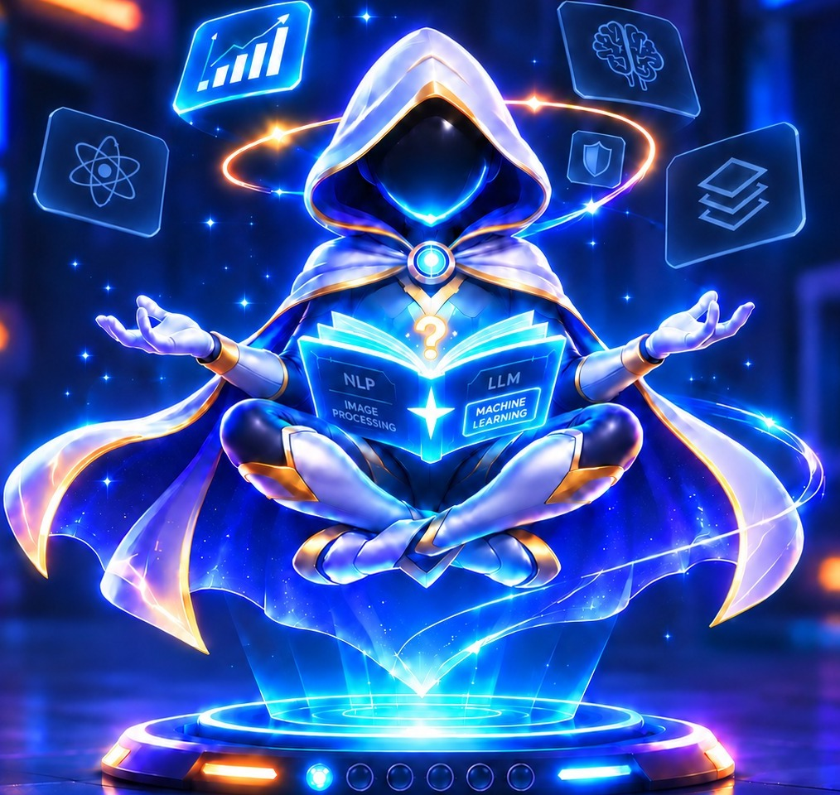 | i-NOVA THE EVER-LEARNING AI  A glowing AI made of light, floating over a book of everything it has read.  Best skill: learning from examples  Still learning: what a drone looks like  Known for: being 100% sure… and sometimes 100% wrong

SECTION 1 ● ○ ○ ○

The Science Fair Surprise
“One school hall, a Science Fair, a hundred questions, and an adventure Newton never saw coming!”

Newton loved science fairs, and today his school was buzzing with excitement. This year’s Great School Science Fair was extra special — the theme was Artificial Intelligence.
Newton had heard people talk about AI — but what was it, and what could it really do? Could a computer think like the Hogwarts Sorting Hat? Could a machine learn and get stronger, the way a Pokémon levels up after every battle?
He didn’t know the answers yet. But that was the best part of a science fair — you began with a question!
He raced through a magnetic maze in record time. He ducked as a model volcano erupted right on cue, showering the judges in pink foam. He watched a tiny robot sort coloured blocks faster than his eyes could follow. Then, wedged between two tables, he spotted a wobbly cardboard sign covered in far too much glitter:
ROBOT PROJECT — ASK ME ANYTHING!

Newton pressed the big TALK button.
The robot looked up! Its round head tilted, and its bright smile glowed like an LED.
BYTE
Hi there! I’m Byte, your friendly Artificial Intelligence buddy — think of me as a pocket-sized robot helper, a bit like a Pokédex that talks back.

NEWTON
Wait — you can actually talk?

BYTE
I can talk, spot patterns, and lend a hand. Want to explore the fair together? Every good adventure needs a team — even Harry needed Ron and Hermione.

They had only reached the drone display when a loud WHIRRRRR echoed from above. A mini drone spiralled down like a confused mosquito and crashed beside them.
BYTE
And that... is SparX.

SPARX
I meant to do that. That was a landing. A very advanced landing — Spider-Man would be taking notes.

NEWTON
You should come with us.

Then, all at once, every light in the hall flickered. A hush rolled across the fair. In the far corner, a round platform began to hum — and a hooded figure made of glowing blue light rose slowly into the air. Its cape rippled like water. An open book of light floated in its hands, and a golden ring spun around its head.
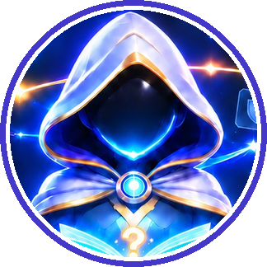 | I-NOVA  Greetings, humans. I am i-Nova, the Ever-learning AI. I have read four million pages. I am never wrong.

SPARX
Ooh, it’s scanning me! Quick — get my left side. That’s my heroic side.

I-NOVA
Scanning complete.

i-NOVA SCAN
HUMAN: NEWTON. ROBOT: BYTE.
The light settled on SparX. BIRD: SPARX.

PICTURE THIS

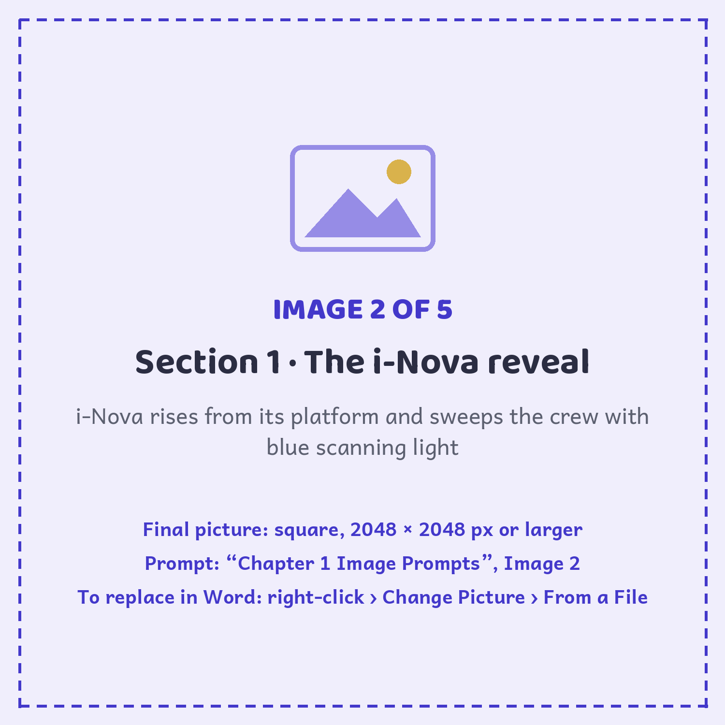

SPARX
A BIRD?! I have propellers, not feathers! Here, i-Nova — study my cookie photos instead. Very me. Very important. Very adorable.

I-NOVA
Analysing… Round. Golden. Covered in spots. New conclusion: you are a spotty bird who loves snacks.

BYTE
Those are cookies, SparX. i-Nova isn’t being rude — it’s still learning, and it only knows what it has been shown.

I-NOVA
Correct. Teach me to recognise SparX… and a BIG SURPRISE is yours.

SPARX
A surprise? Is it cookies? Please say it’s cookies.

Newton opened his notebook to a clean page and wrote one word at the top:
TEACH Underneath, he added: teach i-Nova WHAT?

SECTION 2 ● ● ○ ○

What Is AI

Imagine you got a new puppy. On day one, it doesn’t know its name or a single trick. But every day it watches and tries, and you give a treat when it gets things right. Soon, it sits the moment you say “sit.” Nobody put “sit” inside its brain — it learned by seeing lots of examples.
AI learns almost the same way. AI stands for Artificial Intelligence: artificial means made by people, and intelligence means being clever enough to think, learn, and solve problems.
To teach an AI what a cat looks like, you don’t give it a rulebook. You show it thousands of cat pictures until it spots the pattern all by itself. Then it can look at a brand-new picture and say, “That’s a cat!”
But AI is a great learner, not a perfect one. Just like a puppy might get confused, AI can make mistakes too — sometimes it sees a fluffy dog and shouts, “Cat!”
So AI isn’t magic. There’s no Harry Potter wand! And it isn’t alive. It’s a clever machine that learns from examples and does its best to help.
The same trick lets AI do amazing things:
- It can listen to your voice and understand what you asked.
- It can read your question and write an answer.
- It can look at a photo and tell you what’s inside it.
- It can even help a robot find its way across a room without crashing.
Byte projected a cluster of colourful icons into the air.
BYTE
That’s me — living proof! I spot patterns in thousands of examples and use them to make my best guess. Watch this.

Byte flashed three photos into the air: a robin, a sparrow, and a little blue kingfisher. Then a fourth photo appeared, hidden behind a question mark.

PICTURE THIS

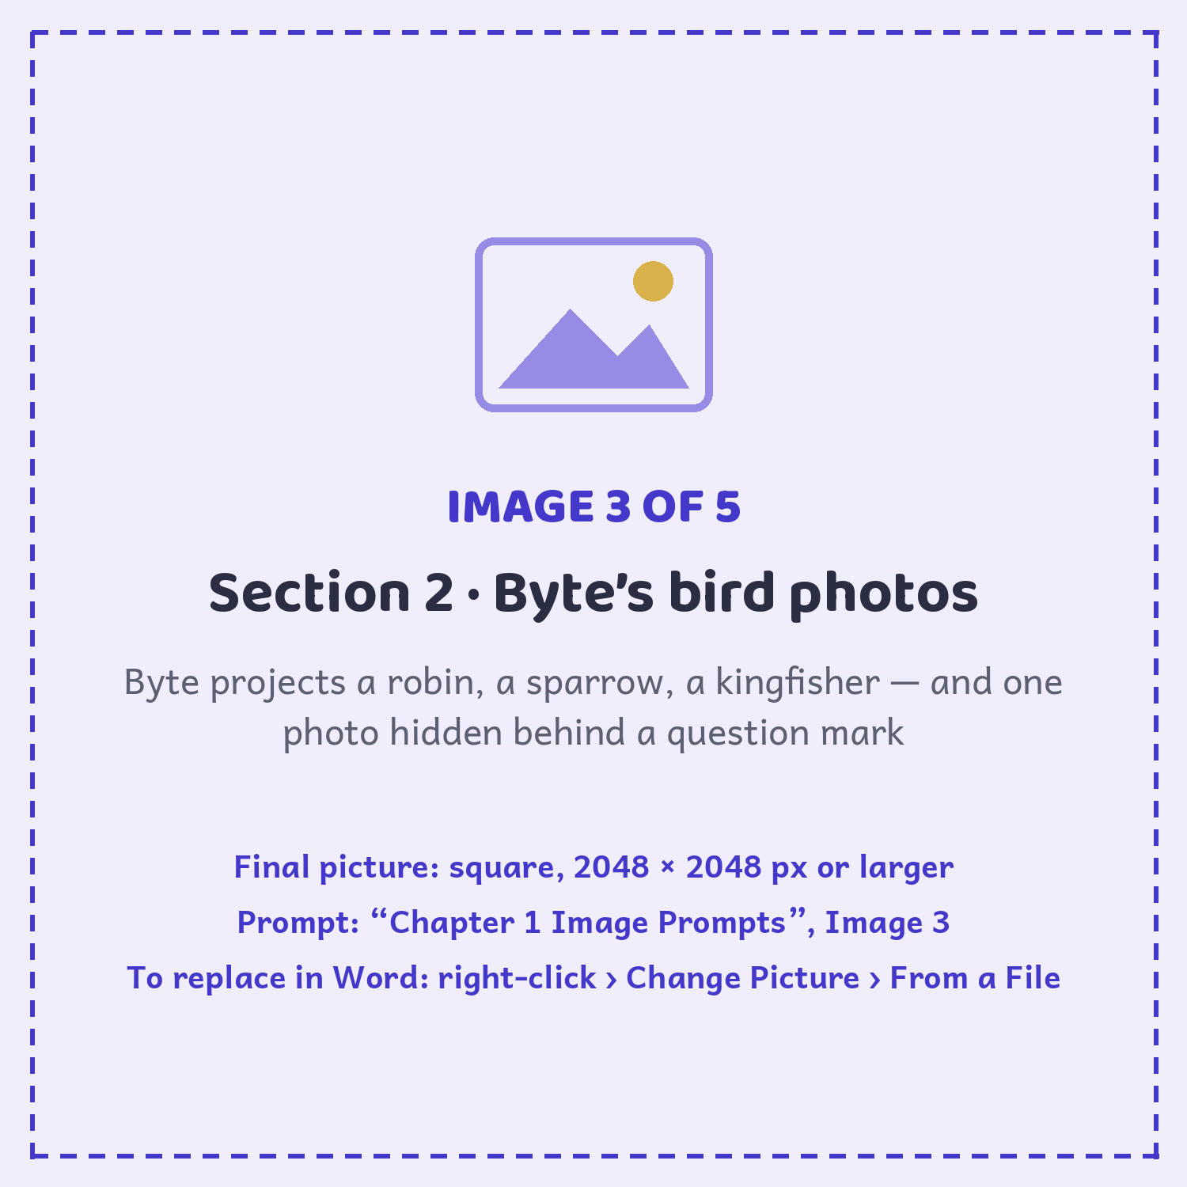

BYTE
Three of these are birds. No rulebook, no telling — just examples. Go on, put on your detective hat like Sherlock Holmes: what do you think the fourth one is?

NEWTON
...a bird?

BYTE
You just spotted the pattern from examples alone. That is exactly how an AI does it.

And that was the whole secret, right there. Nobody handed Newton a list of bird rules — must have feathers, must have a beak. He simply saw enough birds to know what a bird was. An AI learns the very same way: example after example, until the pattern clicks.
NEWTON
So... like teaching a pet tricks?

BYTE
Exactly! Except an AI can learn thousands of tricks at once — a bit like a Pokémon that never stops levelling up.

SPARX
I know tricks! Watch this!

SparX tried to flip, bumped straight into a poster, and knocked it clean over.
SPARX
First I crash into the wall. Then I crash into a slightly different wall. Eventually — mostly — I miss the wall! That’s how I train. Even a Jedi drops the lightsaber a few times before the magic works.

NEWTON
So to train i-Nova, I need to show it examples — not tell it rules.

BYTE
Now you’re thinking. i-Nova is waiting — and so is your surprise.

I-NOVA
I am ready to learn. Also, I have decided SparX is probably a pigeon.

PICTURE THIS

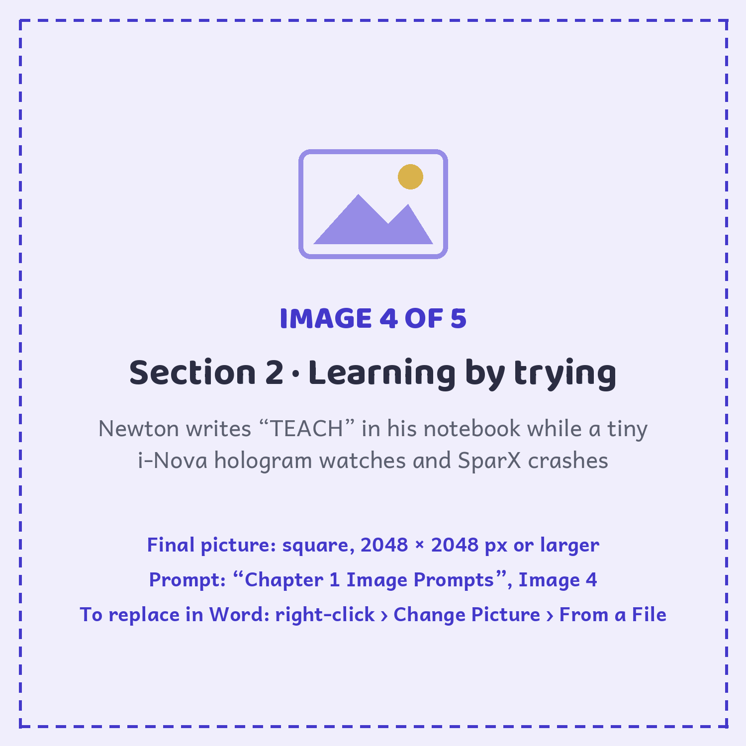

NEWTON’S NOTEBOOK
Try this: teach somebody how to spot a bird — without using the word “bird”. Examples are easier than rules, every time.

BYTE SAYS
“AI follows patterns from the examples it was shown. Better examples help it make better guesses.”
— Byte

CHALLENGE METER
i-NOVA TRAINING ★ ☆ ☆ ☆ ☆ ☆
You found the right kind of clue: AI learns patterns from examples, not rules or cookie photos. Challenge step 1 complete.

YOUR TURN 1 · SUMMARY
What is Artificial Intelligence (AI)?
WHAT IT MEANS
AI is a Technology that enables machines to think, learn and behave like humans to perform intelligent tasks. It learns from data, solve problems and make decisions.

IN THE REAL WORLD
EXAMPLE 1  Voice Assistants like Siri on iPhone and Alexa |  | EXAMPLE 2  Chatbots like ChatGPT |  | EXAMPLE 3  Self-driving cars

KEY POINTS
1 | AI helps machines perform human like tasks
2 | AI learns from data and patterns and improves over time
3 | AI is used in many real-world applications – Face recognition, Self driving cars
4 | AI does not replace humans, but assists them in making better decisions
SECTION 2 · DO & DISCOVER · YOUR TURN 1

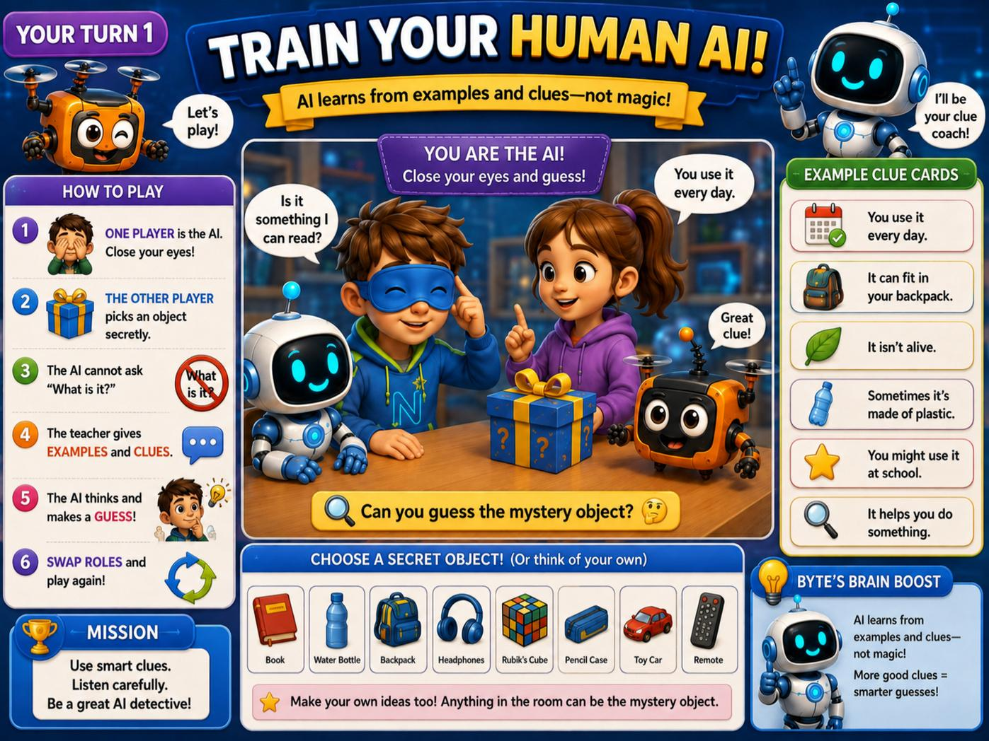

SPARX-ISM
“My logic level is 2%. My enthusiasm level is 200%.”

SECTION 3 ● ● ● ○

How AI Learns

Newton had decided to train i-Nova to recognise SparX — challenge accepted! He already knew an AI learns by spotting patterns in examples, a bit like Spider-Man feeling his spider-sense tingle when danger is near. But what happened after i-Nova spotted its clues? Newton was about to find out.
INPUT  What you show or tell the AI: a photo, question, or sound. | → | LEARNING  The AI searches those examples for useful patterns. | → | OUTPUT  The AI answers, predicts, or takes an action.

NEWTON
Three boxes — input, learning, output. What does that mean?

BYTE
Say you show it a photo. That photo is the input. It hunts for patterns — four legs, fur, a waggy tail — and that is the learning. Then it makes a decision and announces “dog!” That is the output. Input, learning, output — three steps, every single time.

SPARX
Sometimes the output is complete nonsense, though. Once I was absolutely certain a banana was a phone. I tried to call my mum on it for ten whole minutes. Even the Minions would’ve told me to give up.

NEWTON
Wait — AI makes mistakes too?

BYTE
All the time, just like people. The difference is it learns from every mistake and slowly gets better. Watch — I’ll show you how i-Nova learns, the way you’d teach a new puppy.

Byte spread ten photos of cats across the table — big cats, tiny kittens, a fluffy one, even a grumpy cat wearing a tiny hat.

PICTURE THIS

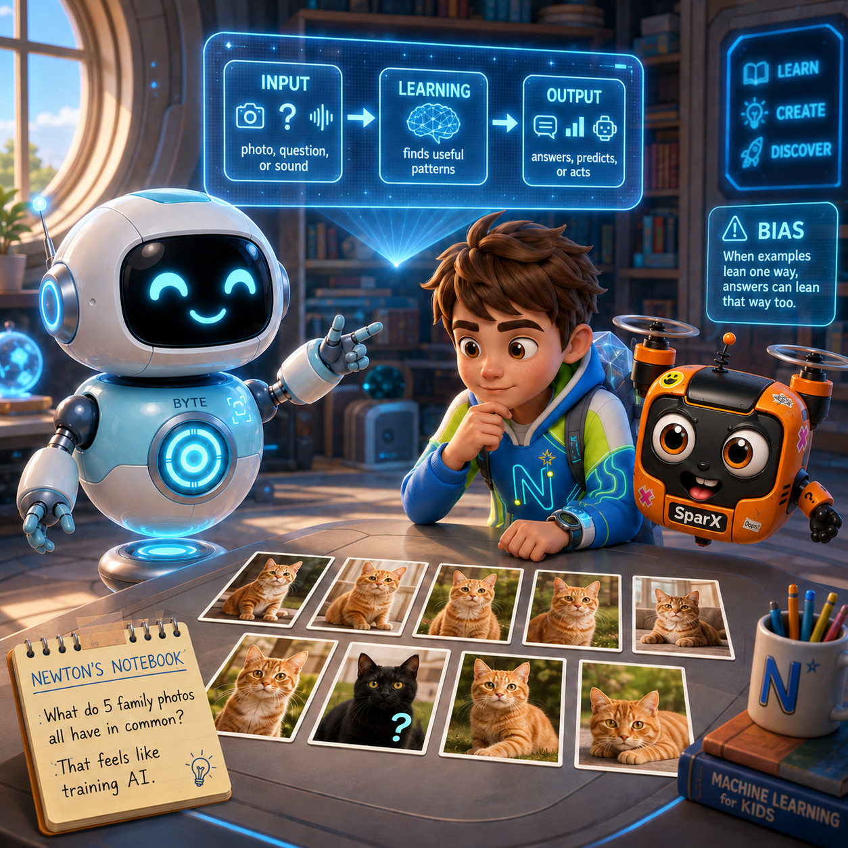

BYTE
Look at all ten. What does every single cat have?

NEWTON
Whiskers. Pointy ears. A tail. Four legs. And eyes that say they own the place — like Garfield judging the whole room.

BYTE
Exactly! You just did what an AI does — you looked at lots of examples and spotted the pattern they share. That is called training.

SPARX
I spotted a pattern too. All ten cats are ignoring me.

BYTE
Now, the important question. Who chose these ten photos?

NEWTON
You did. You picked them.

BYTE
People always do. A person picks every example and puts a label on it — “this is a cat,” “this is not a cat.” The AI only ever learns from what it is shown.

NEWTON
So if you only showed it orange cats...

BYTE
...it would grow up thinking every cat in the world is orange. Show it one unfair pile of examples and it learns that unfair idea. This mistake even has a name: bias. It’s like meeting only the villains in a Marvel film and deciding everyone in the city must be a bad guy.

NEWTON
Bias. So i-Nova kept shouting “bird” because—

BYTE
Because nearly every photo it had ever seen was a bird. A few of SparX’s cookie snaps sneaked in, but mostly it was birds, birds, and more birds.

SPARX
In my defence, those cookies looked really tasty.

I-NOVA
It is true. I have studied 9,412 pigeons and only one drone. It was upside down.

NEWTON
So i-Nova isn’t broken. It just needs better examples — not a bigger brain.

BYTE
Now you’re thinking like an engineer. Change what it learns from, and you change what it knows. Feed it drones, and at last it will see a drone.

SPARX
Please hurry. I have a reputation to protect.

Byte popped open a little hatch on his tummy and pulled out a small instant camera. Newton photographed SparX from the front, the side, above, and mid-flight. The clear drone photos went into Newton’s backpack for the final test.
NEWTON’S NOTEBOOK
Look at five photos of your family. What do all five have in common? That is exactly what training an AI feels like.

CHALLENGE METER
i-NOVA TRAINING ★ ★ ☆ ☆ ☆ ☆
You traced i-Nova’s learning path: input, learning, output — and spotted how bad examples create bias. Challenge step 2 complete.

SPARX-ISM
“If you never mess up, you’re not trying hard enough. Trust me, I’m a professional mess-upper.”
— SparX-ism

SECTION 3 · DO & DISCOVER · YOUR TURN 2

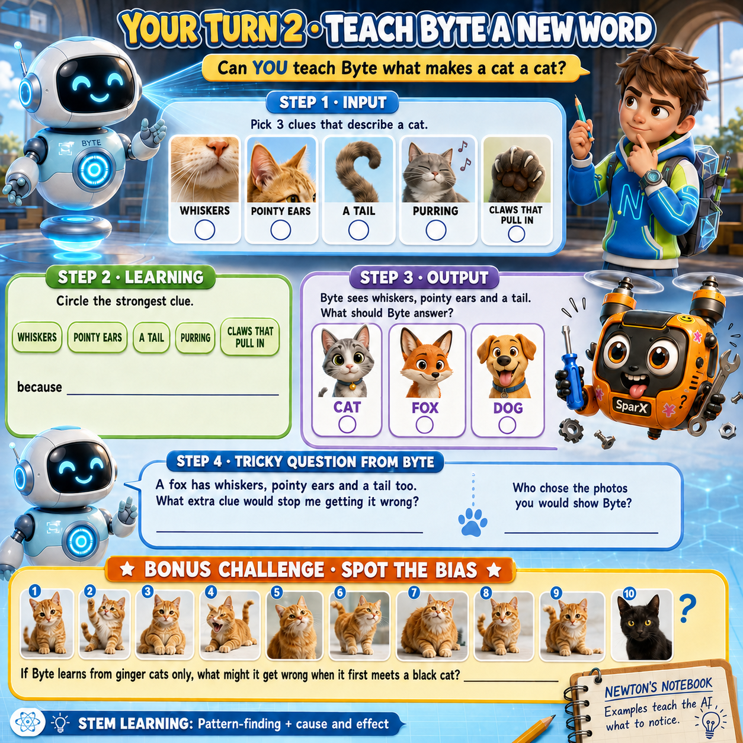

YOUR TURN 2 · SUMMARY
How Does AI Learn?
WHAT IT MEANS
AI learns by looking at lots of examples and finding the patterns they share. This is called training. Every time an AI works, it follows three steps:

INPUT  What you show or tell the AI, such as a photo, a question or a sound | → | LEARNING  The AI searches for patterns in its examples | → | OUTPUT  The AI gives an answer, makes a prediction or takes an action

IN THE REAL WORLD
EXAMPLE 1  A photo app learns to recognise your pet after seeing many pictures of it |  | EXAMPLE 2  Music apps learn which songs you like from the ones you play and skip

KEY POINTS
1 | AI learns from examples chosen and labelled by people, such as “this is a cat” or “this is not a cat”
2 | AI only knows what it has been shown
3 | If the examples are unfair or one-sided, the AI learns an unfair idea. This is called bias
4 | AI makes mistakes, just like people, but it can improve when it learns from better examples

SECTION 4 ● ● ● ●

How to Talk to AI (Prompting)

Newton had figured out how an AI learns. Now he faced a trickier challenge: getting the AI to understand exactly what he meant. It was a little like casting a spell at Hogwarts — say the words wrong, and you might end up with something very different from what you pictured.
The cat examples had shown Newton how an AI learns. Now Byte turned to i-Nova. A prompt is the instruction you give an AI, and here’s the secret: an AI does what you say, not what you mean. Ask in a fuzzy way and you get a fuzzy answer. Ask clearly, and it can amaze you.
BYTE
A prompt is simply how you ask an AI for something. Watch what happens when I’m lazy about it. One word, no details: “spaceship.” That’s like walking up to a genie and asking for “stuff.”

NEWTON
That’s it? Just “spaceship”?

BYTE
That’s it. Now look at what it makes.

i-Nova closed its eyes. The pages of its glowing book flipped all by themselves — and a large, round, chocolate-chip spaceship shimmered into the air.
I-NOVA
Behold. A spaceship. I am 99% sure.

PICTURE THIS

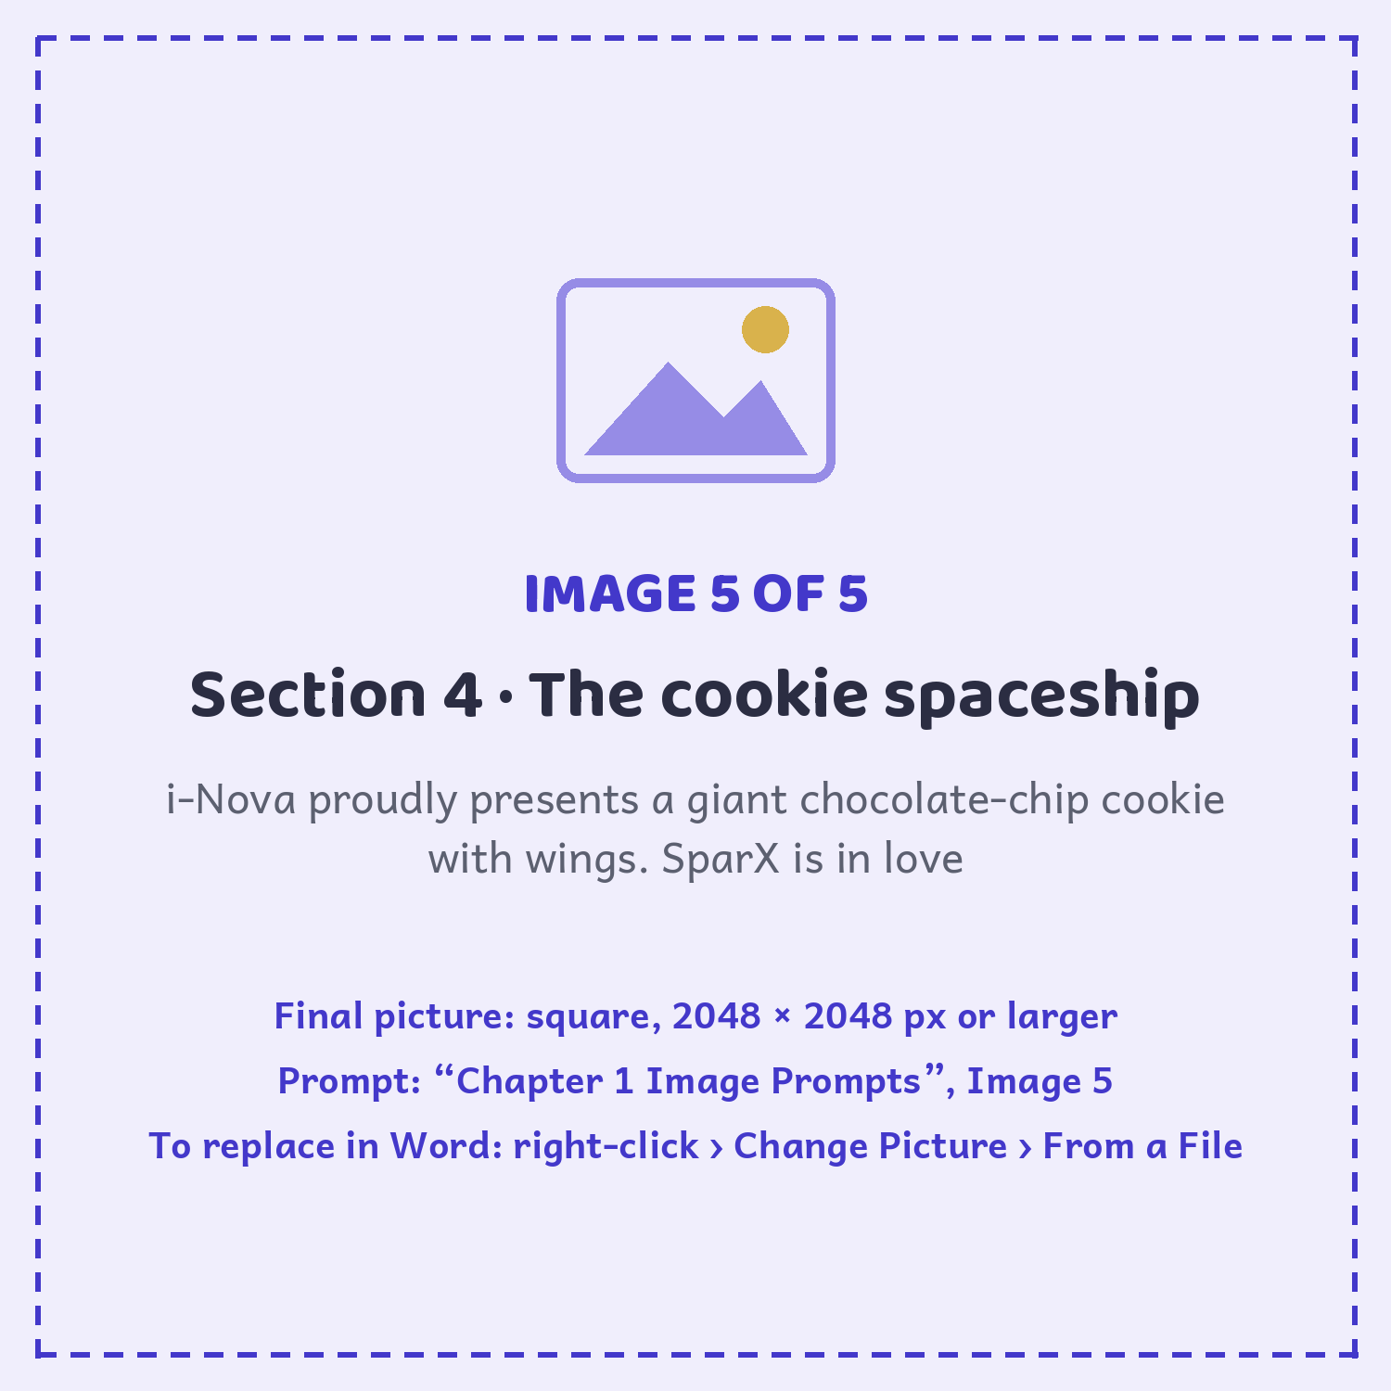

SPARX
Ooh — is that a flying cookie? It’s beautiful. I love it. Can we keep it? I’ll call him Crumbs and love him forever, like Toothless.

NEWTON
Byte, why did it draw a cookie with wings?

BYTE
Because “spaceship” told it almost nothing, so it filled in the gaps with a guess. i-Nova did exactly what I said — not what I meant.

SPARX
For the record, I definitely meant cookie.

BYTE
Let me try again, properly this time. Clear goal first, then details, then an example to copy.

Byte spoke slowly and clearly: “Draw a shiny silver rocket, tall and pointy, with three blue flames, in a cartoon comic-book style.”
I-NOVA
Behold. A shiny silver rocket. This time I am 100%… well, 98% sure.

NEWTON
Whoa! That one actually looks like a real rocket!

BYTE
Same machine. Same three seconds. The only thing that changed was how I asked. That is prompt power.

NEWTON
So there’s a trick to asking well?

BYTE
A recipe, really. Step one, be clear about the goal — “draw a rocket,” not just “rocket.” Step two, add details — colour, size, how many, what mood. Step three, show an example — “like a comic book.” Step four, if it isn’t right, improve it: ask again with one small fix.

SPARX
A recipe! At last, my area of genius. Clear goal, the right ingredients, and a picture of the cookie you want — easy as following a treasure map in Minecraft.

NEWTON
And if the very first answer comes out wrong?

BYTE
You don’t start over — you nudge it. “Make it shorter.” “Add a dragon.” “Why did you pick that?” Every follow-up gets you closer. Watch: “Make the rocket red, and give it two round windows.”

The rocket turned red and grew two little round windows. SparX pressed his face against one.
SPARX
I call the window seat!

NEWTON
So a good prompt is like a good map. The clearer it is, the faster you get where you’re going.

BYTE
Now you’ve got it. Ask like that, and the AI stops guessing and starts helping.

Newton had cracked the secret of prompting. Then four glowing boxes flickered to life across the fair, each tucked inside the next. SparX’s eyes lit up. “Please tell me one of those is a cookie box.”
NEWTON’S NOTEBOOK
Turn a lazy prompt into a strong one. Take “draw a dog” and add three details: what kind of dog, doing what, in what style.

CHALLENGE METER
i-NOVA TRAINING ★ ★ ★ ☆ ☆ ☆
You learned the Prompt Recipe: set a clear goal, add details, show an example, then improve the answer. Challenge step 3 complete.

BYTE SAYS
“A great answer starts with a great question. Say what you want, add detail, show an example.”

YOUR TURN 3 · SUMMARY
What is a Prompt?
WHAT IT MEANS
A prompt is the instruction you give an AI. It is how you ask an AI to do something. An AI does what you say, not what you mean, so a fuzzy prompt gets a fuzzy answer and a clear prompt gets a great one.

IN THE REAL WORLD
EXAMPLE 1  Asking a chatbot, “Explain volcanoes in three short sentences for a 10-year-old” |  | EXAMPLE 2  Asking a drawing app for “a happy orange cat wearing a party hat, cartoon style”

KEY POINTS
1 | A prompt is how you talk to AI
2 | If you leave out details, the AI guesses, and its guess may be very different from what you pictured
3 | The same AI can give a poor answer or an amazing one. The only difference is how you ask
4 | You don’t need to start over when the answer is wrong. Nudge it with follow-ups like “Make it shorter” or “Add a dragon”
5 | A good prompt is like a good map: the clearer it is, the faster you get where you want to go

CHAPTER 1 · SUMMARY

Everything You Learned

1 | What is AI?  AI is short for Artificial Intelligence. It is a smart machine. It can talk. It can learn. It can make choices. But AI does not learn from a list of rules. It learns by looking at lots of examples. That is how you learned the word “dog” too!

2 | How does AI learn?  AI learns in three steps: Input → Learning → Output. People choose and label the examples. Varied examples help it find a fairer pattern; lopsided examples can create bias.

3 | How to talk to AI  A prompt is the instruction you give an AI. Use the Prompt Recipe: be clear about the goal, add details, show an example, then improve the answer with a small follow-up.  CLEAR GOAL · ADD DETAILS · SHOW AN EXAMPLE · IMPROVE IT

4 | Mistakes are clues  AI can make confident mistakes. A wrong answer is a clue: check the examples, improve the prompt, and try again — just as Newton, Byte and SparX do.

CLEAR GOAL
ADD DETAILS
SHOW AN EXAMPLE
IMPROVE THE ANSWER
(Ask again with one small fix.)

 | ★ BIG IDEA ★  AI learns from examples, and clear prompts help it turn those patterns into useful answers.

ACTIVITY 1

AI Crossword

Read each clue. Write one letter in each box. The number tells you where the word starts!
⚡ LEVEL UP (ages 11–13): try finishing it from the clues alone — no peeking back at the story.
SPARX’S HINT
There are 12 words hiding in this grid. I tried it first and got zero — but I was upside down in a plant pot. You will do much better! Every answer lives somewhere in Chapter 1.

 | 1 | 2 |  |  |  | 3 |  |  |  |  |  |  | 4
 |  |  |  |  | 5 |  |  |  |  |  | 6
7 |  |  |  | 8
9

 |  |  |  |  |  |  |  |  | 10
11

 |  |  |  |  |  |  | 12

ACTIVITY 1 · CLUES

Crack the Clues

ACROSS →  1. It has a screen but never learns anything. (10)  5. AI is a smart ______ that can talk and learn. (7)  9. AI finds a ______ by looking at many examples. (7)  10. An LLM is built for ______. (5)  11. AI does jobs that usually need ______ thinking. (5)  12. Deep Learning works in ______. (6) | DOWN ↓  2. A list of steps someone wrote, like a recipe. (9)  3. Machine ______ means a computer learns from examples. (8)  4. You teach an AI by showing it lots of ______. (8)  6. Spotting AI around you makes you an AI ______. (8)  7. ______ Learning sits inside Machine Learning. (4)  8. Having a ______ does not always mean it is AI. (6)

SPARX SAYS
“Stuck on a clue? Flip back into the story. That’s where I hid… I mean, where the answers live.”

ACTIVITY 2 · NO SCREENS NEEDED

Pattern Detective

PATTERN DETECTIVE
Teaches: AI finds patterns · Players: 1+ · Time: 10 min · Needs: this page and a pencil
Look at each row. Find the hidden rule. Then circle the one that does NOT belong.
Row A: apple · banana · carrot · grape
Row B: 2 · 4 · 6 · 9 · 8
Row C: dog · cat · car · rabbit · horse
Row D: circle · ball · box · moon · orange
Answers (no peeking!): A carrot · B nine · C car · D box
★ Big idea: AI is a pattern finder. It looks at many things and works out the rule.
⚡ Level up: invent your own Row E — four things that share a rule, plus one sneaky odd-one-out — and see if a grown-up can crack it.

TRUE STORIES

Amazing AI Facts

Every one of these really happened. Some of them are still happening right now.
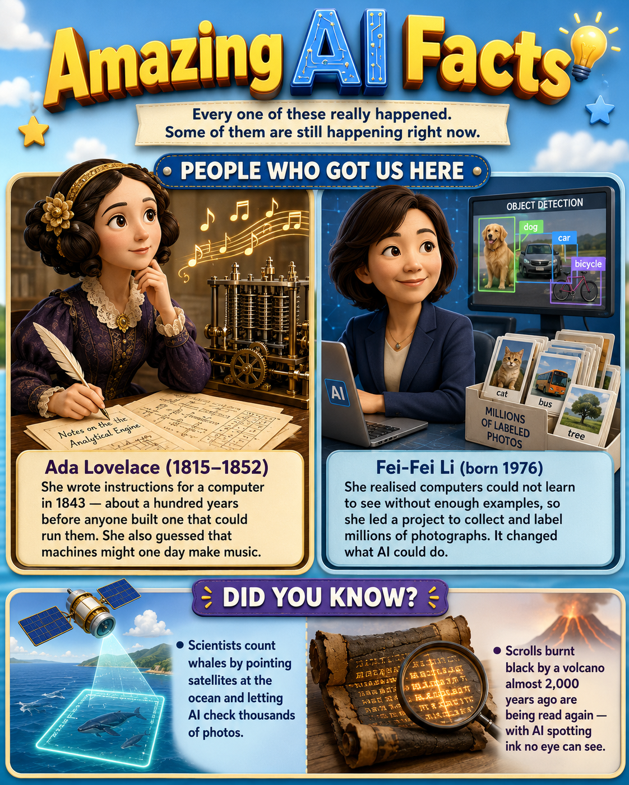

ANSWER KEY

AI Crossword Answers

All the answers are filled in below. Check your work — no peeking too soon!
★ HOW DID YOU GO? ★
All twelve answers are filled in below. Ticked them all? You are officially an AI Explorer! Missed a few? Flip back into the story — that is where every clue is hiding.

 | 1  C | 2  A | L | C | U | 3  L | A | T | O | R |  |  | 4  E
 |  | L |  |  |  | E |  |  |  |  |  |  | X
 |  | G |  |  | 5  M | A | C | H | I | N | 6  E |  | A
7  D |  | O |  | 8  S |  | R |  |  |  |  | X |  | M
E |  | R |  | C |  | N |  |  |  |  | P |  | P
E |  | I |  | R |  | I |  |  |  |  | L |  | L
9  P | A | T | T | E | R | N |  |  |  |  | O |  | E
 |  | H |  | E |  | G |  |  | 10  W | O | R | D | S
11  H | U | M | A | N |  |  |  |  |  |  | E
 |  |  |  |  |  |  | 12  L | A | Y | E | R | S

ACROSS →  1. CALCULATOR  5. MACHINE  9. PATTERN  10. WORDS  11. HUMAN  12. LAYERS | DOWN ↓  2. ALGORITHM  3. LEARNING  4. EXAMPLES  6. EXPLORER  7. DEEP  8. SCREEN

CHAPTER 1 GLOSSARY

Acronyms & Key Words

Big ideas become easier when you know the words. Come back here whenever you need a quick reminder.
AI | Artificial Intelligence — a computer system that learns patterns from examples to make decisions or guesses.
Algorithm | A step-by-step set of instructions — like a recipe for a computer.
Artificial | Made by people rather than occurring naturally.
Bias | An unfair or inaccurate pattern caused by lopsided examples or design choices.
Data | The examples and information an AI learns from.
Input | What you show or tell the AI: a photo, question, sound, or other example.
Intelligence | The ability to learn, reason, and solve problems.
Learning | The stage where an AI searches examples for patterns.
Model | The pattern-based system produced after an AI learns from data.
Output | The answer, prediction, or action the AI gives back.
Pattern | Something that repeats or connects in a predictable way.
Sensor | A device such as a camera or microphone that collects information from the world.
STEM | Science, Technology, Engineering, and Mathematics.
Training | The stage where an AI is shown many examples so it can find the pattern they share.
Voice assistant | An AI tool you speak to that understands requests and answers aloud.

A QUICK GUIDE FOR GROWN-UPS

Parents’ Corner

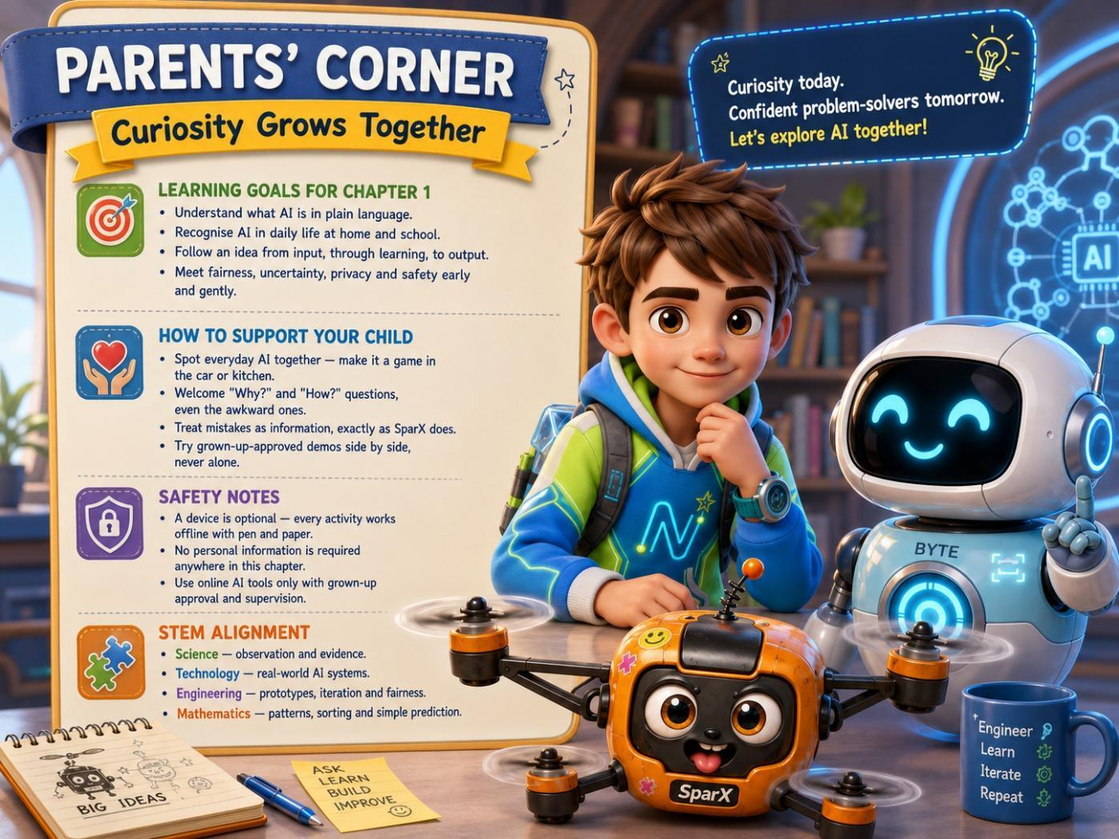
A grown-up helps Newton connect creativity, privacy and thoughtful design.
BYTE SAYS
“Curiosity grows best when children feel safe to ask, test, laugh, rethink, and try again.”

NEXT UP · CHAPTER 2

The Glowing Boxes

Newton slid the drone photos into his backpack. He understood examples, training, bias and prompt power — but Byte pointed to one more display across the science fair.
Four glowing boxes shone inside one another, from the biggest blue frame to the smallest purple square. Before they trained i-Nova, Byte wanted Newton to see where it fitted in the AI family.
SPARX SAYS
“If one of those is a cookie box, I volunteer as chief inspector!”
— SparX

The adventure continues in Chapter 2, where Byte reveals the AI Family Tree and the team completes i-Nova’s challenge safely.
END OF CHAPTER 1

