**TIME SERIES FOR FINANCE AND ECONOMICS – TEAM ASSIGNMENT**

*Alejandro Acosta, Federico Caccialanza, Roberto Antonio Mapa*

**Problem 1 – Forecasting energy variables**

1. This is the dataset and the plot of the variable Value, which consists in Small-Scale Solar Energy Consumption

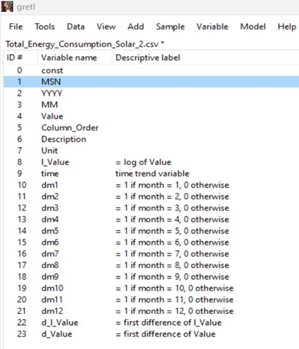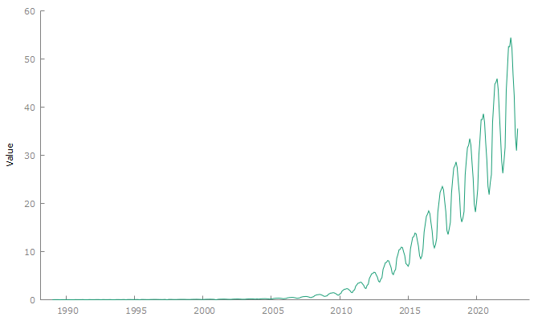

1. We decided to adopt a log transformation of the Value. We observed that to have an acceptable correlogram we needed to use a Seasonal Arima. We observed that we had two possible unit roots, one in the AR and the other in the seasonal AR. So, to preserve stability, we added a I(1) in both. We observed that the best BIC (-1603) was achieved with a SARIMA (2,1,0) (2,1,0). The R squared is high, we can explain 99,99 percent of the variance. We can observe that the only three coefficients with a good p_value are phi_1 (ar not seasonal), Phi_1 (seasonal) and dm1. We can observe that the remaining modulus of the roots are far away from 1.

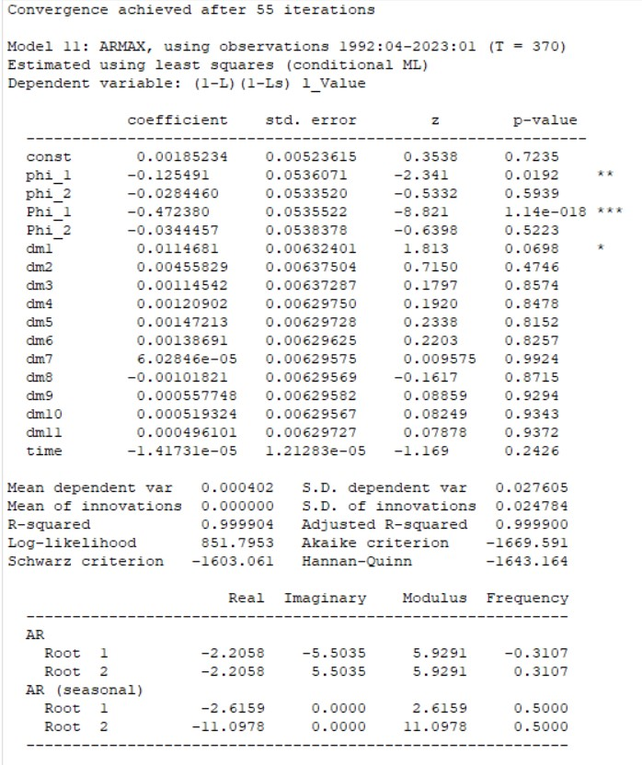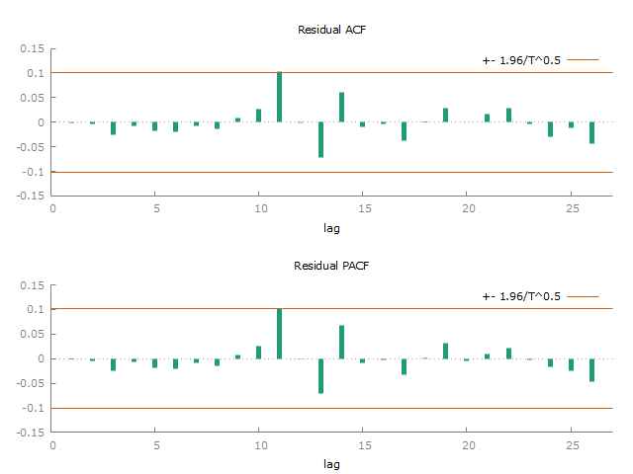

1. This is the forecast using the last two months as a test. We can observe the more we try to forecast in the future the more our confidence interval becomes bigger and bigger. This is because the standard errors are being added along the way. We can also observe that the forecasts for the first months are really accurate.

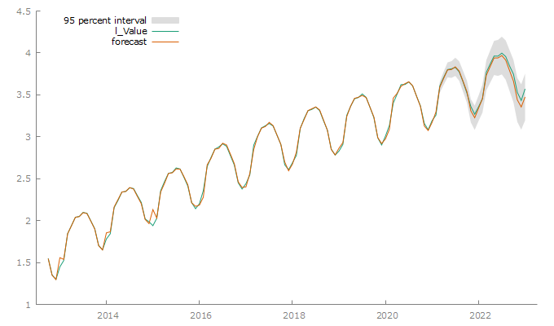

1. This is the forecast 24 months in the future:

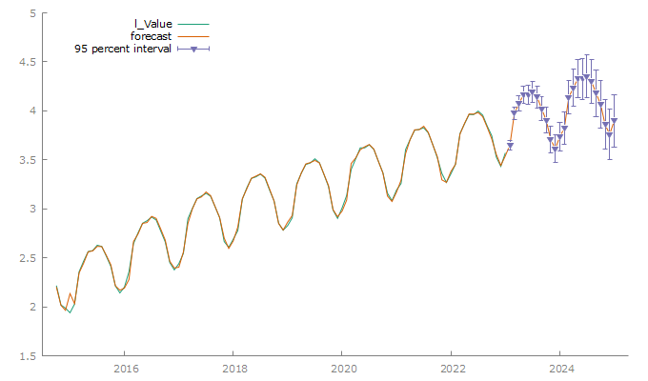

1. Small-Scale Solar Photovoltaic Generation Total Net Generation and Utility-Scale Solar Energy Consumption: Total were the two other time series chosen to analyse.

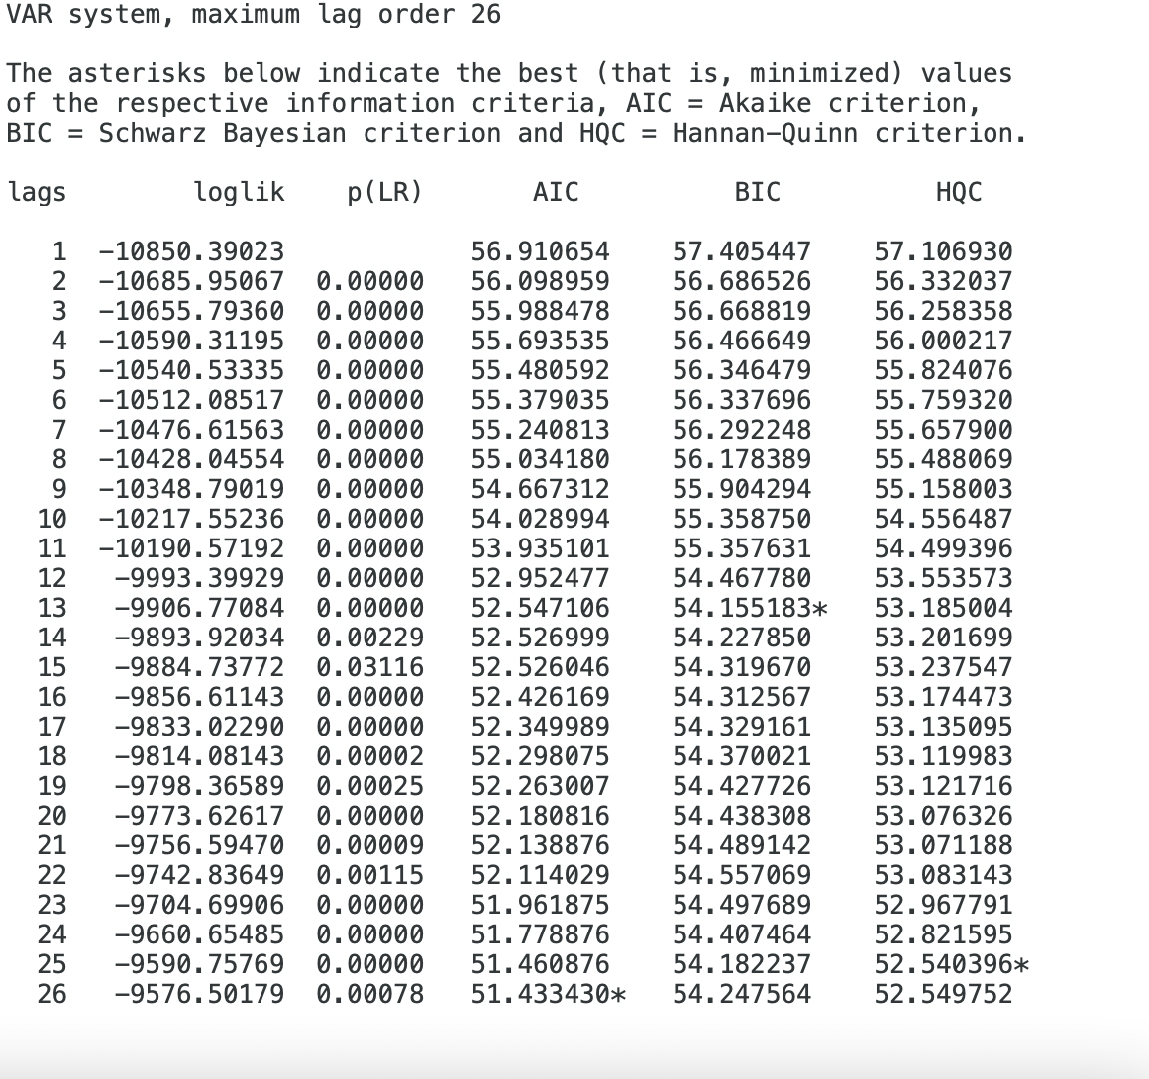

1. Lags 26, 13, and 25 exhibit significant autocorrelation. However, lag 13 generally has higher ACF and PACF values, indicating a stronger correlation and the best fit.

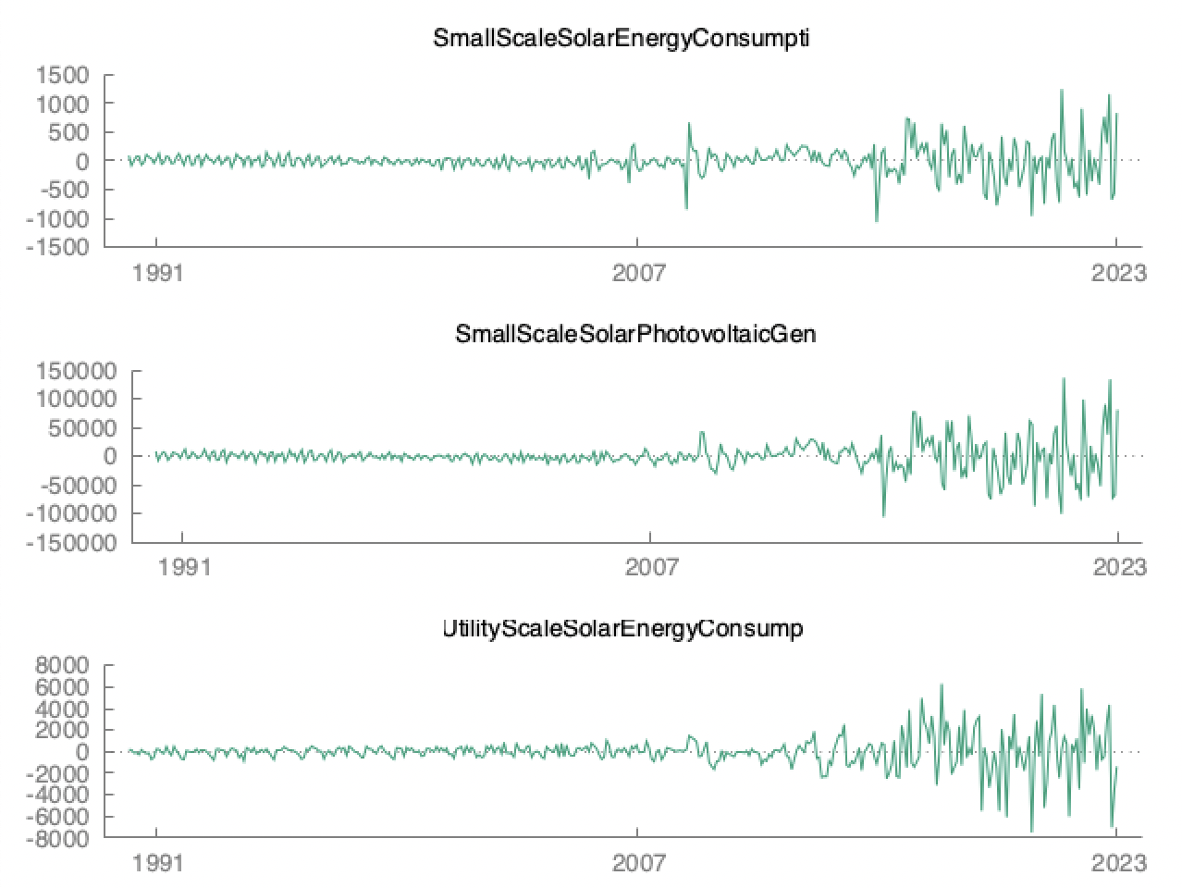

* The log-likelihood of -10224.73 suggests a good fit
* The high determinant of 5.3649611e+18 indicates significant linear dependence
* The p-value of 0.0000 indicates strong evidence of residual autocorrelation
* A high R-squared value of 0.999594 explains the large portion of the dependent variable's variance

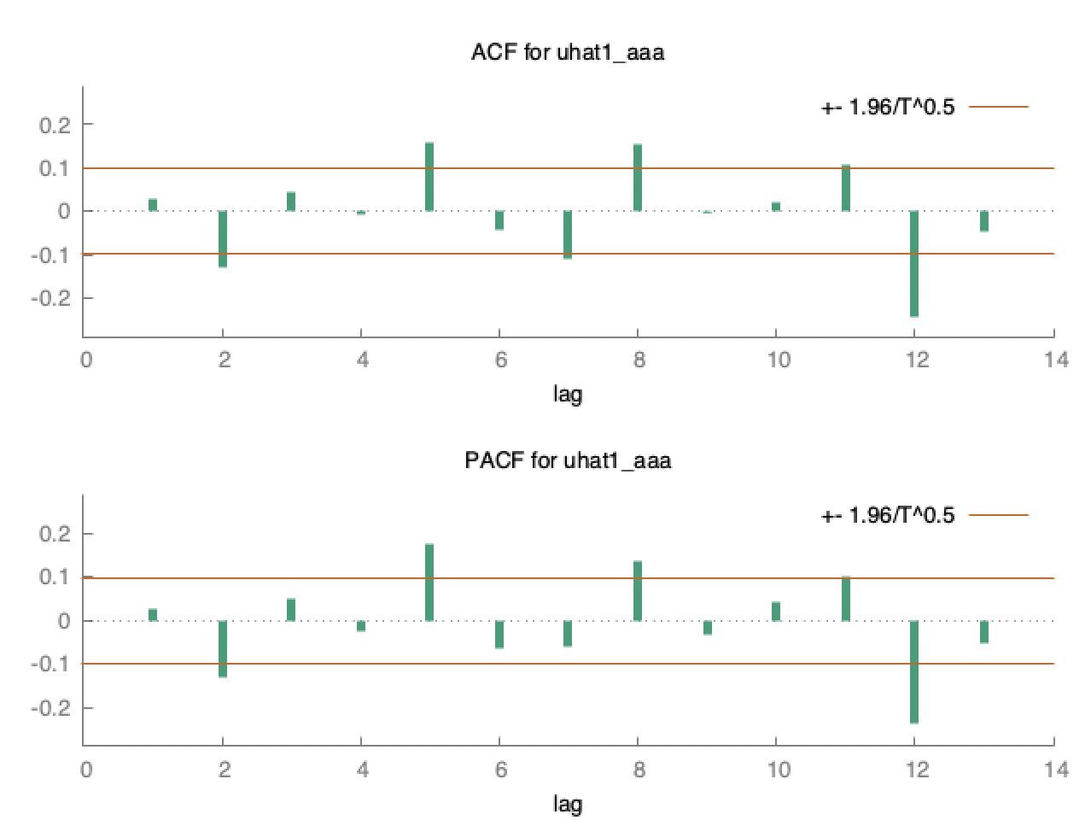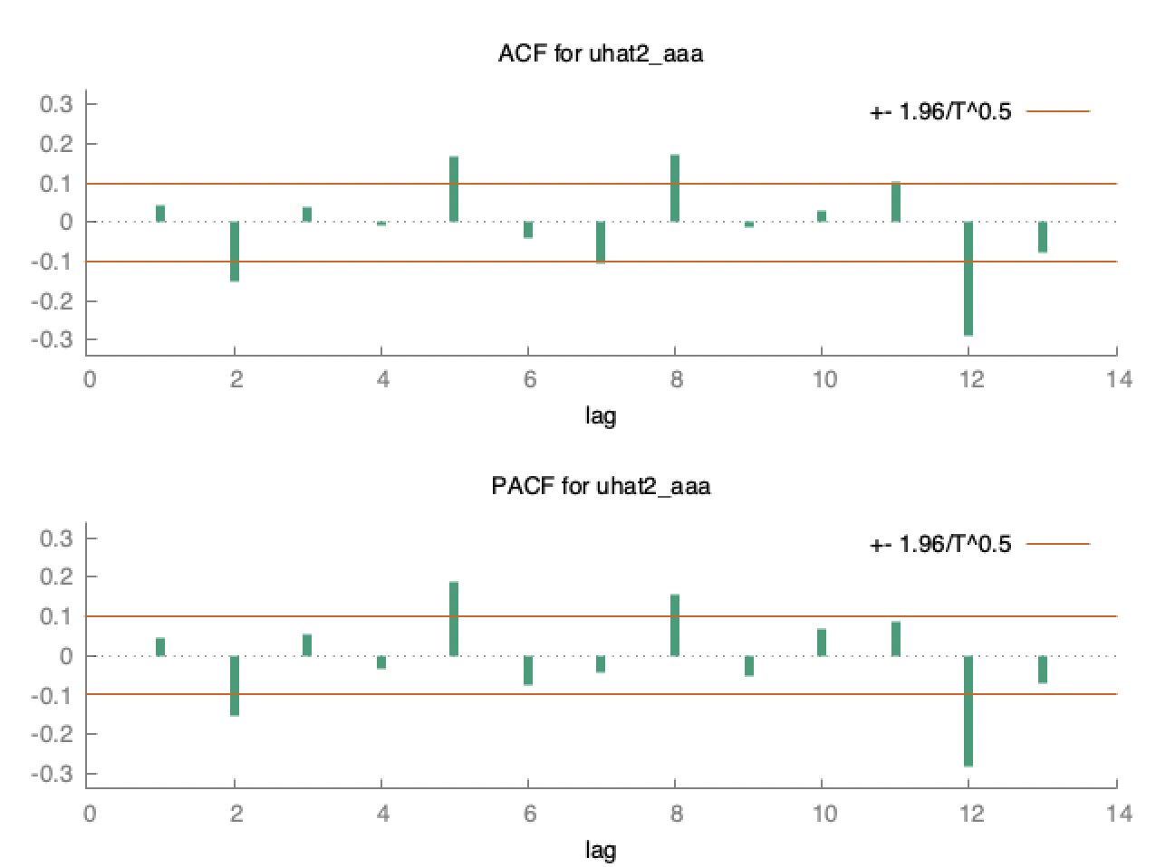

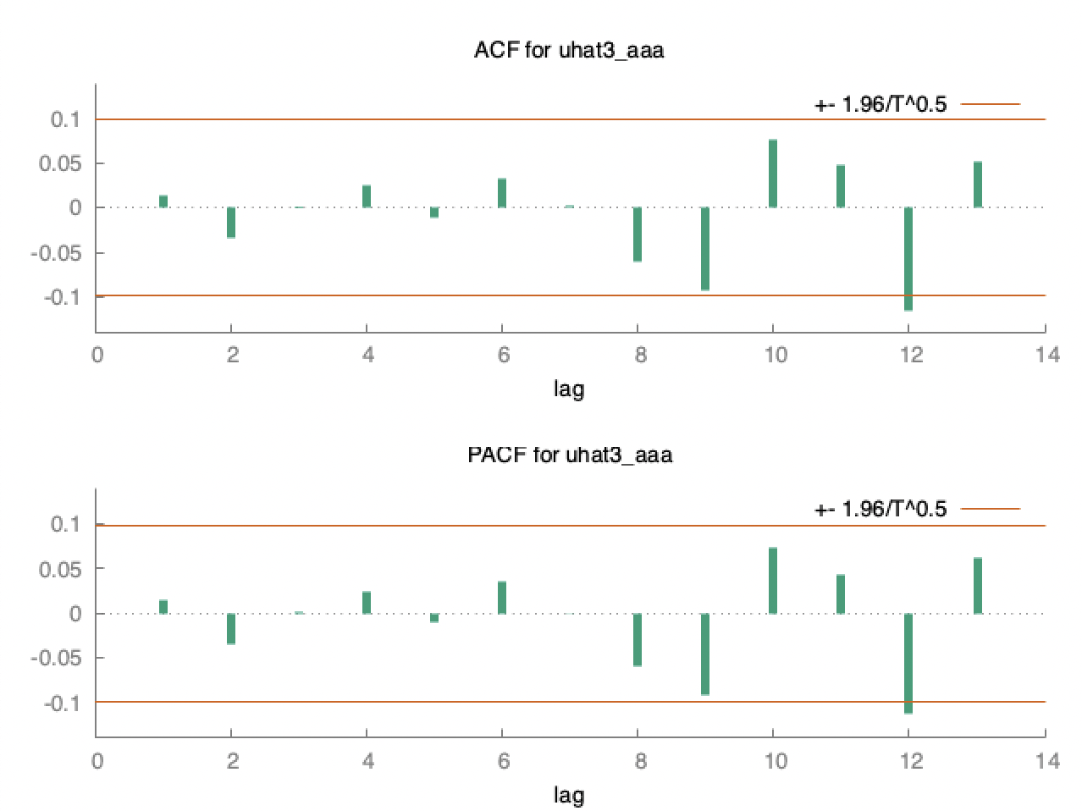

* All ACF tables show consistent high levels for autocorrelation coefficients
* When comparing the VAR forecasts with the univariate ARIMA forecasts, we find:
  + The ARIMA model provides accurate short-term forecasts but has larger confidence intervals for longer-term forecasts
  + Regarding autocorrelation lags, lag 13 has the strongest correlation
  + Comparing the ACF results of the residuals, uhat3_aaa exhibits weaker autocorrelation with smaller magnitudes and fewer significant coefficients
  + The lag order and Q-statistic analysis indicate that uhat3_aaa has a weaker overall autocorrelation structure compared to uhat1_aaa and uhat2_aaa
* The univariate ARIMA model performs well for short-term forecasts, while the VAR model may capture specific autocorrelation patterns

**Problem 2 – Modelling volatility**

1. Uber was chosen as our stock with a 3-year span of Historical Data

1. Then we created a new variable called daily returns and logDaily returns and perfomed a timeseries plot on the latter. The shape indicates volatility. Moreover, summary statistics indicate a mean close to 0 and a high standard deviation.

1. There is almost total uncorrelation according to the correlogram. There’s a hint of predictability from the squared excess returns correlogram.

1. In exploring values of GARCH p and ARCH q, we find the best model is the following:
   * Garch 1 arch 1 including variable
     + **Unconditional st error** of 0.03294

The forecasted values are very close to the unconditional st error



1. Standardized square residual are uncorrelated:

