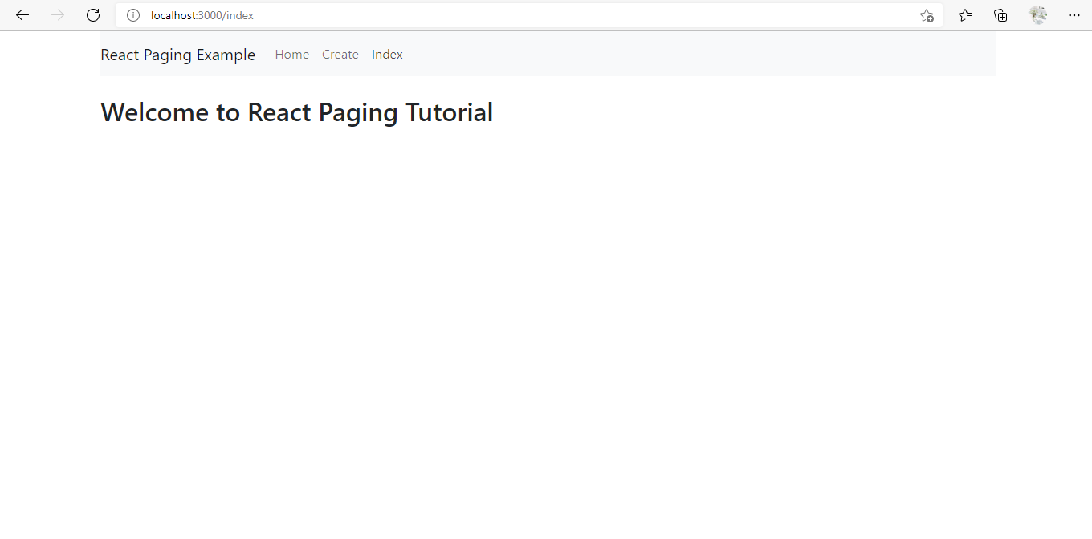

App.js

import React, { Component } from 'react';

import 'bootstrap/dist/css/bootstrap.min.css';

import { BrowserRouter as Router,Routes, Route, Link } from 'react-router-dom';

import Create from './components/create.component';

import Edit from './components/edit.component';

import Index from './components/index.component';

class App extends Component {

  render() {

    return (

      <Router>

        <div className="container">

          <nav className="navbar navbar-expand-lg navbar-light bg-light">

            <Link to={'/'} className="navbar-brand">React Paging Example</Link>

            <div className="collapse navbar-collapse" id="navbarSupportedContent">

              <ul className="navbar-nav mr-auto">

              <li className="nav-item">

                  <Link to={'/index'} className="nav-link">Home</Link>

                </li>

                <li className="nav-item">

                  <Link to={'/create'} className="nav-link">Create</Link>

                </li>

                <li className="nav-item">

                  <Link to={'/index'} className="nav-link">Index</Link>

                </li>

              </ul>

            </div>

          </nav> <br/>

          <h2>Welcome to React Paging Tutorial</h2> <br/>

          <Routes>

              <Route exact path='/' component={ Index } />

              <Route  path='/create' component={ Create } />

              <Route path='/edit/:id' component={ Edit } />

              <Route path='/index' component={ Index } />

          </Routes>

        </div>

      </Router>

    );

  }

}

export default App;

index.js

import React from 'react';

import ReactDOM from 'react-dom';

import './index.css';

import App from './App';

import reportWebVitals from './reportWebVitals';

ReactDOM.render(

  <React.StrictMode>

    <App />

  </React.StrictMode>,

  document.getElementById('root')

);

// If you want to start measuring performance in your app, pass a function

// to log results (for example: reportWebVitals(console.log))

// or send to an analytics endpoint. Learn more: https://bit.ly/CRA-vitals

reportWebVitals();

**components**

create.component.js

import React, { Component } from 'react';

export default class Create extends Component {

    render() {

        return (

            <div>

                <p>Welcome to Create Component!!</p>

            </div>

        )

    }

}

edit.component.js

import React, { Component } from 'react';

export default class Edit extends Component {

    render() {

        return (

            <div>

                <p>Welcome to Edit Component!!</p>

            </div>

        )

    }

}

index.component.js

import React, { Component } from 'react';

export default class Index extends Component {

    render() {

        return (

            <div>

                <p>Welcome to Index Component!!</p>

            </div>

        )

    }

}