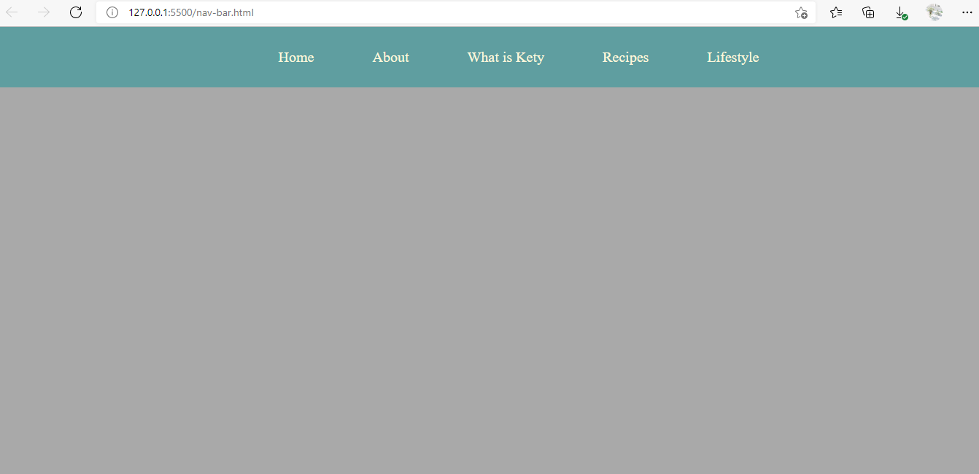

Nar-bar.html

<!DOCTYPE html>

<html lang="en">

<head>

    <meta charset="UTF-8">

    <meta http-equiv="X-UA-Compatible" content="IE=edge">

    <meta name="viewport" content="width=device-width, initial-scale=1.0">

    <link rel="stylesheet" href="../nav-bar.css">

    <title>Document</title>

</head>

<body>

    <div class="danhmuc">

        <ul class="ul">

                  <p><a href="#home">Home</a> </p>

                  <p><a href="#about">About</a></p>

                  <p><a href="#what">What is Kety</a></p>

                  <p><a href="#recipes">Recipes</a></p>

                  <p><a href="#life">Lifestyle</a></p>

                     </ul>

</div>

</body>

</html>

Nar-bar.css

* {

    padding: 0;

    margin: 0;

    box-sizing:border-box;

}

body

{

    background-color: darkgrey;

}

.ul

{

    display: flex;

    padding:30px 0px 30px 0px ;

    text-align: center;

    justify-content: center;

}

.ul a

{

    text-decoration: none;

    color:cornsilk;

    margin-left: 80px;

     font-size: 20px;

}

.danhmuc

{

    background-color: cadetblue;

}

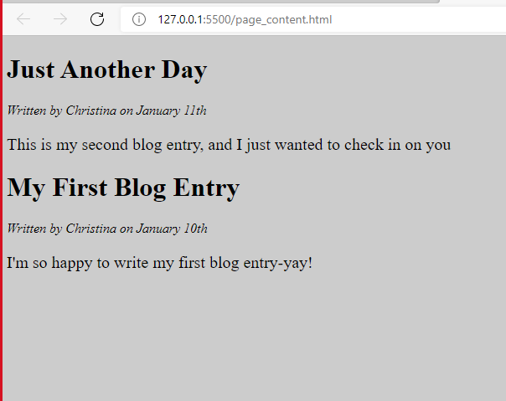

Page_content.html

<!DOCTYPE html>

<html lang="en">

<head>

    <meta charset="UTF-8">

    <meta http-equiv="X-UA-Compatible" content="IE=edge">

    <meta name="viewport" content="width=device-width, initial-scale=1.0">

    <link rel="stylesheet" href="../page_content.css">

    <title>Document</title>

</head>

<body  >

   <h1> Just Another Day</h1>

   <p class="a">Written by Christina on January 11th</p>

<p class="b">This is my second blog entry, and I just wanted to check in on you </p>

<h1>My First Blog Entry</h1>

<p class="a">Written by Christina on January 10th</p>

<p class="b">I'm so happy to write my first blog entry-yay!</p>

    </script>

</body>

</html>

Page_content.css

.a

{

 font-style: italic;

}

.b

{

   font-size: 20px;

}

body

{

    background-color: #ccc;

}

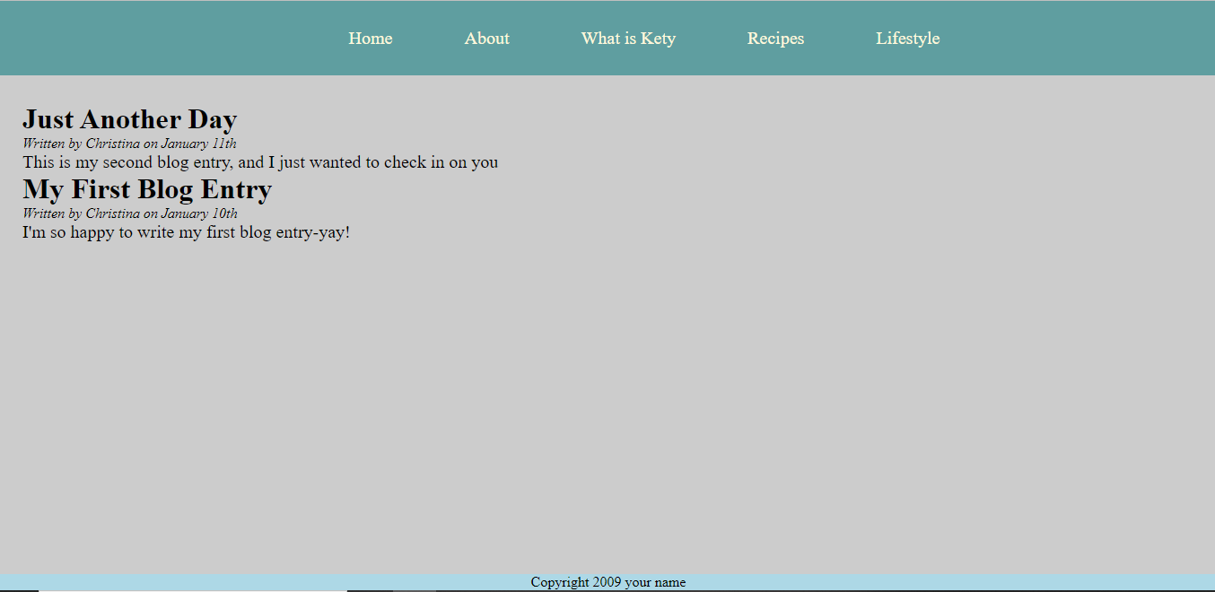

Simple_page.html

<!DOCTYPE html>

<html lang="en">

<head>

    <meta charset="UTF-8">

    <meta http-equiv="X-UA-Compatible" content="IE=edge">

    <meta name="viewport" content="width=device-width, initial-scale=1.0">

    <link rel="stylesheet" href="../simple_page.css">

    <title>Document</title>

</head>

<body>

    <div class="danhmuc">

        <ul class="ul">

                  <p><a href="#home">Home</a> </p>

                  <p><a href="#about">About</a></p>

                  <p><a href="#what">What is Kety</a></p>

                  <p><a href="#recipes">Recipes</a></p>

                  <p><a href="#life">Lifestyle</a></p>

                     </ul>

</div>

<div class="haha">

<h1> Just Another Day</h1>

   <p class="a">Written by Christina on January 11th</p>

<p class="b">This is my second blog entry, and I just wanted to check in on you </p>

<h1>My First Blog Entry</h1>

<p class="a">Written by Christina on January 10th</p>

<p class="b">I'm so happy to write my first blog entry-yay!</p>

</div>

<footer class="hrhr">

    <p>Copyright 2009 your name</p>

</footer>

</body>

</html>

Simple_page.css

.a

{

 font-style: italic;

}

.b

{

   font-size: 20px;

}

body

{

    background-color: #ccc;

    display:flex;

  flex-direction:column;

}

* {

    padding: 0;

    margin: 0;

    box-sizing:border-box;

}

.ul

{

    display: flex;

    padding:30px 0px 30px 0px ;

    text-align: center;

    justify-content: center;

}

.ul a

{

    text-decoration: none;

    color:cornsilk;

    margin-left: 80px;

     font-size: 20px;

}

.danhmuc

{

    background-color: cadetblue;

}

.haha

{

    margin-top: 30px;

    margin-left: 30px;

}

footer

{

    position: absolute;

    bottom: 0;

    width: 100%;

    text-align: center;

    background-color: lightblue;

}