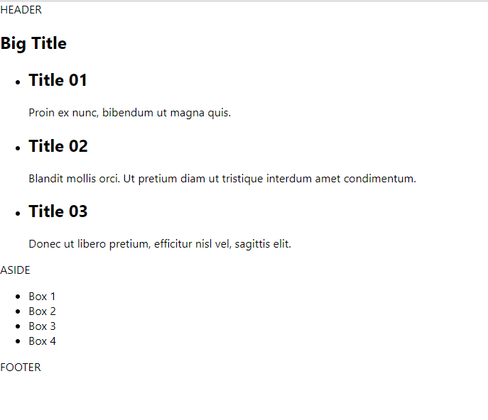

Header.js

import React from 'react';

const Header = () => {

  return (

    <header>HEADER</header>

  )

}

export default Header;

Headline.js

import React from 'react';

const Headline = () => {

  return (

    <h1>Big Title</h1>

  )

}

export default Headline;

ItemList.js

import React from 'react';

const ItemList = () => {

  return (

    <ul className="item-list">

      <li>

        <h2>Title 01</h2>

        <div>

          Proin ex nunc, bibendum ut magna quis.

        </div>

      </li>

      <li>

        <h2>Title 02</h2>

        <div>

          Blandit mollis orci. Ut pretium diam ut tristique interdum amet condimentum.

        </div>

      </li>

      <li>

        <h2>Title 03</h2>

        <div>

          Donec ut libero pretium, efficitur nisl vel, sagittis elit.

        </div>

      </li>

    </ul>

  )

}

export default ItemList;

Aside.js

import React from 'react';

const Aside = () => {

  return (

    <aside>

      ASIDE

    </aside>

  )

}

export default Aside;

BoxList.js

import React from 'react';

const BoxList = () => {

  return (

    <ul className="box-list">

      <li>Box 1</li>

      <li>Box 2</li>

      <li>Box 3</li>

      <li>Box 4</li>

    </ul>

  )

}

export default BoxList;

Footer.js

import React from 'react';

const Footer = () => {

  return (

    <footer>FOOTER</footer>

  )

}

export default Footer;

App.js

import React, { Component } from 'react';

import './App.css';

import Header from './components/Header';

import Headline from './components/Headline';

import ItemList from './components/ItemList';

import Aside from './components/Aside';

import BoxList from './components/BoxList';

import Footer from './components/Footer';

class App extends Component {

  render() {

    return (

      <div id="layout">

        <Header />

        <main>

          <section id="content">

            <Headline />

            <ItemList />

          </section>

          <Aside />

          <BoxList />

        </main>

        <Footer />

      </div>

    );

  }

}

export default App;