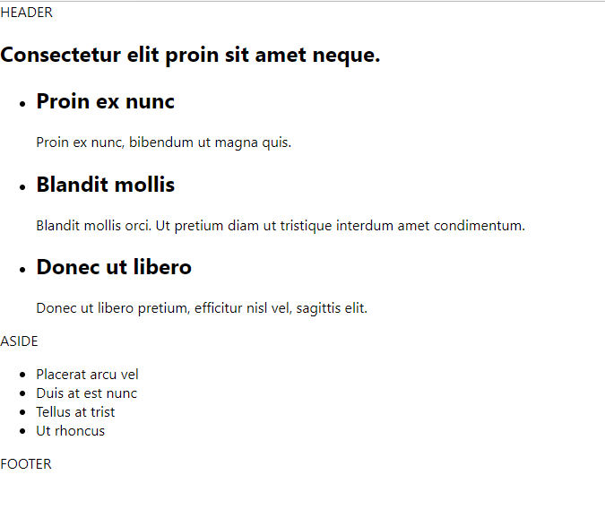

Header.js

import React from 'react';

const Header = () => {

  return (

    <header>HEADER</header>

  )

}

export default Header;

Headline.js

import React from 'react';

const Headline = (props) => {

  return (

    <h1>{props.bigTitle}</h1>

  )

};

export default Headline;

ItemList.js

import React from 'react';

const ListItem = (props) => {

  return (

    <li>

      <h2>{props.propsItem.title}</h2>

      <div>

        {props.propsItem.info}

      </div>

    </li>

  )

};

const ItemList = (props) => {

  const propsList = props.itemList;

  return (

    <ul className="item-list">

      {propsList.map((item) =>

        <ListItem propsItem={item} />

      )}

    </ul>

  )

};

export default ItemList;

Aside.js

import React from 'react';

const Aside = () => {

  return (

    <aside>

      ASIDE

    </aside>

  )

}

export default Aside;

BoxList.js

import React from 'react';

const BoxItem = (props) => {

  return (

    <li>

      {props.propsBox}

    </li>

  )

};

const BoxList = (props) => {

  const boxList = props.boxList;

  return (

    <ul className="box-list">

      {boxList.map((itemBox) =>

        <BoxItem propsBox={itemBox} />

      )}

    </ul>

  )

};

export default BoxList;

Footer.js

import React from 'react';

const Footer = () => {

  return (

    <footer>FOOTER</footer>

  )

}

export default Footer;

app.js

import React, { Component } from 'react';

import './App.css';

import Header from './components/Header';

import Headline from './components/Headline';

import ItemList from './components/ItemList';

import Aside from './components/Aside';

import BoxList from './components/BoxList';

import Footer from './components/Footer';

class App extends Component {

  render() {

    return (

      <div id="layout">

        <Header />

        <main>

          <section id="content">

            <Headline bigTitle={blog.bigTitle} />

            <ItemList itemList={blog.itemList} />

          </section>

          <Aside />

          <BoxList boxList={blog.boxList} />

        </main>

        <Footer />

      </div>

    );

  };

};

const blog = {

  bigTitle: 'Consectetur elit proin sit amet neque.',

  itemList: [

    {

      title: 'Proin ex nunc',

      info: 'Proin ex nunc, bibendum ut magna quis.'

    },

    {

      title: 'Blandit mollis',

      info: 'Blandit mollis orci. Ut pretium diam ut tristique interdum amet condimentum.'

    },

    {

      title: 'Donec ut libero',

      info: 'Donec ut libero pretium, efficitur nisl vel, sagittis elit.'

    }

  ],

  boxList: [

    'Placerat arcu vel',

    'Duis at est nunc',

    'Tellus at trist',

    'Ut rhoncus'

  ]

};

export default App;