The Seattle Pier 57 Flow and WebAPI release
Released from The Fisherman’s Bar on Pier 57 in Seattle
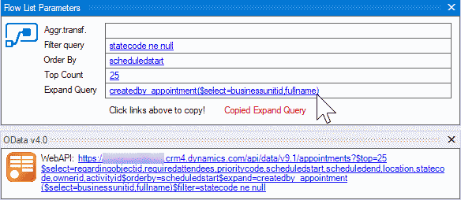

New features
- The WebAPI query generator is finally here!
Huge thanks to @MarkMpn for the contribution!
https://github.com/rappen/FetchXMLBuilder/issues/123
- Flow List Records parameters let’s you easily copy parameters to the List Records task
https://github.com/rappen/FetchXMLBuilder/issues/241
- QueryExpression parser converting from C# code to FetchXML
Huge thanks to @BetimBeja for the contribution!
https://github.com/rappen/FetchXMLBuilder/issues/195

Bug fixes
- Cancelling close wipes the window
https://github.com/rappen/FetchXMLBuilder/issues/237
- New – Paste FetchXML action does not update the query builder
Huge thanks to @rajrao for the fix!
https://github.com/rappen/FetchXMLBuilder/issues/231
Other
Removed XML validation with fetch.xsd schema as this is no longer up to date with the platform
Patch updates
- 1.2019.3.7 – huge amount of condition operators added to WebAPI support, filter for aggregate WebAPI queries, fix #250 url for onprem environments.
- 1.2019.3.6 – fix bug #246, #247, #248 that causes crash when connected to CRM 2015 or earlier.
- 1.2019.3.4 – improvements to WebAPI / Flow query generator, including bug fixes and support for aggregate queries.

