
New features
- Repository for easy access to favorite queries
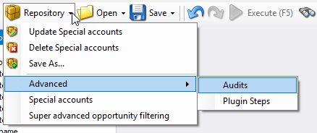
https://github.com/rappen/FetchXMLBuilder/issues/229
- Variables for conditions in QueryExpression code
https://github.com/rappen/FetchXMLBuilder/issues/215
- More modern colors / font in XML window
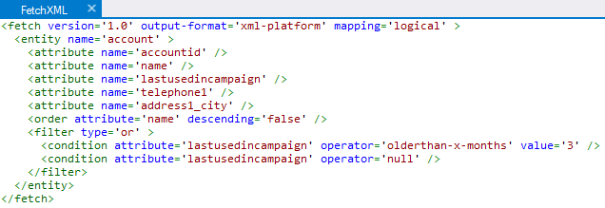

Bug fixes
- Crash in Result View in some null value scenario
https://github.com/rappen/FetchXMLBuilder/issues/219
- Code generator error for multiple condition values
https://github.com/rappen/FetchXMLBuilder/issues/220
- Save File does actually save the file
https://github.com/rappen/FetchXMLBuilder/issues/221
- Filters not generated correct in C# code
https://github.com/rappen/FetchXMLBuilder/issues/223

