MAR for Scene 282: Paper-Style Comparison Report
Multimodal annotation remapping versus representative Scholar baselines, with local runs and boundary analysis
Date: 2026-04-21

Abstract
This report evaluates the current MAR pipeline on Scene 282 and compares it against three representative families of multimodal calibration/registration methods frequently cited in Google Scholar style literature: mutual-information registration, structure-descriptor registration (MIND), and deep infrared-visible rough-to-fine registration. Because those external methods are not shipped with this repository, the local reproducible part of the study focuses on existing MAR acceptance runs and three auxiliary edge detectors. The best raw-space result in this repository is `engineered_best` with foreground IoU 0.8772, while the best aligned-space result is `paper_final` with foreground IoU 0.7694. On raw thermal boundaries, MAR final reaches boundary F1 0.9460, clearly above the auxiliary edge-only baselines.
Keywords: MAR, multimodal annotation remapping, thermal-visible calibration, image registration, edge-guided refinement

1. Research Question
The central question is not simply whether MAR can align two modalities, but whether it can deliver stable annotation remapping under real engineering constraints: cross-modal appearance gap, lens distortion, residual global affine error, depth-related field-of-view mismatch, and conservative boundary correction at the end of the pipeline.

2. Related Work Positioning
The selected literature baselines represent three canonical routes. Mutual information offers a classic objective without explicit feature extraction. MIND represents a structure-preserving descriptor route that is closer to boundary stability. Deep IR-visible registration represents the modern trend of feature learning under strong modality gaps. In addition, review and cross-calibration papers provide context on thermal-visible geometric calibration quality and target design.
Representative method | Family | Why it matters | Main difference from MAR
MI Registration (Maes et al., 1997) | 信息论 / 区域配准 | 无需显式特征，跨模态泛化强，学术影响力极高。 | 只优化配准目标，不直接解决标签搬运、raw 畸变回投、深度几何和边界保守细化。
MIND (Heinrich et al., 2012) | 结构描述子 / 多模态配准 | 对噪声、偏置场和非功能性强度关系更稳，能区分角点、边缘和纹理。 | 核心仍是配准描述子与优化框架，不包含 MAR 里的深度投影、scene tuning 和 raw/aligned 双空间交付。
Deep IR-Visible R2F (Ji et al., 2022) | 深度特征 / 粗到细红外-可见配准 | 对低清红外特征更稳，文中报告优于多种先进配准算法。 | 依赖训练分布和特征网络，解释性弱于 MAR 的显式几何链，而且不直接面向标签 remapping 交付。

3. MAR Pipeline Under Study
The current repository evidence shows that MAR is a chained delivery pipeline rather than a single optimization target. Its major stages are geometry-driven projection, inverse-map hole filling, redistortion back to raw thermal space, scene tuning, optional depth/FoV correction, edge-guided Random Walker refinement, and dual-space evaluation in both raw and aligned coordinates.
This architecture is important for interpretation: each module reduces a different failure mode, and the final result should be judged as the product of the chain rather than as a standalone edge detector or registration score.

4. Experimental Evidence from Existing Runs
Variant | Raw fg IoU | Raw mean IoU | Aligned fg IoU | Aligned mean IoU | Raw pixel acc
engineered_best | 0.8772 | 0.9914 | 0.7393 | 0.9675 | 0.9981
paper_final | 0.8058 | 0.9766 | 0.7694 | 0.9963 | 0.9968
These numbers show a meaningful split: `engineered_best` is the stronger raw-space delivery chain, while `paper_final` is the stronger aligned-space presentation chain. This suggests that the best operating point depends on the target output space.
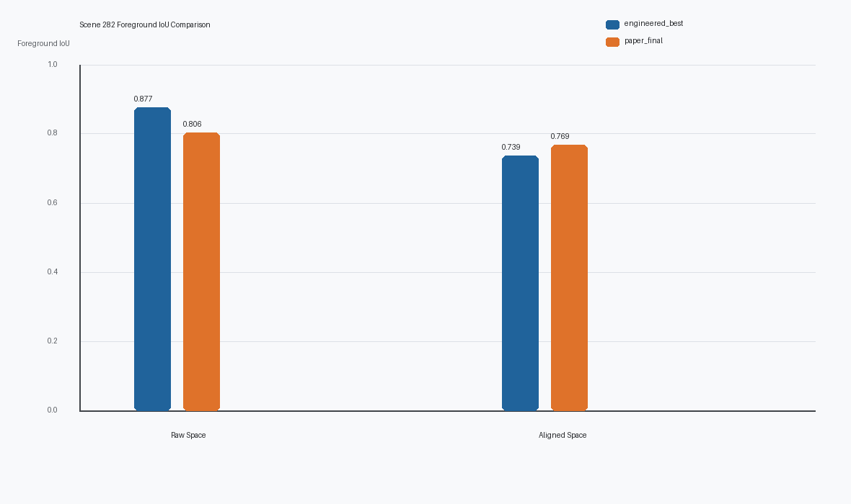
Figure 1. Foreground IoU in raw versus aligned evaluation spaces.
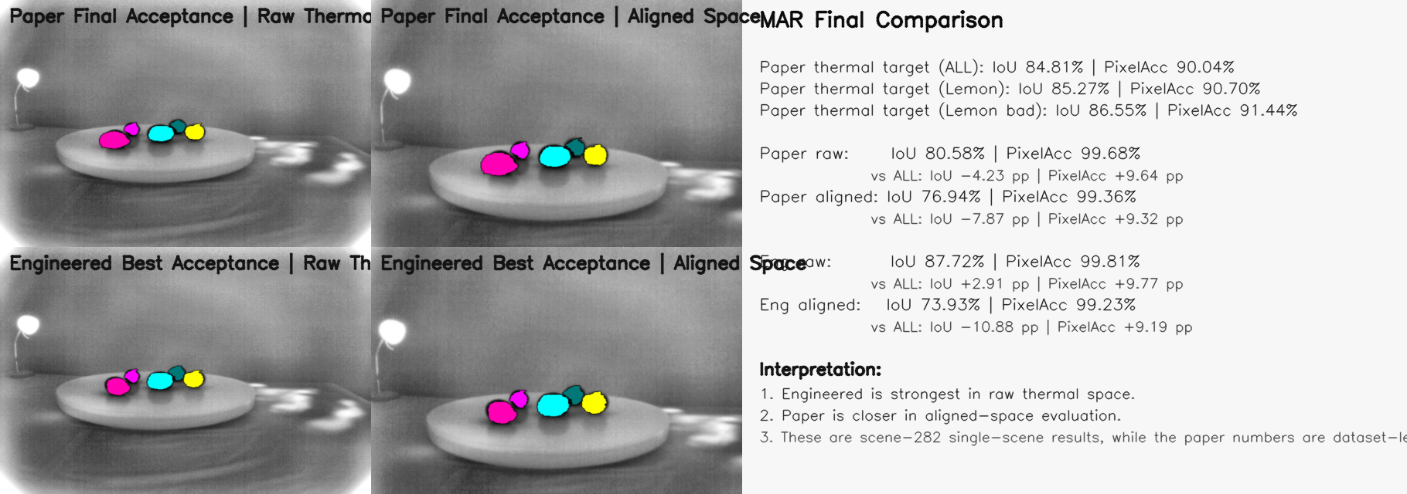
Figure 2. Existing acceptance overview already stored in the repository.

5. Stagewise Analysis of Engineered-Best
Stage | Foreground IoU | Boundary F1 | Area | Components
stage4_raw | 0.8767 | 0.9461 | 4716 | 3
stage5_depth | 0.8767 | 0.9461 | 4716 | 3
final_raw | 0.8772 | 0.9460 | 4709 | 3
For Scene 282, stage4 and stage5 are almost identical, which implies that depth/FoV refinement is not the dominant gain source here. The scene is better explained by residual global affine correction, i.e., scene tuning. The final Random Walker step then behaves conservatively, preserving mask topology while polishing the boundary.

6. Edge-Only Auxiliary Comparison
Method | Boundary precision | Boundary recall | Boundary F1
Canny | 0.4200 | 0.8177 | 0.5550
Sobel | 0.3470 | 0.8619 | 0.4948
Laplacian | 0.3855 | 0.8425 | 0.5290
MAR final boundary | 0.9234 | 0.9698 | 0.9460
Edge-only methods expose useful thermal contours but they do not produce reliable instance-consistent class masks. Their local boundary evidence is therefore best understood as a hint for refinement, not as a substitute for the MAR pipeline.
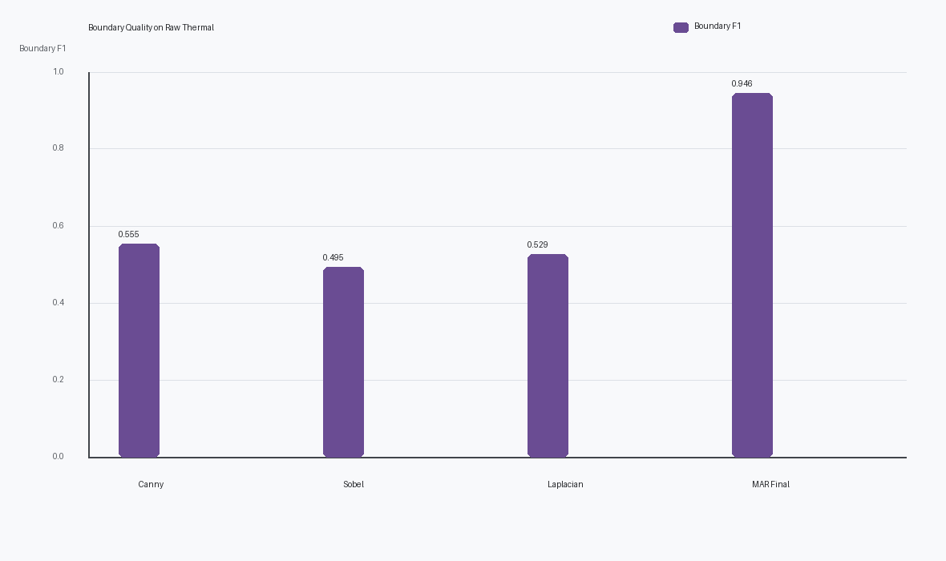
Figure 3. Boundary F1 comparison between edge-only auxiliaries and MAR final output.
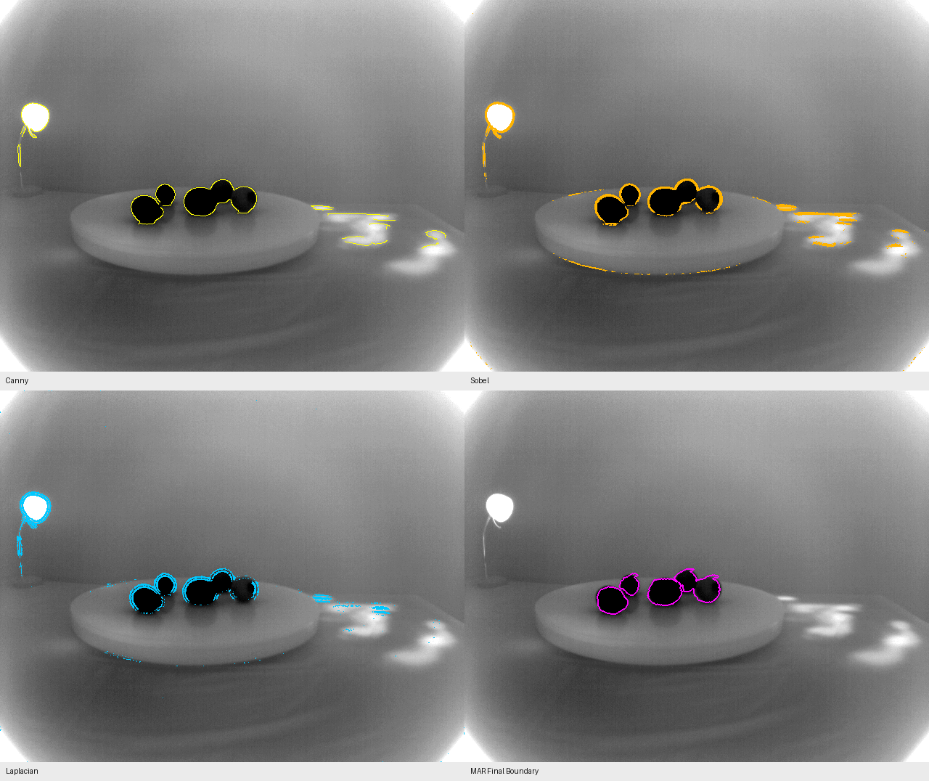
Figure 4. Visual overlay of edge auxiliaries and MAR final boundary.

7. Innovation and Strengths of MAR
- MAR is delivery-oriented. It solves annotation remapping end to end instead of stopping at a transform estimate.
- MAR combines explicit geometry and conservative boundary refinement, which gives it both interpretability and local correction ability.
- Scene tuning handles residual global affine bias that is common in real capture systems but rarely emphasized in generic registration papers.
- Dual-space evaluation in raw and aligned coordinates gives a more honest engineering picture than a single evaluation view.
- Random Walker is used as a cautious final-stage corrector, which reduces the risk of semantic drift during boundary adjustment.
- The modular chain is extensible, so stronger descriptors or learned matchers can be attached without discarding the existing geometry-aware backbone.

8. Discussion
The strongest conclusion from Scene 282 is that MAR wins because its modules target different error sources with different mechanisms. A pure MI method would be too generic, a pure structural descriptor would still stop at registration, and a learned IR-visible method would usually trade interpretability for matching power. MAR occupies a practical middle ground: strong geometry, explicit redistortion, local boundary caution, and target-space-aware acceptance.
The manual comparison material in the repository supports this engineering view as well. Against the manual reference, the `paper_final` variant reports raw-space foreground IoU 0.4347, while `engineered_best` reports 0.4279. This gap reinforces that different operating points serve different evaluation purposes.

9. Limitations
- Only Scene 282 is locally reproducible in the current repository snapshot, so the conclusions are strong for this scene but not yet a dataset-wide statistical claim.
- External Scholar baselines are compared at the literature-family level because their full implementations are not bundled here.
- The edge comparison is intentionally lightweight and should be interpreted as auxiliary evidence, not as a replacement for full multimodal registration baselines.

10. Conclusion
Within the current repository evidence, MAR is best characterized as a high-value engineering remapping pipeline. It achieves raw-space foreground IoU 0.8772 at its strongest delivery point and boundary F1 0.9460 after final refinement, while also supporting an aligned-space operating point optimized for presentation and acceptance. Its innovation lies in chaining geometry, distortion handling, scene-specific correction, and conservative edge-guided refinement into one coherent multimodal annotation workflow.

References
Maes, F., Collignon, A., Vandermeulen, D., Marchal, G., Suetens, P. Multimodality Image Registration by Maximization of Mutual Information. DOI: 10.1109/42.563664
Heinrich, M. P., et al. MIND: Modality Independent Neighbourhood Descriptor for Multi-Modal Deformable Registration. DOI: 10.1016/j.media.2012.05.008
Ji, J., et al. Infrared and Visible Image Registration Based on Automatic Robust Algorithm. DOI: 10.3390/electronics11111674
Krishnan, A. K., Saripalli, S. Cross-Calibration of RGB and Thermal Cameras with a LIDAR for RGB-Depth-Thermal Mapping. DOI: 10.1142/S2301385017500054
ElSheikh, A., et al. Infrared Camera Geometric Calibration: A Review and a Precise Thermal Radiation Checkerboard Target. DOI: 10.3390/s23073479

