**ALFALFA**

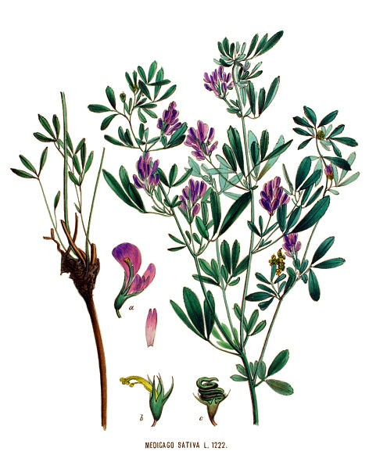

# Compiled by Jehanne-Marie Gavarini – GavHerbs

**Botanical Name***:* Medicago Sativa

**Family:** Fabaceae

**A.K.A.:** Lucerne, Buffalo Herb, Purple Medick, Purple Medicle, Purple Medic, Spanish Clover, California Clover, buffalo brass, Chilean clover.

**Description:** a perennial plant, member of the pea family. Features trifoliate leaves, bluish purple flowers and kidney-shaped seeds. Has been grown as forage for livestock longer than any other plant. It has deep roots that allow the plant to absorb more vitamins and minerals than the average plant.

**Parts used:** Leaves, aerial parts and sprouted seeds.

**Constituents:** Contains organic minerals such as calcium, magnesium, iron, phosphorus, copper, molybdenum, zinc, manganese, and potassium and almost all known vitamins, including A, C, D,

E, K, and the full family of B vitamins, very high in chlorophyll, biotin, folic acid. It is high in protein, especially when dried. Sprouts contain phytoestrogens, isoflavones, coumarins (both isoflavones and coumarins are estrogenic), alkaloids, porphyrins and saponins. Contains the anti-oxidant tricin.

# Medicinal Properties:

Alterative, antipyretic, diuretic, appetite stimulant, mineralizing, hemostatic, anti-hemorrhaging, anti-cholesterol. Can aid in flushing the bowels of built up toxins. Dr Finley Ellingwood observed that it increased secretion of the kidneys, and in the female, of the milk glands; increased peristaltic action of the bowels; increased appetite; increased assimilation of food, and increased weight. It is given to convalescents who need easily assimilated nutrients. It promotes pituitary gland function. Alfalfa contains an anti-fungus agent. Its phytoestrogen components can help normalize the effects of estrogen in the body. It is calcium-rich; therefore is useful to fortify bones, in cases of osteoporosis and menopause (Gladstar, 227 and Chevalier, 233). Can also ease digestive discomfort and help joints and connective tissues.

# Uses:

Alfalfa has medicinal applications and is also a food (sprouts), and beverage. Nutritious fresh or dried leaf tea is traditionally used to promote appetite, to fight fatigue, anemia, and to gain weight. Alfalfa is high in chlorophyll and nutrients. It alkalies and detoxifies the body, especially the liver (Gladstar uses it in a liver tonic formula). It is good for all colon disorders, anemia, hemorrhaging, indigestion, vitamin or mineral deficiency. It helps muscle spasms. It is a laxative and diuretic. It has been used for cystitis, as a blood purifier, for gas, edema, diabetes, ulcers, asthma, bronchitis, skin disorders, and arthritis. It can be used for brittle nails and hair.

# Health Benefits:

A study in the San Francisco Bay Area revealed that women who frequently ate alfalfa sprouts and soy foods were at a lower risk for thyroid cancer (Murray, 384).

The saponins contained in alfalfa have been shown to lower diet-induced LDL cholesterol in animal studies and to boost the immune system. Alfalfa sprouts contain L-canavanin, an amino acid analogue that may be effective against leukemia and cancer of the pancreas and colon.

Sprouts are high in antioxidants.

**Caution:** Alfalfa has been known to aggravate lupus and other auto-immune disorders. Avoid alfalfa is you have an auto-immune problem. Recent reports suggest that Alfalfa sprouts (or the canavanine therein, especially in the seeds) may be associated with lupus (systemic lupus erythematosus), causing recurrence in patients in which the disease had become dormant.

Because it also has a significant estrogenic effect, patients with hormone-sensitive cancers should avoid alfalfa.

# References:

Andrew Chevalier, *Encyclopedia of Herbal Medicine*. London, New York: Dorling Kindersley, Second American Edition, 2000.

Doctissimo Santé: Alfalfa (Luzerne):

<http://www.doctissimo.fr/html/sante/phytotherapie/plante-medicinale/alfalfa-luzerne.htm> (Accessed September 8, 2016).

Rosemary Gladstar. *Herbal Recipes for Vibrant Health.* North Adams, MA: Storey Publishing, 2008.

Henriette’s Herbal Home page: *Ellingwood, Finley 1919: the American Materia Medica, Therapeutics and Pharmacognosy. Group VII. Agents acting upon the genito-urinary organs.* Chapter II. Renal stimulants. (scanned by Michael Moore for the Southwest School of Botanical Medicine) <http://www.henriettes-herb.com/eclectic/ellingwood/medicago.html>

(Accessed September 8, 2016).

Herbwisdom.com: Alfalfa: Medicago Sativa. <http://www.herbwisdom.com/herb-alfalfa.html> (Accessed September 8, 2016).

Medicinal Herb Info: <http://medicinalherbinfo.org/herbs/Alfalfa.html> (Accessed September 8, 2016).

Memorial Sloan Kettering Cancer Center: https://[www.mskcc.org/cancer-care/integrative-](http://www.mskcc.org/cancer-care/integrative-) medicine/herbs/alfalfa (Accessed September 8, 2016).

Michael Murray, Joseph Pizzorno, Lara Pizzorno: *The Encyclopedia of Healing Foods.* New York: Atria Books, 2005.