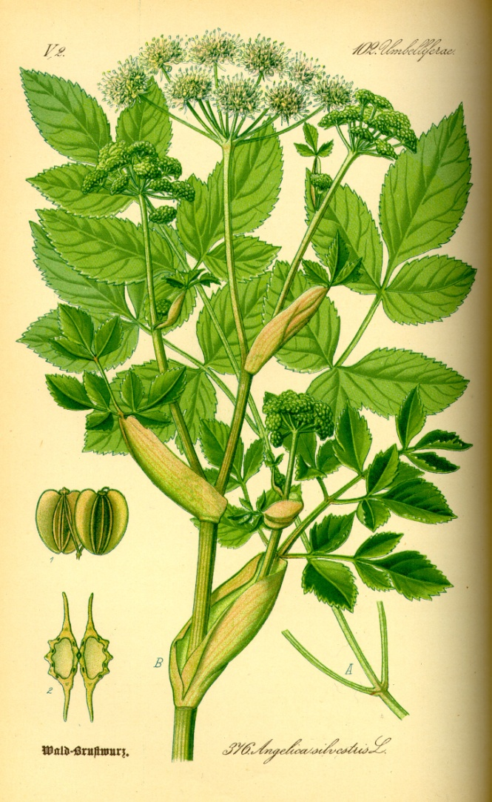

Angelica monograph

*By: Christianna Ferri*

**Name:** Angelica atropurpurea, Angelica archangelica, Angelica Venenosa

**Other names**: Alexander’s, American Dong Quai, Archangel, Purple-stem Angelica, American Angelica, High Angelica, Wild Archangel, Wild Angelica, Masterwort

**Parts used:** Roots, leaves, seeds

**Action**: Anti- bacterial, infusion of stems, seeds and roots carminative, diaphoretic, emmenagogue, sedative, stomachic, tonic

**Uses:** Strengthen the heart, infusion (stems, seeds, root), medicinal gargle for sore throats and mouths, medicinal poultice for broken bones, swellings, itching and rheumatism, used as a face wash it can prevent acne, powder from dried root can be used for athletes foot, insecticide and pesticide , amenorrhea, colds, congestion, cough, cramps, depression, digestion, menstrual discomfort, hypertension, IBS, pregnancy/ childbirth

**Taste:** bitter and pungent

**Tincture:** 5-15 drops in a cup of warm water every 4 hours

**Capsules:** 1000 mg every 4 hours

**When to harvest:**

* *Stalks-*in the second year and on, cut for candying in mid to late spring while still young and green
* *Leaves*- late spring early summer
* *Roots*- first of autumn or could get woody

**Decoction:** simmerchopped dry root in a pot for 15-30 minutes drinking a cup every 4-5 hours

Psychology:

**Flower essence**: encourages individual to form a relationship with the spiritual world

**Combines:** blends well with basil, chamomile, geranium, [grapefruit](https://www.organicfacts.net/health-benefits/fruit/health-benefits-of-grapefruit.html?utm_source=internal&utm_medium=link&utm_campaign=smartlinks), [lavender](https://www.organicfacts.net/health-benefits/herbs-and-spices/lavender.html?utm_source=internal&utm_medium=link&utm_campaign=smartlinks), [lemon](https://www.organicfacts.net/health-benefits/fruit/health-benefits-of-lemon.html?utm_source=internal&utm_medium=link&utm_campaign=smartlinks), mandarin, and [patchouli essential oils](https://www.organicfacts.net/health-benefits/essential-oils/health-benefits-of-patchouli-essential-oil.html?utm_source=internal&utm_medium=link&utm_campaign=smartlinks).

**Contradictions:** Potential drug interaction with blood thinning agents, do not use during pregnancy and lactation, can cause a light laxative effect, hyposensitivity may lead to excessive bleeding and occasional fever, do not take if you have diabetes

References:

<https://www.organicfacts.net/health-benefits/essential-oils/health-benefits-of-angelica-essential-oil.html> <http://healingcommunication.blogspot.com/2012/10/angelica-flower-essence-for-deep_21.html> <http://www.anniesremedy.com/herb_detail70.php> <http://www.the-herb-guide.com/growing-angelica.html> <https://altnature.com/gallery/angelica.htm> <http://www.sisterzeus.com/Angelic.htm>