# ARTICHOKE – CYNARA SCOLYMUS

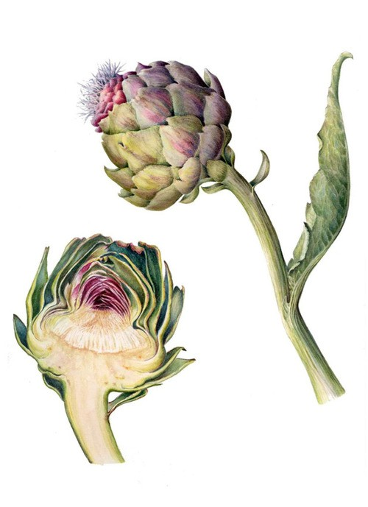

**Compiled by Jehanne-Marie Gavarini – GavHerbs**

**Common Name:** Artichoke Leaf **Botanical Name:** *Cynara scolymus* **Family: Asteraceae**

* + 1. Globe Artichoke, Cynara, artichoke, garden artichoke

**Taste:** Bitter

## Constituents:

* + - * Sesquiterpene Lactone Cynaropicrin (bitter component)
      * Cynarin (bitter constituent and liver protector)
      * Polyphenolic acidic substance
      * Inulin
      * Flavonoids
      * Tannins
      * Enzymes
      * Provitamin A
      * chlorogenic acid (antioxidant and anti-inflammatory)
      * cynarin (lowers cholesterol and protects the liver) The chlorogenic acid, which also lowers cholesterol, is, stimulates bile production, protects the liver and

## Medicinal use:

* + - * increases bile production (good for gallbladder issues),
      * protects the liver,
      * leaf extract is strongly antioxidant
      * protects from toxins and infection
      * reduces cholesterol and triglycerides,
      * promotes urination,
      * protects against urea,
      * stimulates appetite and digestion,
      * helps with indigestion, nausea and abdominal distention,
      * helps to regenerate the liver, and enhances overall liver function,
      * diuretic,
      * relieves indigestion
      * significantly lowers blood sugar: good food for diabetics.
      * protects kidneys
      * enhances overall immunity
      * helps with arthritis

## Safety issues and concerns

Artichoke leaf is not associated with any significant side effects, and no restrictions on its use are suggested during pregnancy or nursing.

**Parts used:** Flower Heads, leaves, stem, root.

## How to use:

* + - * Brew tea from fresh leaves (for liver)
      * Eat leaves and heart (cooked or raw)
      * Press out the juices of the stem and leaves
      * Steep the root in white wine
      * Water in which it is cooked is very rich in minerals: save water for soups and stews.

## References:

Botanical.com: A Modern Herbal: [http://www.botanical.com](http://www.botanical.com/) (Accessed August 13, 2016).

Botanical Online: <http://www.botanical-online.com/medicinalscynaraangles.htm>(Accessed August 13, 2016).

Andrew Chevalier, *Encyclopedia of Herbal Medicine*. London, New York: Dorling Kindersley, Second American Edition, 2000.

Medicine Hunter: <http://www.medicinehunter.com/page/artichoke-leaf>(Accessed August 13, 2016).

Maurice Mességué, *Way to Natural Health and Beauty.* Clara Winston, translator. New York:

MacMillan Publishing Co, 1974.

Malcom Stuart, *The Encyclopedia of Herbs and Herbalism.* London: Orbis Publishing Limited,

1979.

The University of Maryland Medical Center:

<http://umm.edu/health/medical/altmed/condition/gallbladder-disease>(Accessed July 13, 2016).