**Name:** Atractylodes macrocephala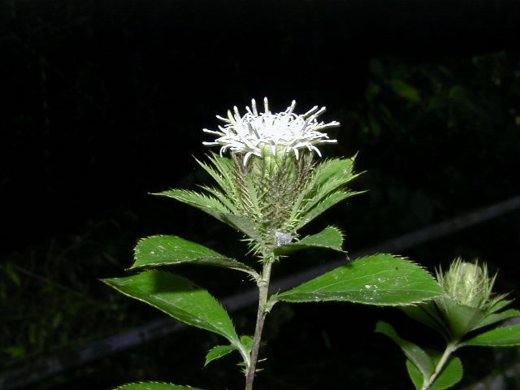 Other species used: A. alba, A. japonica, A. lancea

macrocephala means “big headed,” in reference to the plant’s flowers. The species name “alba” means white, in reference to the color of the root. The species name “japonica” means “of Japan,” in reference to the plant’s origin. Also known as: Cantonese: pack sat, Japanese: byakujutsu, shojutsu, Mandarin: dong zhu, Spanish: atractylodes, China: Baizhu

**Family:** Asteraceae (Daisy)

**Location:** Mountain valleys of Northern Asia

**Description:** Perennial. Large, scaled, egg shaped buds that bloom in Autumn. The blossoms resemble sea anemones.The flowers are dioecious (individual flowers are either male or female, but only one sex is to be found on any one plant so both the male and female plants must be grown if seed is required).

**Growing Conditions:** Well drained soil in full sun to partial shade.

**Parts Used:** Rhizome

**Uses:** Atractylodes is one of the most important and commonly used herbs used in Chinese Tonic herbalism. It is found in the majority of formulations that are designed to build qi (life force or as we would say, immune system), Bloating, Diarrhea, Edema, Dampness of any kind, Excessive Perspiration, Exhaustion(Supreme Energy Tonic), Fever, Movement of Digestion, Night Blindness,Paralysis or spasm of muscles, Poor Appetite, Mitigates side effects of Chemo & Radiation, Vomiting, Regulating Spleen Function by helping the digestive system transport nutrients, Strengthens the muscles of the legs,limited urinary elimination but excessive sweating.

A. lancea: helps dry digestive dampness. Topically: wrinkles, dark spots on the hands and face. Essential oil used in perfumery wind-cold imbalances

**Actions:** Anticoagulant, Anti-emetic, Anti-inflammatory, Anti-tumor, Aromatic, Chi Tonic, Digestive, Diuretic, Expectorant, Hepatoprotective, Spleen Chi Tonic, Immune Tonic, Stomachic, Hypoglycemic

**Constituents:** Essential Oils: Attractylol, Attractylone, Eudesmol, Hinesol.

Other: Sesquiterpenes, Polysaccharides, Beta-carotene.

**Preparation:** The rhizomes are edible and are most often added to immune building soups **.** Baizhu: white roots, Chizhu: red roots, essential oils more concentrated

**Tincture:** 10-30 drops 2-3 times a day

**Tea:** Decoction 1 Tablespoon per 10 ounces of water.

**Pills:** 3-10 grams

**Harvest: Taste:** Bitter, Sweet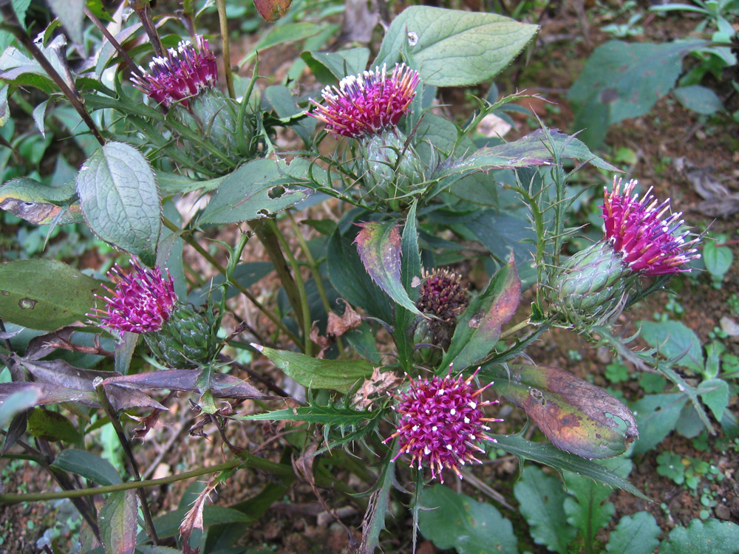

**Psychology:**

**Flower Essence:**

**Combines:** When there is weakness, combine with Licorice root. When there is excessive cold that leads to abdominal colic, combine with ginger or aconite. To enhance spree functioning combine with Astragalus, Bupleurum and Bugbane

Other combinations: Codonopsis, Dan Shen(Red Sage) Unripened Bitter Orange(Zhi Shi), Poria, Cassia, Perilla, Aged Tangerine Rind,

**Constitution:**

**Pulse:**

**Tongue:**

**Temperature:** Warm

**Moisture:** Dry

**Polarity:** Yang

**Element:** Fire

**Contra-Indications:** Bleeding Ulcers, Dehydration, Yin deficiency with heat symptoms, Dry Stools.

**References:**

***The Desktop Guide to Herbal Medicine*** by Brigitte Mars

***<http://www.itmonline.org/arts/atract.htm>***

***<http://www.shen-nong.com/eng/herbal/baizhu.html>***

***<http://www.encyclopedia.com/doc/1G2-3435100064.html>***