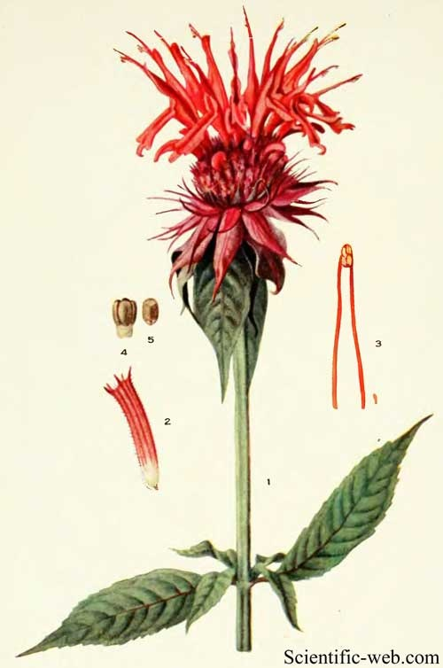

Bee Balm

Name: Bee Balm, Monarda, Bergamot, Oswego, (Monarda fistulosa)

Plant Family: Lamiaceae

Parts Used: areal plant, leaves

Energetics: stimulating, diffusive

Uses: culinary, teas, mouthwashes, foot baths, a wash for minor cuts and scrapes, douches (alleviate itching/odor), fever, stomach ache, sleep aid, yeast infections, diarrhea, vomiting, loosen mucus, burn remedy

Actions: antifungal, antibacterial, antiseptic, carminative, diaphoretic, diuretic, stimulant, emmenagogue, nervine, anti-spasmodic

Constituents: essential oil, thymol, carvacrol, rosemarnic acid  
Poultice: topical use for skin irritations

Tincture/Honey Infusion: removes heat from kidney, bladder, and gallbladder. Pick fresh leaves and flowers, loosely pack into jar and cover with vodka.

Infusion: crushed and boiled to treat fevers, used to treat mouth, throat, dental and yeast infections.

Dried Infusion

1 tsp. dried herb

1 cup boiling water, steep 10-20 min.

Fresh Infusion  
1/2 cup Bee Balm flowers and leaves  
8 cups boiling water

Pour the boiling water over the Bee Balm. Cover and steep until cool, about an hour. Strain and discard flowers

Dosage: Can be used regularly. For chronic ailments, use in small amounts over a long period of time

Harvest: Cut flowers when they are in full bloom to promote more abundant growth. Cut leaves as needed and dry.

Taste: similar to peppermint, spearmint, oregano, citrus, spicy

Sources:

<http://www.witchipedia.com/herb:monarda>

<https://en.wikipedia.org/wiki/Monarda>

<https://altnature.com/gallery/beebalm.htm>

<http://www.herbalremediesadvice.org/bee-balm.html>

<http://www.henriettes-herb.com/eclectic/kings/monarda.html>