**Name:** Latin-Bidens pilosa (Bidens meaning two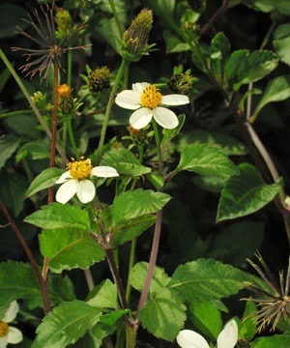 teeth & pills meaning hairy), Common: Tick Seed, Beggar Ticks (hobos would gather the seeds on their clothing as they walked the railroad tracks. they would stick to their clothes like ticks), Black Jack, Cobbler’s Pegs, Spanish Needle, Broom Stick, Broom Stuff, Devil’s Needles, Hairy Bidens, Farmer’s Friend, Devil’s Pitchfork, Needle Grass, Demon Spike Grass, Ghost Needle Weed, Burr Marigold

**Similarly Used Species:** B. bipinnata (gui zhen cao, nian shen cao), B. biternata, B. chinensis, B. parvif ora (xiao hua gui zhen cao) B. tripartite, B. chilensis

**Family:** Aster

**Location:** Native to South America but spread into North America, Eurasia, Africa, Australia & the Pacific Islands, Can be found in gardens, woodlands, and disturbed/waste areas and is considered invasive in most of the world. Likes high sunlight, dry soils & disturbed areas but have been found in every type of eco range on the planet. It can stand long periods of drought and can stand temperatures as low as -15 degrees.

**Description:** A **t**all annual, branched with small & thin white flowers with a yellow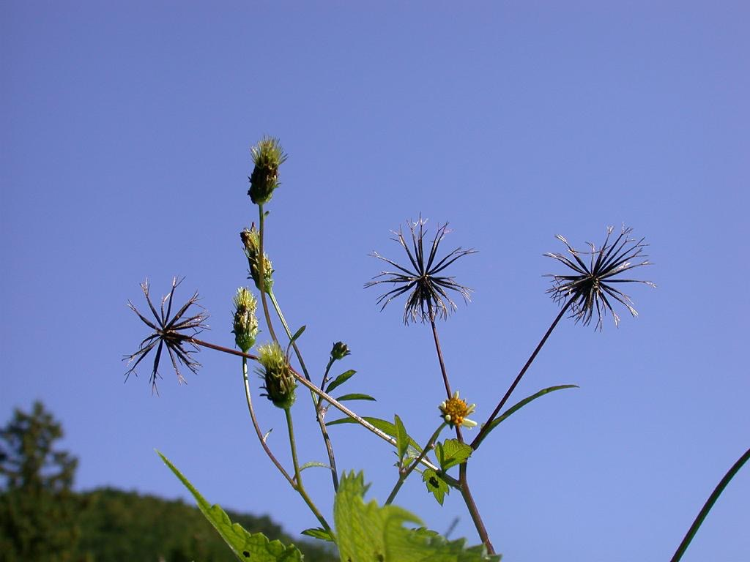 center that develop into a cluster of barbed seeds which have two spines. Blooms summer though autumn.

**Parts Used:** young leaves eaten raw or steamed, fresh aerial parts while in flower but the roots can be used as well

**Uses:** any systemic infection involving the mucus membranes anywhere in the body, mucus membrane tonic, urogenital tonic, promotes circulation, colds/flus, acute or chronic hepatitis, general bacterial infections, swollen and sore throat, inflammatory conditions, urinary tract infections, conjunctivitis, dysentery, cystitis, urethritis, kidney stones, diarrhea, peptic ulcers, lucrative colitis, mucoid colitis, IBS, swollen spleen, hemorrhoids, respiratory infections and irritations, hay fever, sinusitis, sinus headaches, uterine hemorrhage, vaginal discharges, gout, acute appendicitis, gastroenteritis, rheumatic arthralgia/arthritis, malaria, pruritus, sprain, rashes, herpes virus, insect/snake bites & scorpion stings, inflammation of the large intestine, esophageal and gastric cancer, lyme, tonsillitis, pneumonia, externally: boils, eczema & tinea versicolor, systemic antibiotic for babesial parasites, cardiac spasm, jaundice, boils, joint pain, traumatic injury, epilepsy, asthmas, allergies, whooping cough, heart palpitations, rate based kidney stones.

Chinese Uses: cools & resolves the surface, clears heat & toxins, removes stagnation, invigorates blood, clears damp heat from the lower jiao, removes wind dampness, purges fire, reduces swelling. Used as a beverage to prevent summer heat.

**Actions:** hepatoprotective, alterative, systemic antibacterial, antiviral antidysentric, antihemorrhagic, anti-inflammatory,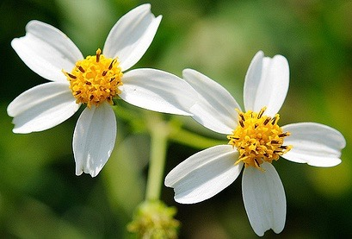 antimalarial, antimicrobial, antipyretic, astringent, carminative, diuretic, expectorant, emmenagogue, emollient, hypotensive, intoxicant, lactogogue, sialogogue, styptic, vulnerary, antifungal, antiparasitic, antispasmodic, cardiac tonic, antioxidant, anti-diabetic, anti-cancer, anti-protozoa , hypoglycemic, immunomodulant, antiseptic, neuroprotectant, blood tonic, prostaglandin synthesis inhibitor. Chinese medicine: clears heat, toxins, reduces inflammation, promotes urination, drains pus & promotes generation of tissues.

**Constituents:** Polyacetylenes (inhibit various pathogenic organisms), Aurone Flavonoids (reduce inflammation), the Chalcone Okanin, Ethyl Caffeine & Hydroxycinnamic Acid, Volatile Oils, Gaalic & Oxalic acid, Phenolic astringents, Butoxy Lipids, Coumaric Acids, Erythronic Acid Phenylpropanoids, Heptaphenyl and Phenylheptatriyne Benzenoids, Stigmasterol Steroids, Quercetin Flavanoids, Daucosterol

Active against: Bacillus cereus, Bacilis subtilis, Candida albicans, Human cytomegalovirus, Entamoeba histolytica, Enterococcus faecalis, Escherichia coli, Herpes Simplex 1 & 2, Klebsiella pneumoniae, Leishmania amazonensis, Mycobacterium tuberculosis, Neisseria gonorrhoeae, Plasmodium spp. Psuedomonas aeruginosa, Salmonella spp., Serratia marcescens, Shigella flexneri, Staphylococcus aureus, Staphylococcus epidermidis.

**Preparation:** some of the plant’s most potent constituents begin to degrade when dried. Heat destroys these constituents as well. The most potent constituents are considerably more soluble in alcohol than water. Water extractions are still effective but have about 50% of the potency that an alcohol extract has. Water infusions loose potency rapidly therefore make & consume teas each day.

**Tincture:** Fresh plant tincture: 1:2, 95% alcohol using fresh plant leaves and stems. 45-90 drops in water 4x a day. In acute conditions: 1/4 -1 tsp and up to 1 TBS in water up to 6x a day for up to 28 days

**Fresh Juice:** Run leaves through a juicer. Can stabilize the juice with 20% alcohol so that it will keep. Take internally like the tincture.

**Tea:** 1 tsp of herb in 8 oz of hot water and let steep for 15 minutes. Drink by the cup 2-4x daily.

Or cold infusion: steep 2-4 oz of herb 1 quart of cold water overnight. Drink by the cup 2-4x daily

**Capsules:** 15-60 grams per day divided into 4 doses per day with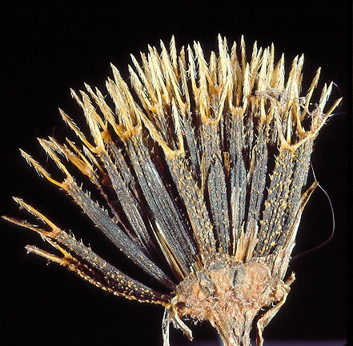 sun exposure

**Harvest:** aerial parts of the plant in late summer/early autumn before it sets seeds. If you are growing it as a medicinal, be sure to remove the flowers to retard aging and promote leaf growth. Leaves most potent, followed by the roots and the juice. Bidens is a toxic waste reclamation plant and has an affinity for heavy metals. So be careful where you harvest.

**Taste:** Sweet, Bland, Bitter

**Psychology:**

**Flower Essence:**Allows one to clarify, claim your own space in a healthy way; useful in households to interact harmoniously, brings joy to living together. Impacts psychological boundary issues related to family. Expands the aura into joy; sometimes there is psychological depression when one isn't getting what one needs. Weathering the storm, perseverance, persistence even when you feel broken. Finding beauty in the imperfect.

**Combines:** Nettles, Elderberry

**Constitution:**

**Pulse:**

**Tongue:**

**Temperature:** Neutral

**Entering Meridians:** Kidney, Small Intestine, Urinary/Bladder, Liver, Spleen, Large Intestine

**Contra-Indications:** can irritate the kidneys and bladder in high doses, caution with diabetes: it will alter blood glucose & insulin levels, potentiating tetracycline, pregnancy, those with Spleen & Stomach deficiency/cold

**References:** Wikipedia, **[earthmedicineinstitute.com](http://earthmedicineinstitute.com)**, **<http://users.comcen.com.au/~sburgess/herbs/Monographs/bidens.htm>**, **<http://www.itmonline.org/arts/bidens.htm>**,

*Healing Lyme 2nd Edition* by Stephen Harrod Buhner.

*Natural Treatments for Lyme Confections: Anaplasma, Babes, and Ehrlichia* by Stephen Harrod Buhner

*Herbal Antibiotics* by Stephen Harrod Buhner

**<http://www.druidlabs.com/hbr/flowers_s.html>**

**<http://www.americandragon.com/Individualherbsupdate/XianFengCao.html>**