MONOGRAPH

by Michelle Jones

Common Name: Blue Vervain

Botanical Name: Verbena hastata L.

Plant Family: Verbenaceae

AKA: American Blue Vervain, Wild Hyssop, Simpler’s Joy, Swamp Verbena, Herb of Grace, Herb of the Cross, Indian Hyssop,

Herba Sacra

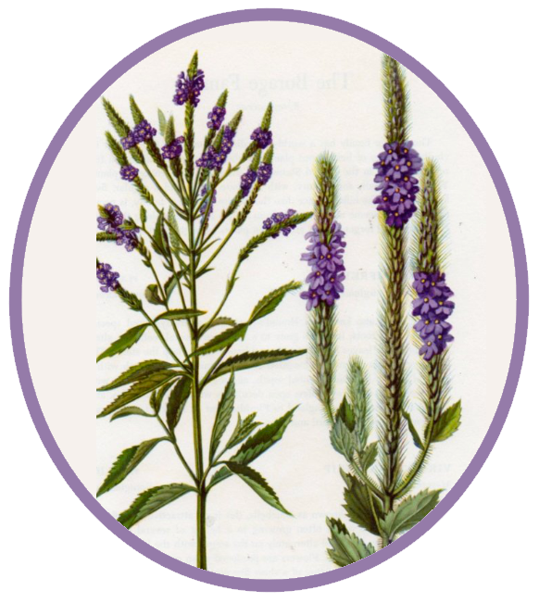

**Parts used:**

All parts of the flower. Can be used both as food (roasted seeds, ground into Indian flour) and as medicine. The root is strong and can cause vomiting.

**Uses:**

Blue vervain is used internally to treat depression, fevers, coughs, cramps, jaundice and headaches. Externally it is used for acne, ulcers and cuts.

**Respiratory –** Blue vervain is considered to be one of the best herbs to use at the onset of a cold. It is especially helpful for upper respiratory inflammation, chest congestion, colds, chronic [bronchitis](https://www.organicfacts.net/home-remedies/home-remedies-for-bronchitis.html?utm_source=internal&utm_medium=link&utm_campaign=smartlinks) and [sore throats](https://www.organicfacts.net/home-remedies/home-remedies-for-sore-throat.html?utm_source=internal&utm_medium=link&utm_campaign=smartlinks). Blue vervain tea can clear up the respiratory tracts and eliminate irritation and chest congestion.

**Astringent -** Blue vervain is astringent. It is anti-diarrheal and is used externally to heal wounds, sores and bruises.

**Digestive -** It is a digestive stimulant and speeds up sluggish digestion. Blue vervain protects the immune system.

**Hepatic –** Blue vervain has the ability to stimulate the liver. It is an excellent liver cleanser and is helpful in treating jaundice. It has a potent tonic effect on the liver that nourishes and restores function.

**Nervine –** Blue vervain has affinity for the spine and nervous system. Blue vervain is a truly acrid bitter. Acrid bitters make one shiver when the herb touches the tongue. The taste indicates Blue vervain’s use, specifically for unbreakable patterns of tightness and constriction in the nervous system. Blue vervain is a mild sedative that acts as a natural tranquilizer and relaxes the nervous system. Sensitive people who have imbalanced energy from anxiety and nervous exhaustion improve with blue vervain. It backs off excess energy in the nervous system and spine channeling it to other places in the body that are deficient, such as the digestive tract and the urinary tract. There are certain soothing properties of Blue vervain that can effectively treat various ailments, including nervous disorders, [chronic anxiety, stress, and insomnia](http://onlinelibrary.wiley.com/doi/10.1111/j.1479-8425.2009.00405.x/abstract?userIsAuthenticated=false&deniedAccessCustomisedMessage=). A cup of blue vervain tea can calm our nerves and re-balance hormone levels, allowing the body to rest. Blue vervain restores nerve function, including the capacity for synapses to fire appropriately, which balances serotonin and endorphins (calming, uplifting and pain relieving).

**Analgesic -** Blue vervain can act as a powerful analgesic as it’s organic compounds can numb certain areas and stop pain from registering in those nerves. It seems to be particularly effective on arthritic pain and the pain from kidney stones and bowel pain.

**Aphrodisiac –** Blue vervain was once considered an aphrodisiac.

**Hormone Regulator –** A cup of Blue vervain tea can calm the nerves and re-balance hormone levels.

**Anti-inflammatory –** The anti-inflammatory properties of the herb are the perfect complement to its ability to provide pain relief, as it will also reduce swelling and inflammation, as in cases of [gout](https://www.organicfacts.net/home-remedies/gout.html?utm_source=internal&utm_medium=link&utm_campaign=smartlinks), [arthritis](https://www.organicfacts.net/home-remedies/home-remedies-for-arthritis.html?utm_source=internal&utm_medium=link&utm_campaign=smartlinks), or [inflammation in the gastrointestinal system](http://www.researchgate.net/profile/Akuodor_Godwin_Chris/publication/228488488_Ethanolic_leaf_extract_of_Verbena_hastata_produces_antidiarrhoeal_and_gastrointestinal_motility_slowing_effects_in_albino_rats/links/53ebb57d0cf202d087ce91dd.pdf). It also has a dispersive effect, which makes it great to use as an infused oil on bruises, sprains, and strains.

**Hypnotic –** Blue vervain can treat insomnia. A cup of blue vervain tea can calm the nerves and re-balance hormone levels, ensuring that our body can rest.

**Antidepressant -** Blue vervain is helpful in treating depression and mood swings. This relaxing and uplifting herb can promote positive thinking, stimulate the release of neurotransmitters like dopamine and serotonin, and generally improve your mood by clearing your mind of worry. It is an excellent remedy when depression is accompanied by headaches that radiate from the spine, and liver congestion. Blue vervain is a good treatment for anxiety and depression linked to hormonal imbalances. It can ease recurring depression or depression that arises after a debilitating illness.

**Antispasmodic –** Blue vervain is helpful for women who suffer from particularly strong or severe periods. It has been known to [reduce cramps](http://www.jstor.org/stable/4607320?seq=1#page_scan_tab_contents) and general discomfort, primarily for women who are bloated and cramping. Its effects on mood and depression can also soften the symptoms of menstruation. Its regulation of hormones will keep women balanced and functional. It can be used for people who have muscle soreness and pain, due to either muscle tension or previous injuries, especially when there is tightness at the nape of the neck.

**Alterative-** Blue vervain cleanses the blood and stimulates removal of waste products from the body.

**Diuretic –** One of the oldest uses of blue vervain is as a diuretic, as it stimulates the release of urine from the body. Blue vervain was used by the American Indians to clear up cloudy urine. Blue vervain is highly effective in treating [bladder infection](https://www.organicfacts.net/home-remedies/home-remedies-for-bladder-infection.html?utm_source=internal&utm_medium=link&utm_campaign=smartlinks)s.

The increased urine flow removes gravel from the bladder and promotes the flow and expulsion of uric acid.

**Diaphoretic -** Blue vervain is a potent diaphoretic by inducing sweating and cooling the exterior, thereby reducing a fever that is stuck in a spike and rising very high.

**Expectorant -** Coughs and colds all over the world have been cured by using Blue vervain, as it acts as a powerful expectorant, helping to expel mucus and phlegm that have accumulated in the respiratory tracts.

**Bitter –** Blue vervain stimulates digestion.

**Detoxifier -** Blue vervain’s use as a diuretic can help to [eliminate toxins from the system](http://www.researchgate.net/profile/Akuodor_Godwin_Chris/publication/267384227_IN_VIVO_ANTIMALARIAL_ACTIVITY_OF_ETHANOLIC_LEAF_EXTRACT_OF_VERBENA_HASTATA_AGAINST_PLASMODIUM_BERGHEI_BERGHEI_IN_MICE/links/54741f0e0cf29afed60f5f47.pdf), as well as excess water, [salts](https://www.organicfacts.net/health-benefits/other/health-benefits-of-salt.html?utm_source=internal&utm_medium=link&utm_campaign=smartlinks), and fat. This can help to protect the kidneys and the liver by reducing the presence of dangerous substances and toxins that accumulate. By inducing sweat it eliminates toxins through the skin.

**Antispasmodic -** Blue vervain is considered antispasmodic and relieves spasms. It also relieves spasms caused mental activity.

**Galactagogue -** An infusion of the herb is a good way to increase breast milk production.

**Anti-nausea** - In small doses it can relieve nausea.

**Emetic -** The root induces vomiting if taken in large doses.

**Nephritic -** Blue vervain supports the kidneys. The infusion is used to help pass kidney stones and for infections of the bladder.

**Antithemintic-** Blue vervain expels parasites from the intestines and is said to work when other remedies fail. The natural anti-parasitic nature of the herb means that you can eliminate or prevent the growth and development of any worms or parasites in the intestines, which protects the [digestive health](https://www.organicfacts.net/home-remedies/20-tips-to-improve-digestive-health.html?utm_source=internal&utm_medium=link&utm_campaign=smartlinks) and nutrient absorption.

**Oral Health-** Blue vervain has a high concentration of tannins, which make it effective in protecting a person’s oral health. The tannins function as antioxidants, which promote healing and prevent degradation of mouth tissues. It treats bleeding gums, mouth ulcers, bacterial infections and any unhealthy aspect of oral health. Blue vervain tea can quickly clear up any oral health issues.

**Emmenagogue -** Blue vervain promotes and regulations menstrual flow, when it has been obstructed or delayed.

**Other -** Blue vervain has an affinity for the stomach. It is also helpful for treating stomach flu and food poisoning. The bitter action of the plant also lessens stomach and nerve pains. As a medicinal poultice it is good to treat headaches.

**Actions:**

Bitter, astringent, hepatic, nervine, analgesic, aphrodisiac, expectorant, hormone regulator, anti-inflammatory, hypnotic, anti-depressant, diuretic, diaphoretic, expectorant, antispasmodic, detoxification, galactagogue, anti-nausea, emetic, nephritic, antithemintic, oral health support, sedative, anti-anxiety, anti-diarrheal, anti-periodic, emmenagogue, expectorant, vermifuge, vulnerary, alterative.

**Constituents:** Mucilages, bitters, iridoid glycosides (hastatoside verbenalin), caffeic acid, essential oil, adenosine, aucubin, beta-carotene, citral, hastatoside, lupeol, ursolic-acid, verbenalin, verbenin.

**Tincture:** Parts above ground, including flower.

1:5 Tincture: 28-56 drops 2-4x’s per day.

**Tea:** Warm infusion of roots, leaves and flowers. 1 tbsp. dry herb, add 1 pint boiling water, steep 10 min., take 1 tbsp. up to six times a day.

**Salve or infused oil:** to Treat tight muscles.

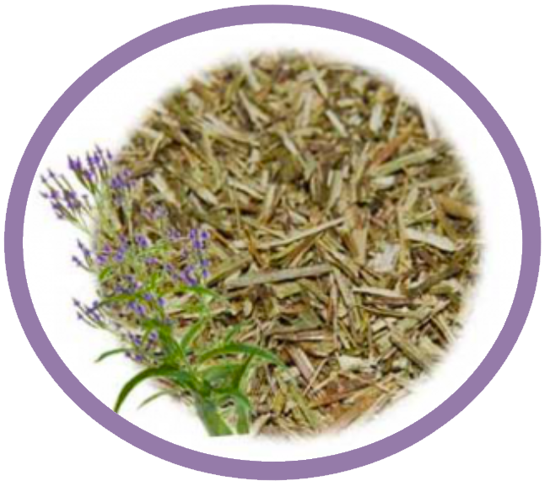

**Harvest:** Harvest the parts above ground, in the spring, just before the plant flowers (Blue Vervain flowers bloom from June to September). Dry the harvested parts. Harvest the roots in the spring or fall. Harvest the flowers from June-September.

**Taste:** Acrid, Bitter, Dispersive. Cool to neutral.

**Psychology:** Used as a charm to recover lost love. Mixed into love potions to make love intense and strong.

**Folklore:** Iroquois witchcraft medicine used a cold infusion of smashed leaves to make an obnoxious person leave. In medieval times it was considered a cure-all and sacred plant, helping to save people from plagues. The ancients attributed aphrodisiac qualities to Blue vervain. Priests used it for sacrifices, hence the name Herba Sacra. The name, Verbena, was the classical Roman name for “altar-plants”. It was used by magicians and sorcerers in various rites and incantations.

**Constitution:**

Useful for over-thinking worrywart types (Pitta-on-fire). The type that is always planning, and having a hard time accepting changes to their schedule. Appropriate for people who cannot help but work and push, sensitive people who have imbalanced energy from anxiety and nervous exhaustion, women who fit the constitutional picture of being intense and driven, those of us who don't have the physical container or constitution to hold the nervous and mental energy we are inclined to create.

**Contra-indications:** Do not use if pregnant as it can be a uterine stimulant. Do not use if nursing, unless under the guidance of a practitioner to help produce breast milk. Use under the supervision of a practitioner. Blue vervain can interfere with blood pressure medication, blood thinning agents and hormone therapy. Do not use with MAO inhibitors. Contains caffeine. Large doses will induce vomiting and diarrhea. Also, when used in larger concentrations, such as in medicinal supplements, mild [skin](https://www.organicfacts.net/home-remedies/10-best-foods-for-healthy-skin.html?utm_source=internal&utm_medium=link&utm_campaign=smartlinks) rashes may also appear and stomach aches can occur.

**Where it grows:**

Blue Vervain, Verbena hastata, grows in North America and Southern Canada. It is similar in appearance and properties to Verbena officinalis, which grows in Europe. It grows abundantly in the great plains of American and in meadows, woodlands and prairies. The Dakota indian’s word for Blue Vervain means “medicine”. It prefers moist conditions and full to partial sun. It is most commonly found in moist meadows, pastures, riversides, marches, prairies at the bottom of a river and ditches. It is a perennial flower that grows 2’-5’ tall. Blue vervain has hairy stems that can be green or red in color. It has lance shaped leaves that are toothed and grow in pairs up the stem. The leaves are 6” long and 1” wide. The blooms are 1/4” wide and lobed. The flowers are purplish-blue and have multiple blooms arranged on the stem. The blooms can be up to 5” long. Blue vervain produces nutlets, which contain seeds, after 1.5 months of blooming. It spreads through rhizomes (horizontal roots that produce new plants).

**Citations:**

[www.mountainroseherbs.com/products/vervain/profile](http://www.mountainroseherbs.com/products/vervain/profile)

[www.botanical.com/botanical/mgmh/v/vervai08.html](http://www.botanical.com/botanical/mgmh/v/vervai08.html)

<http://plants.usda.gov/factsheet/pdf/fs_veha2.pdf>

[www.anniesremedy.com/herb_detail121/php](http://www.anniesremedy.com/herb_detail121/php)

[www.pacificbotanicals.com/store/Blue-Vervain.html](http://www.pacificbotanicals.com/store/Blue-Vervain.html)

<https://altnature.com/gallery/vervain.htm>

<http://www.hawthornehillherbs.com/node/158>

<http://www.redrootmountain.com/relieving-stress-part-i-nervine-tonics-for-a-new-year/277>

[www.organicfacts.net/health-benefits/herbs-and-spices/blue-vervain.html](http://www.organicfacts.net/health-benefits/herbs-and-spices/blue-vervain.html)

The Complete Herbal Guide Directory: A Natural Approach to Healing the Body and Maintaining Optimal Health Using Herbal Supplements, Vitamins, Minerals, Fruits, Vegetables and Alternative Medicine by [Stacey Chillemi](https://www.amazon.com/Stacey-Chillemi/e/B002BLN31Y/ref=dp_byline_cont_ebooks_1) and [Dr. Michael Chillemi](https://www.amazon.com/s/ref=dp_byline_sr_ebooks_2?ie=UTF8&text=Dr.+Michael+Chillemi&search-alias=digital-text&field-author=Dr.+Michael+Chillemi&sort=relevancerank).