**Burdock*, *Arctium lappa***

(* Note: “burdock” in this monograph always refers to *arctium lappa*)

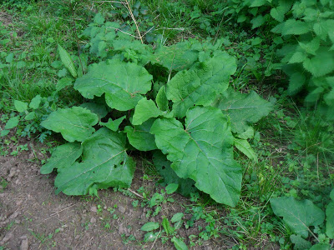**Name**1,2,3

beggar's buttons, burr seed, cocklebur, gobō, goboshi, greater burdock hardock, happy major, harebur, lappa, personata, thorny burr

**Description**

Native to Europe and Asia, burdock may be found in temperate regions throughout the world, including most of the United States and Canada.

This biennial plant has large wavy leaves at the lower level and a branched stem that can grow up to 4 feet. The smaller upper leaves can be more “egg shaped”3 and are not as densely placed.

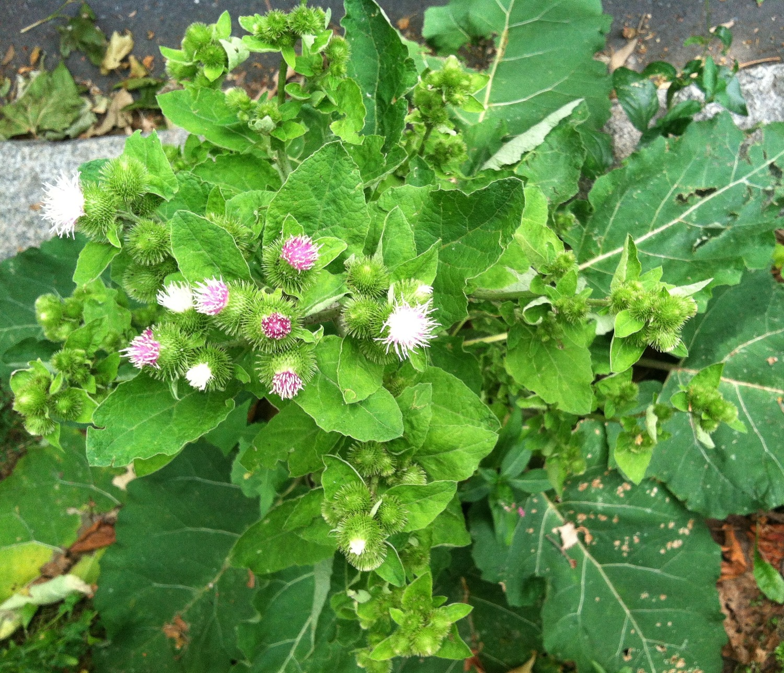When in bloom, burdock has purple, round-headed flowers. Many traditional medical remedies use the plant’s deep roots which often grow “12 inches or more in length” and, often, “can be 2 to 3 feet deep.” 6

**Parts Used:** Roots, leaves and seeds

**Uses:**

Recent medical literature has reported burdock to have anti-inflammatory, anticancer, antidiabetic, antimicrobial and antiviral activities.5

* Cleansing the liver, kidneys, and bowel. Blood purifier.
  + Examples of treatments:
    - Tea decoction with dandelion, yellow dock, sarsaparilla, licorice
    - Tincture alone or in combination with herbs such as yellow dock.
  + Burdock is known for cleansing all of these systems which relates to its use for various conditions including gout and rheumatoid arthritis.
  + Its power in protecting the liver was demonstrated in a study where burdock helped reverse acetaminophen-induced liver damage.11
* Skin
  + Dryness, eczema, scales, ulcers
    - Root decoction as an external wash
    - Leaves as a poultice
* Gastric ulcers
  + Tincture.
* Menstrual pains – Traditional use in central Italy10
* Tuberculosis
  + Lab tests on aerial parts of the plant demonstrated that it has an anti-tubercular effect. 8
* 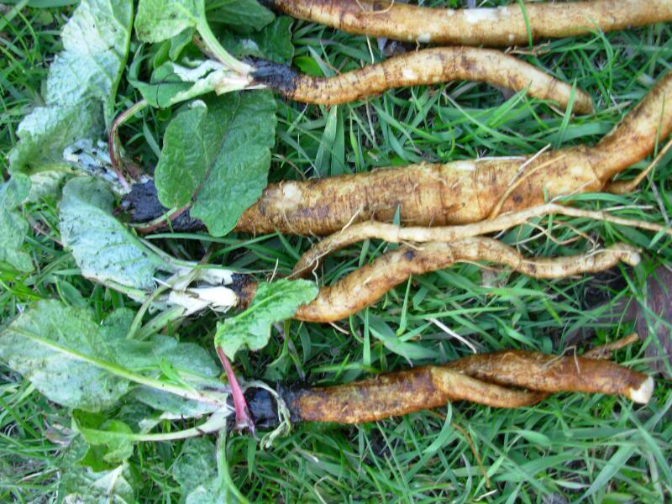Aphrodisiac
  + A 2012 medical journal study using rats appears to verify burdock’s purported aphrodisiac qualities.7

**Actions**: alterative, anti-inflammatory, antiscorbutic , antioxidant , depurative, diuretic, diaphoretic, hypoglycemic, laxative

**Often Used with:** dandelion, sarsaparilla, yellow dock

**Constituents**:9 Tannins, inulin, sugar, resin, phenolic acids, mucilage, flavonoids, tannic acid, fatty oils.

**Harvest**:

* **Roots:** Dug in the Fall, preferably first-year roots.6
* **Leaves:** Before the fall.

**Contra-indications:**

* Consult a healthcare practitioner if you are pregnant or have diabetes.2

**Interesting Notes**:

The curved hooks of Burdock burrs inspired Swiss engineer George de Mestral to invent Velcro.

**References**

1 Wikipedia, Arctium Lappa, <https://en.wikipedia.org/wiki/Arctium_lappa>

2 Health Canada. Monograph: Burdock - Oral. <http://webprod.hc-sc.gc.ca/nhpid-bdipsn/monoReq.do?id=51>

3 Botanical.com. Burdock, Arctium lappa. <http://www.botanical.com/botanical/mgmh/b/burdoc87.html>

4 Panda, H. Handbook on Medicinal Herbs with Uses, 2004. Greater Burdock, p. 127

5 Chan, Yuk-Shing, et al. "A review of the pharmacological effects of Arctium lappa (burdock)." Inflammopharmacology 19.5 (2011): 245-254.

6 Herbal Academy. 3 Medicinal Roots to Harvest in Fall: Dandelion, Burdock and Yellow Dock. <https://theherbalacademy.com/3-medicinal-roots-to-harvest-in-fall-dandelion-burdock-and-yellow-dock/>

7 JianFeng, Cao, et al. "Effect of aqueous extract of Arctium lappa L.(burdock) roots on the sexual behavior of male rats." BMC complementary and alternative medicine 12.1 (2012): 1.

8 Zhao, Jinlian, et al. "Antitubercular activity of Arctium lappa and Tussilago farfara extracts and constituents." Journal of ethnopharmacology 155.1 (2014): 796-800.

9 Nejad, Amir Sasan Mozaffari, et al. "Ethnobotany and folk medicinal uses of major trees and shrubs in northern Iran." Journal of Medicinal Plants Research 7.7 (2013): 284-289.

10 Menale, B., et al. "Traditional uses of plants in North-Western Molise (central Italy)." Delpinoa 48 (2006): 29-36.

11 Lin, Song-Chow, et al. "Hepatoprotective effects ofArctium lappa linne on liver injuries induced by chronic ethanol consumption and potentiated by carbon tetrachloride." Journal of Biomedical Science 9.5 (2002): 401-409.

**Images**

Page 1, Image 1 http://gonewild2011.blogspot.com/2011/04/arctium-lappa.html

Page 1, Image 2 <http://www.cambridgenaturals.com/blog/beautiful-burdock-root-arctium-lappa>

Page 2, Image 1 http://www.clearconsciencesoapcompany.com/burdock-root-extract-aqua-arctium-lappa-alcohol/