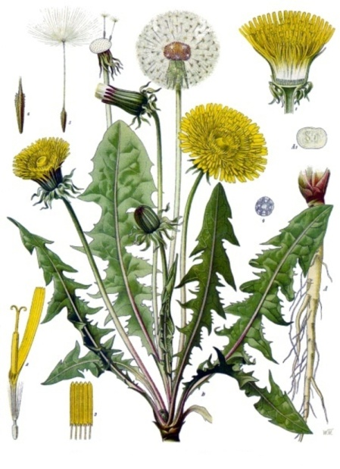

*Dandelion*

Monograph by: Christianna Ferri

**Name**: Dandelion (name comes from the French word “dent de lion” which means lion tooth; used to describe the coarsely-toothed leaves), Taraxacum officinale

**Other names:** Blow ball, Cankerwort, Clock Flower, Irish Daisy, Lion's Tooth, Milk Witch, Monk's Head, Piss-a-bed, Priest's Crown, Puffball, Swine Snout, Tell time, White Endive, Wild Endive

**Parts used**: Leaf and root

**Properties**: High source of vitamins (A,C,E,K), anti-inflammatory, minerals (calcium, phosphorus,iron,magensium,sodium)

**Action:** Taraxacin, acrystalline, bitter substance, an acrid resin, inulin (a sort of sugar), luteolin, gum and potash are the major constituents of the dandelion root. Luteolin demonstrates antioxidant properties, and dandelion juice possesses diuretic and laxative properties, good remedy for rheumatism, clears heat and resolves damp, promotes lactation, relieves fire toxicity

**Uses**: great for skin, supports liver health, toxin remover, healthy coffee substitute (roasted root), preventing UTIs, loss of appetite, upset stomach, flatulence, constipation, helpful for people with type II diabetes (helps to stabilize blood sugar), helps to detoxify system, diuretic (helps the body to get rid of too much fluid), in Chinese medicine it is said it can prevent cancer by clearing internal blockages and blood stagnation so that cells can breathe and function properly, helps breast issues such as inflammation or lack of milk flow

*Leaves and root as tea or tincture*

Leaf- as edible food for example can be used in salad, most diuretic part of plant (helps kidney function) dried leaf tea folk laxative

Root- tougher than leaf and more often used in decoctions and tinctures, aperient, helps digestion/mild laxative, helps stimulate appetite, treat dyspepsia

**Taste: Leaf and root**-bitter

**Flower-**sweet and crunchy

**Tincture**: fresh roots and leaves: 2:1 ratio, 50% alcohol content. If using dried root, 5:1 ratio. ½ teaspoon 3-4 times a day

**When to harvest**: late Fall through early spring, for medicinal use it is said fall harvest may be best

**Decoction:** place one ounce of dried roots or two ounces fresh roots (by weight) in a pan with one pint of water.  Bring to a boil, cover, and simmer for 20 minutes.  Strain and compost the spent roots.

* The dandelion is the only flower that represents the 3 celestial bodies of the sun, moon, and stars which describe its life cycle. The yellow flower resembles the sun, the puff ball represents the moon , and the dispersing seeds resemble the stars
* Opens up in the morning, and closes at night or during gloomy weather

Psychology:

**Flower essence**: Helps balance feelings of emotional stress, helps move and release emotion that is stuck in the body

**Combines:** chicory, cinnamon, ginger (great for digestion)

**Constitution:** works well forover-heated, aggressive person (loud voice, red complexion) and the slow, heavy damp person. Thinner types with damp conditions like Candida benefit as well(moves energy inward and lower into the body)

**Contra-indications:** Should not be used by patients with gallstones or an obstruction of the bile ducts. Also patients with gastritis and stomach ulcers are urged to avoid dandelion because it may over produce stomach acid. May reduce the effect of antibiotics. The root and steams contain a milky substance which may cause an allergic reaction in some people.

References:

Steven Foster, James A. Duke: Field Guide to Medicinal plants and herbs, ,<http://www.acupuncturetoday.com/herbcentral/dandelion.php> ,<http://www.softschools.com/facts/plants/dandelion_facts/597/> <http://mydandelionisaflower.org/did-you-know/> <https://www.chinesemedicineliving.com/nutrition/foods-temperatures/dandelion/> <http://www.chinese-herbs.org/dandelion/> <http://wellnessmama.com/5680/dandelion-herb-profile/> <http://commonsensehome.com/harvesting-and-using-dandelion-roots/>