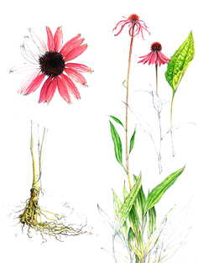

**Name:** Echinacea, *Echinacea angustifolia, E. purpurea, E. pallida, Purple Cone Flower*

**Parts Used:** Roots, leaves, seeds and flowers

*Stephanie Ragusa*

Echinacea

**Uses:** Immune enhancer (stimulates production of white blood cells), blood cleanser (especially for skin problems associate with impure blood), excellent remedy for tonsillitis, inflamed gums and for mucus in the sinuses, lungs and digestive tract. Externally can be used to treat wounds or ulcers; a wash made from the flowers

**Actions:** Anti-microbial, immunomodulator, anti-catarrhal, alterative; effective against both bacterial and viral infections. Also known to activate the macrophages that destroy cancerous cells.

**Constitutents:** Essential oil, glycoside, polysaccharides, caffeic acid, echinacoside, linoleic acid, tannins, beta-carotene, vitamin C

**Taste**: Bitter, pungent

**Contraindication**: Very few known side effects or residual buildup in the body – 100% safe for children and elderly. Discontinue use if showing signs of allergy.

**Decoction of roots:**  A mouthwash can be made to soothe sore gums and mouth inflammation

**Tinctures:** Use entire plant in a tincture and use at first sign of cold, flu or bronchial infection and boost immunity

**Teas/Infusions:** Use aerial parts to make a tea to combat cold/flu symptoms; tea can be used as a throat spray to soothe sore throats

**Preparations & Dosage:** Decoction: 1-2 teaspoons of the root in one cup of water and bring it slowly to boil. Let it simmer for 10-15 minutes. This should be drunk three times a day.

Tincture: take 1-4 ml of the tincture three times a day

* Echinacea’s effectiveness will decrease if it is used continually so best to use it in cycles (5 days on; 2 days off)

**Combines:** With Goldenseal as an antibiotic and antiviral; with Pau d’Arco, Dandelion, Burdock, Sassafras and Ginger for immune boosting properties

**Harvest:** Flowers when plants are in full bloom, and the roots of 4-year-old plants are gathered normally, during the autumn season. Seed may be harvested during the fall of the second year.

**Psychology**: Helps one maintain a strong sense of self, especially when challenged by stress of illness

**Constitution:** Echinacea is a nourishing and warming herb that can be of particular benefit to those with cooler constitutions