**EVENING PRIMROSE**

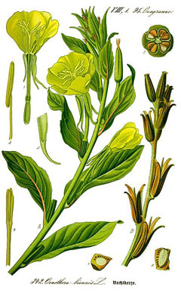

**Name**: Evening Primrose

**Scientific** **Name**: *Oenothera biennis*

**Parts** **Used**: the whole plant, flower, seeds, dried root

**Actions**: tonic, antispasmodic, vermifuge, emetic, astringent

**Uses**: alleviate PMS symptoms, atopic eczema, psoriasis, multiple sclerosis, cancer, coronary heart disease, diabetic neuropathy, immune support, autoimmune conditions, gastrointestinal symptoms, anti-inflammatory (arthritis), prevent blood clotting, strengthen hair skin and nails (protective barrier), menopausal symptoms

**Constituents**: GLA (gamma linoleic acid), linoleic acid, Omega-6 fatty acids

**Harvest**: Autumn (seeds)   
  
**Taste**: pungent, sweet

**Contraindications**: nausea, headache in high doses

**Medicinal** **Preparations**:

**Tincture:** 1-15 drops of whole plant up to 3-4 times per day

**Infusion:** 1-3 tsp whole plant in infusion per day

**Root:** 1tb of ground root or plant in honey as needed

**Oil** **from** **seeds**: capsule form (2-3gm/day)

**Flower Essence Properties:**

* Positive qualities: Awareness and healing of painful early emotions absorbed from parents; ability to open emotionally and form deep, committed relationships.
* Patterns of imbalance: Profound feeling of rejection stemming from in *utero* or early childhood experience; avoidance of commitment in relationships, fear of parenthood; sexual and emotional coldness or repression.

**Sources**:

http://www.essencesonline.com/FESQuints.htm#E

<http://www.drweil.com/vitamins-supplements-herbs/herbs/evening-primrose-oil/>

<http://www.botanical.com/botanical/mgmh/p/primro69.html>

<http://www.sacredearth.com/ethnobotany/foraging/EveningPrimrose.php><http://bearmedicineherbals.com/a-fogotten-tonic-herb-evening-primrose.html>