# YELLOW GENTIAN

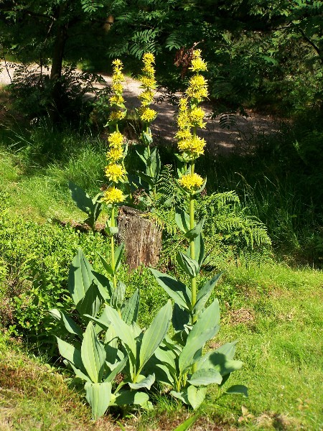

**Compiled by Jehanne-Marie Gavarini – GavHerbs**

**Name:** Yellow Gentian — Gentiana lutea

* + 1. **:** Asterias Hybrid, Asterias lutea, Coilantha Biloba, Gentiana Major, Bitterwort, Sampson’s Snakeroot, Felwort, Balmoney.

**Family:** Gentianaceae

The Gentians are an extensive group of plants, numbering about 180 species, distributed throughout all climates, though mostly in temperate regions and high mountains, being rare in the Arctic. In South America and New Zealand, the prevailing color of the flower is red, in Europe blue (yellow and white being of rarer occurrence).

# Description:

A tall attractive plant with yellow flowers (sometimes with reddish spots). The stem grows 3 or 4 feet high or more, with a pair of leaves opposite to one another, at each joint, their bases almost embracing the stem. Leaves are yellowish-green, oblong and pointed, with 5 prominent veins on [1][2]the underside. They diminish gradually in size as they grow up the stem.

**Taste:** Bitter. Gentian contains some of the most bitter compounds known and is used as a scientific basis for measuring bitterness 1

# Habitat:

The Yellow Gentian is a native of the Alps and mountainous regions of central and southern Europe. Symbol of Cantal, a region in Central France, yellow gentian root is known for its many medicinal and tasty properties. It can weigh several kilograms and reach a meter long! It is estimated that this plant can live at least 50 years but it blooms only every 4-8 years. Be careful not to confuse it with the white hellebore (*Veratrum album*), very toxic, whose leaves are arranged alternately on the stem and not opposite as those of the yellow gentian. Yellow gentian is used to manufacture well-known aperitifs (Avèze or Salers) but the plant has been over-harvested and is now endangered. So its harvest is carefully regulated2.

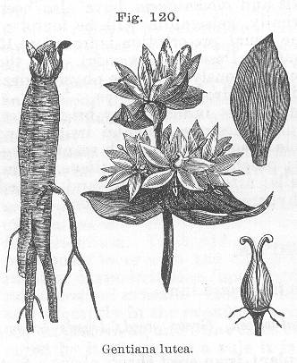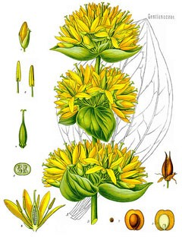

**Part used**: root. It is likely that the roots are richest in medicinal properties before the plants have flowered.

**Properties:** Tonic, bitter stomachic, sialagogue (increases the flow of saliva), cholagogue (stimulates the flow of bile from the liver), hepatoprotective, emmenagogue (stimulates menstrual bleeding), antimicrobial, antiseptic, antihelminth (expels parasitic worms), antidepressant, anti-inflammatory, antibiliary, antispasmodic, antiseptic, febrifuge.

# Plant Actions:

Activates the bitter taste receptors on the tongue, causing an increase in saliva and gastric secretion production. Stimulates the appetite and digestive system. Helps gas and bloating. Gall bladder and liver stimulant. Helps absorb nutrients, particularly iron and Vitamin B12 (useful for anemia and women with heavy menstrual bleeding).

Excellent bitter tonic. Strengthens a weak or underactive digestive system. It can be used for jaundice.

Guido Masé cites a study in which gentian root “was administered to a group of 205 patients with a range of dyspeptic, or ‘bad belly’ symptoms, including nausea and vomiting, heartburn, gas and bloating, spasmodic pain, and constipation. All were quickly relieved” (Massé, 156).

# Traditional Use:

* + - * Digestive stimulant
      * Appetite stimulant
      * Relieves gas and indigestion
      * Gallbladder and liver stimulant
      * Digestive tonic (especially good for elders)
      * Nervine
      * Aids the absorption of nutrients, particularly iron and vitamin B12
      * Heavy menstrual bleeding and anemia

# Tongue and Pulse:

Red tongue with yellow fur and rapid string like pulse (Wiseman,and Ye, 356)

# Caution:

Do not take if suffering from acid indigestion and peptic ulcer. Can cause headaches.

# How to use/Recipes:

* + - * A tincture made with 2 OZ. of the root, 1 OZ. of dried orange peel, and 1/2 oz. bruised cardamom seeds in a quart of brandy is an excellent stomach tonic, and is efficacious in restoring appetite and promoting digestion.
      * Fresh Gentian root is largely used in France, Germany and Switzerland for the production of an alcoholic beverage. The roots are cut, macerated with water, fermented and distilled; the distillate contains alcohol and a trace of volatile oil, which imparts to it a characteristic odor and taste.3
      * Gentian wine fortifies the stomach, stimulates the liver and bile production: combine 1 TBSP of chopped up gentian roots, 5 grams each of Menyanthes trifoliate, Acorus calamus, orange peel, and 3 grams of anis, soak in 1 liter of red wine for 14 days. Drink 2 or 3 shots a day (Oertel-Bauer, 65).

**Constituents:** Gentiopicoside**,** Amarogentin**,** Gentianose**,** Inulin**,** Phenolic acid**,** Gentiin and Gentiamarin, bitter glycosides, together with Gentianic acid (gentisin), the latter being physiologically inactive. Gentiopicrin, another bitter glucoside, a pale yellow crystalline substance, occurs in the fresh root, and may be isolated from it by treatment with boiling alcohol. The saccharine constituents of Gentian are dextrose, laevulose, sucrose and gentianose, a crystallizable, fermentable sugar.

# Resources:

Botanical.com: A Modern Herbal by Mrs M. Grieve: https://[www.botanical.com/botanical/mgmh/g/gentia08.html](http://www.botanical.com/botanical/mgmh/g/gentia08.html) (accessed May 1, 2016)

Chevalier, Andrew: *Encyclopedia of Herbal Medicine*. London, New York: Dorling Kindersley, Second American Edition, 2000.

Gladstar, Rosemary: *The Herbal Apothecary.* Portland, OR: Timber Press, 2015.

*Grand Site de France: Puy Mary, Volcan du Cantal. Gentiane Jaune:*

<http://www.puymary.fr/fr/gentiane-jaune>(accessed May 1, 2016)

Masé, Guido*: The Wild Medicine Solution: Healing with Aromatic, Bitter, and Tonic Plants*. Rochester, NY: Healing Arts Press, 2013.

*Plants for a Future: Earth, Plants, People. Gentiana Lutea-L:*

[3][4][http://www.pfaf.org/user/Plant.aspx?LatinName=Gentiana+lutea](http://www.pfaf.org/user/Plant.aspx?LatinName=Gentiana%2Blutea) (accessed May 1, 2016)

Oertel-Bauer: *La Santé par les plantes et la thérapeutique végétale naturelle.* Paris: Editions Alsatia, 1964.

Wiseman, Nigel and Feng, Ye: *A Practical Dictionary of Chinese Medicine*. Brookline, MA: Paradigm Publications, Second Edition, 1998.

1 http://www.pfaf.org/user/Plant.aspx?LatinName=Gentiana%2Blutea

2 http://www.puymary.fr/fr/gentiane-jaune

3 https://www.botanical.com/botanical/mgmh/g/gentia08.html#yelcon

1.
2.
3.
4.