**GOTU KOLA**

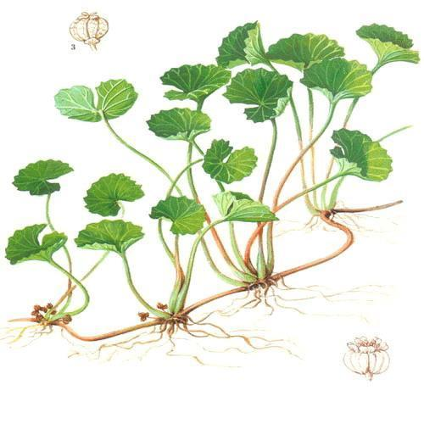

*“Fountain of Life”*

**Scientific Name**: *Centella Asiatica*

**Parts** **Used**: leaves, all above ground parts

**Constituents**: triterpenoid compounds (collagen producing), asiaticoside and madecassoside (veins and blood vessels, antibacterial), oxyasiaticoside, and madecassoside, centelloside, centellasponins, brahmoside, brahminoside, thankunoside, isothankunoside, sapogenins from various chemotypes such as asiatic, madecassic, centellic, indocentoic, brahmic, thankunic, isothankunic acids, volatile oil, rhamnose, arabinose, glucose, fructose, sucrose, rafinose, pectin, centellose, glycerides of oleic, linoleic, lignoceric, palmitic, stearic, linolenic and elaidic acids, steroids, amino acids, flavanols, polyphenals, tannins, carotenoids, villarin, and ascorbic acid

**Actions**: nervine, tonic, anti-bacterial, anti-inflammatory, analgesic, febrifuge, alterative, diuretic, vulnerary, rejuvenative, anthelmintic

**Uses**: fatigue, anxiety, depression, psychiatric disorders, immune strengthening, Alzheimer’s disease, improving memory and intelligence, increases collagen- wound healing/scars/stretch marks, trauma, reduces inflammation- circulation problems (varicose veins, clotting), sunstroke, [tonsillitis](http://www.webmd.com/vitamins-supplements/ingredientmono-753-gotu%20kola.aspx?activeingredientid=753&), fluid around the [lungs](http://www.webmd.com/lung/picture-of-the-lungs) ([pleurisy](http://www.webmd.com/lung/tc/pleurisy-overview)),[liver](http://www.webmd.com/digestive-disorders/picture-of-the-liver) disease ([hepatitis](http://www.webmd.com/hepatitis/default.htm)), [jaundice](http://www.webmd.com/vitamins-supplements/ingredientmono-753-gotu%20kola.aspx?activeingredientid=753&), longevity, systemic [lupus](http://www.webmd.com/vitamins-supplements/ingredientmono-753-gotu%20kola.aspx?activeingredientid=753&) erythematosus (SLE), [stomach pain](http://www.webmd.com/vitamins-supplements/ingredientmono-753-gotu%20kola.aspx?activeingredientid=753&), [diarrhea](http://www.webmd.com/digestive-disorders/digestive-diseases-diarrhea), indigestion, [stomach](http://www.webmd.com/digestive-disorders/picture-of-the-stomach) ulcers, [epilepsy](http://www.webmd.com/epilepsy/default.htm), [asthma](http://www.webmd.com/asthma/default.htm), “tired [blood](http://www.webmd.com/heart/anatomy-picture-of-blood)” ([anemia](http://www.webmd.com/a-to-z-guides/understanding-anemia-basics)),[diabetes](http://www.webmd.com/vitamins-supplements/ingredientmono-753-gotu%20kola.aspx?activeingredientid=753&), preventing [pregnancy](http://www.webmd.com/baby/default.htm), absence of menstrual periods, and to arouse sexual desire.

**Taste**: sweet, bitter, astringent, cooling

**Medicinal Preparations**

**Orally**- 4-8 weeks: improve blood circulation and reduce swelling in people with poor blood circulation in the legs.

**Infusion, tincture, capsule**

**Topically/Injections**- onto the tissue for scar/wound repair

**Culinary**: eaten raw

**Spiritually**: used by yogis to improve meditation, highly important in Ayurveda medicine, used to balancing the 3 Doshas

**Botany**: native to South East Asia

**Contraindications**  
**Surgery**: Gotu kola might cause too much sleepiness if combined with medications used during and after surgery. Stop using gotu kola at least 2 weeks before a scheduled surgery.

Sedatives

<http://www.webmd.com/vitamins-supplements/ingredientmono-753-gotu%20kola.aspx?activeingredientid=753&>

<http://www.herbwisdom.com/herb-gotu-kola.html>

<https://www.mountainroseherbs.com/products/gotu-kola-powder/profile>