MONOGRAPH

by Michelle Jones

Common Name: Guggul

Botanical Name: Commiphora wightii

Plant Family: Burseraceae

AKA: Devadhupa, Gomme Guggul, Gomme-Résine de Guggul, Guggal, Guggul Gum, Guggul Gum Resin, Guggul Lipids, Guggulipid, Guggulipide, Guggulsterone, Guggulstérone, Guggulsterones, Guggulstérones, Guggulu,Guggulu Suddha, Guglipid, Gugulipid, Gum Guggal, Gum Guggulu, Indian Bdellium, Indian Bdellium-Tree, Indian Guggulipids, Koushika, Mukul Myrrh Tree, Palankasha, Yogaraj Guggul Gum Resin.

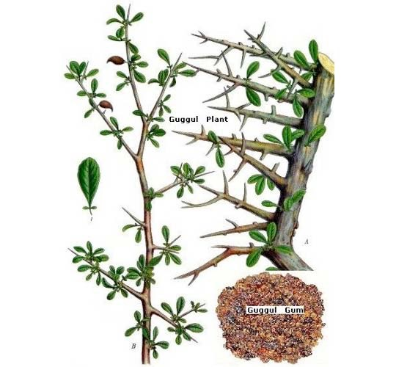

**Parts used:** Resin formed from the sap of the Guggul tree.

**Uses:**

In general, Guggul has an affinity for all of the tissues in the body as well as the circulatory, digestive, nervous, and respiratory systems.

It is astringent, anti-inflammatory and antiseptic. When taken internally it acts as a bitter, stomachic and carminative, stimulating the appetite and improving digestion. It causes an increase in leucocytes in the blood and stimulates phagocytosis.

It acts as a diaphoretic, expectorant and diuretic, and is said to be a uterine stimulant and emmenagogue. The resin is used in the form of a lotion for indolent ulcers and as a gargle in chronic tonsilitis, pharyngitis and ulcerated throat. Guggul promotes detoxification and rejuvenation. It purifies the blood, helps maintain healthy cholesterol levels, kindles digestive fire, promotes healthy weight, supports comfortable movement of the joints, supports thw immune system, supports healthy skin, supports a regular menstrual cycle and is a source of antioxidants.

**Constituents:** The gum resin from the bark contains the octanordammarane terpenes manusumbionic acid and manusumbinone.

**Tincture, Extract, Lotion, Gargle**

**Taste:** Bitter, pungent and astringent

**Constitution:** Guggul pacifies vata, pitta, and kapha, though it is especially renowned for alleviating vata aggravations.

**Contra-indications:** Some adverse side-effects reported on taking guggul are mild diarrhea and nausea. It may possibly raise bilirubin levels, cause hemolysis of blood, hepatitis, and obstruction of the biliary tract. Avoid exposure to direct sunlight while taking it. Guggul is considered an emenogogue (an agent that promotes the menstrual discharge) and a uterine stimulant, and should not be used during pregnancy. Possible diarrhea, hiccups, restlessness, apprehension. In addition, caution is recommended with patients currently on prescribed medications for cardiovascular disease. Due to the diuretic action of this herb the following drug interactions are possible: increased risk of toxicity with anti-inflammatory analgesics; if hypokalemia occurs possible antagonism with antiarrhythmics and potentiation of muscle relaxants; antagonizes antidiabetic (hypoglycemic) drugs; may potentiate and/or interfere with antihypertensives; may potentiate lithium therapy; when taken with corticosteroids there is a risk for hypokalemia; may potentiate other diuretics and increase the risk of hypokalemia.

**Where it grows:** Grows in the arid rocky tracts of Rajputana, Khandesh, Berar, Mysore, Sind and Baluchistan.