# HARPAGOPHYTUM PROCUMBENS

**Devils Claw**

Compiled by Jehanne-Marie Gavarini – GavHerbs

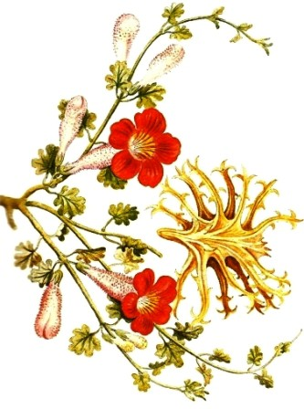

**Botanical Name***: Harpagophytum procumbens*

**Family:** Pedaliaceae

## A.K.A.:

Devils Claw, Devil's Claw Root, Garra del Diablo, Grapple Plant, Griffe du Diable, Harpagophyti Radix, Harpagophytum, Harpagophytum zeyheri, Racine de Griffe du Diable, Racine de Windhoek, Teufelskrallenwurzel, Uncaria procumbens, Wood Spider.

## Description:

Devil’s claw’s botanical name, Harpagophytum, means “hook plant” in Greek. This plant, which is native to Africa, gets its name from the appearance of its fruit. Covered with hooks, it is meant to attach onto animals in order to spread its seeds. It is a traditional African remedy used by various people in South Africa including the Khoikhoin and the Bantu.

**Taste:** Bitter

## Signature:

Matthew Wood writes that Devil’s Claw knobbiness resembles swollen, rheumatic joints such as

those of a gnarled hand

**Parts used:** Tuber harvested in fall

**Preparations**: Decoction, tincture, pills (for arthritis and rheumatism), ointment

## Constituents:

Aluminum, beta sitosterol, calcium, chlorogenic acid, chromium, flavonoids, gum-resin, harpagoquinone, iridoid glycosides (harpagoside, harpagide, and procumbine), kaempferol, luteolin, magnesium, oleanolic acid, phytosterols. selenium, sugars (stachyose), tin, zinc

## Key actions:

* Anti-inflammatory
* Analgesic
* Digestive stimulant
* Anodyne (acts to relieve or soothe pain by lessening the sensitivity of the nervous system)
* Appetite stimulant
* Tonic
* Also diuretic and liver and gall bladder stimulant
* Lymphatic system stimulant
* Blood sugar regulator (lowers blood sugar)

## Uses:

* Joint Pain
* Osteoarthritis, particularly pain in hip and knee
* Arthritis
* Rheumatism
* Myalgia
* Tendonitis
* Bursitis,
* Atherosclerosis
* Gout
* Bitter: stimulates the digestive system
* Ointment for sores, ulcers and boils
* Antipyretic (to reduce fever)

## Research:

According to Andrew Chevalier, “Many arthritic conditions are associated with poor digestion and absorption of food, and the stimulant effect of this herb on the stomach and gallbladder contributes to its overall therapeutic value as an anti-arthritic remedy” (105).

“Devils claw offers slow but sure relief of joint pain caused by both osteoarthritis and rheumatoid arthritis, and it has also been shown to relieve muscle pain and enhance mobility for people with either arthritis or muscle injuries” (Annie’s Remedy).

## Cautions:

Do not take if pregnant or suffering from a duodenal or stomach ulcer.

## References:

Annie’s Remedy: <http://www.anniesremedy.com/herb_detail64.php>(Accessed 6/5/16).

Examine.com: https://examine.com/supplements/harpagophytum-procumbens/ (Accessed 6/5/16).

Andrew Chevalier, *Encyclopedia of Herbal Medicine*. London, New York: Dorling Kindersley, Second American Edition, 2000.

Richard Mabey, *The New Age Herbalist: How to Use Herbs for Healing, Nutrition, Body Care, and Relaxation.* New York: Simon & Schuster, 1988.

WebMD: <http://www.webmd.com/vitamins-supplements/ingredientmono-984-> devil's%20claw.aspx?activeingredientid=984&activeingredientname=devil's%20claw (Accessed 6/5/16).

Tankred Wegener and Niels-Peter Lüpke, *Treatment of Patients with Arthrosis of Hip*

*or Knee with an Aqueous Extract of Devil’s Claw (Harpagophytum procumbens DC)*. Phytotherapy Research, 17(10) (2003):1165-72.

Matthew Wood, *The Book of Herbal Wisdom: Using Plants as Medicine.* Berkeley, CA: North Atlantic Books, 1997.