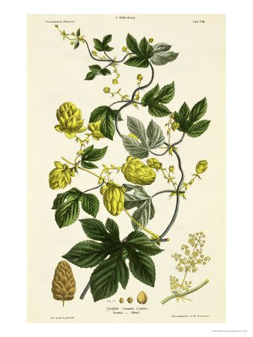

Hops

*Hops, a plant native to Great Britain, is commonly recognized as a bitter that flavors and preserves beer. Due to its strong sedative and pain-relieving components, a condition known as “hops-picker fatigue” was believed to be a result of the essential oil during harvest.*

*Stephanie Ragusa*

**Name:** Humulus Lupulus, “willow wolf”

**Parts Used:** Strobile (pine cone-like fruit of the plant) and pollen

**Constituents:** Volatile oil (comprising mostly humulene, myrcene, B-caryophyllene, farnescence), geraniol, linalool, citral, linionene, serolidol, flavonoid glycosides, fats, amino acids, asparagin

**Uses:**  Insomnia, nervous tension, gastrointestinal spasm/cramps, diuretic, coughs, fevers; externally for bruises and boils, inflammation, rheumatism, known to remove poisons and toxins from the body, treat symptoms from menopause

**Actions:** Hops have tonic, nervine, diuretic and anodyne properties.

**Taste**: Fresh Hops possess a bitter, aromatic taste and a strong characteristic odor

**Preparations:**

*Deep relaxing bath when combies with chamomile, sage and lavender*

*Teas/Infusions are traditionally made using dries strobiles*

*For insomnia, mix hops tincture with valerian tincture and take a few hours before bedtime*

*Pillow made of warm hops will often relieve a toothache or earache but mainly used to induce restful sleep*

*Hops steeped in sherry can be used as a stomachic cordial*

*An infusion of the leaves, strobiles and stalks taken two or three times daily in the early spring, is good for sluggish livers*

**Distribution:** Native to Great Britain but now cultivated throughout the United States, New Zealand, Germany, France, Australia and South Russia

**Combines:** Hops combines well with valerian, lavender as a sedative; with mugwort, motherwort, dandelion root, artichoke or yellow dock as a bitter.

**Harvest**: September

**Contraindication**: Pollen from the strobiles may cause contact dermatitis and because of their sedative effect, hops are not recommended in the treatment of depressive illness. Female hops pickers can suffer disruption of menstruation due to the absorption of oils through the hands due to the oestrogenic principals in hops. Hops contains the most potent of all the plant estrogens, prenylnaringenin - for this reason, children of either sex who have not reached puberty should not be given hops.