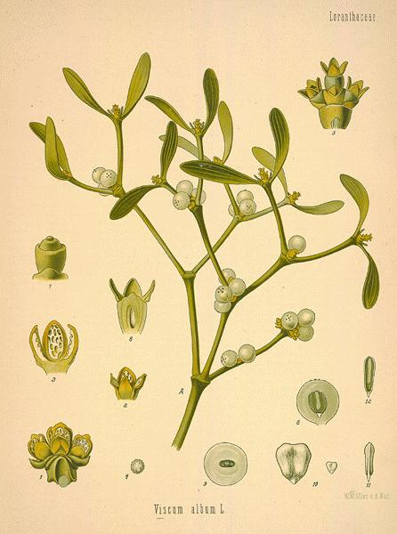

*Mistletoe*

Monograph by: Christianna Ferri

**Names:**  Birdlime Mistletoe, Herbe de la Croix, Mystyldene, Lignum Crucis, Viscum Alum

**Parts used:** The leaves and young twigs, collected just before the berries form

**Constituents:** Contains mucilage, sugar, a fixed oil, resin, some tannin and various salts. The active part of the plant is the resin (Viscin)

**How to prepare:** Fluid extractions and powdered leaves

**Action:** Nervine, antispasmodic, tonic and narcotic

**Uses:** Great reputation for curing “the falling sick” Epilepsy, and other convulsive nervous disorders. Country people use the berries to cure severe stitches in the side. The birdlime of the berries is also used by them for ulcers and sores, cancer therapy, lower blood pressure, treat arthritic pain and snoring

**Combinations:** Combines well with Tilia and Crataegus in benign hypertension

**Contraindications and warnings:** Several cases of severe poisoning from eating the leaves and berries are on record. It produces vomiting, prostration, coma, contraction of the pupil, with muscular spasm. In other cases it produces tenesmus, bloody stools, convulsions, emesis, catharsis and death, only take mistletoe under direction supervision of an experienced herbalist

**Preperations:** Dried leaves: 2-6g or by infusion- Liquid Extract: 1:1 in 25% alcohol, 1-3ml -Tincture: 1:5 in 45% alcohol-0.5ml-Infusion: 1:20 in cold water

**“It wasn’t until around the 1920s that the herb was studied for its application in treating cancer. Today, mistletoe is prescribed in Europe as complementary-based therapy since it appears to help in reducing adverse chemotherapy side effects as well as anti-cancer activity. In fact, using mistletoe extract for treating cancer is so widespread in central Europe, it is estimated that as many as 60 to 70 percent of cancer patients incorporate it into their therapy.**

**This really isn’t too surprising considering that study after study keeps pointing to mistletoe's anticancer properties. For example, according to a 2005 study, " The results of our preclinical investigation demonstrate that intratumoural injections of a lectin-rich ME [mistletoe extract] can effect complete remissions in a pancreatic cancer xenograft." Whereas a study published earlier this year found that a mistletoe extract induces rapid cell death in melanoma cells. Mistletoe also helps modulate your immune system—revving up an underperforming system, yet calming down an overactive immune system--another critical component to preventing and treating cancer. In fact, a National Cancer Institute review of more than 70 studies of mistletoe's effect on cancer in humans found consistent results across the board: including tumor shrinkage, higher survival rates, improved blood counts, and better quality of life for the patients”**

References:

1. <https://www.botanical.com/botanical/mgmh/m/mistle40.html>
2. <http://www.anniesremedy.com/herb_detail427.php>
3. <http://belfastherbalist.blogspot.com/2011/12/miseltoe-monograph.html>
4. <https://jonbarron.org/herbal-library/herbs/health-benefits-mistletoe>