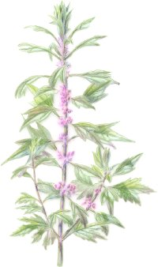

*Stephanie Ragusa*

Motherwort

**Name:** Motherwort, *Leonurus cardiac, Mother’s Herb, Lion’s Tail*

**Parts Used:** The leaves and flowering tops are used in tinctures, teas and poultices

**Uses:** Increases circulations, improves slow, sluggish digestion, calms an overactive thyroid, used to treat postpartum depression, eases hot flashes and night sweats. Eases menstrual cramps and helps move blood and has a mildly diuretic affect. Due to the presence of the chemical alkaloid leonurine, a mild vasodilator, motherwort acts as an anti-spasmodic to relax smooth muscles, one of those muscles being the heart. Chinese studies have also found motherwort to decrease clotting and the level of fat in the blood.

**Actions:** emmenagogue, astringent, carminative, cardiac tonic, diuretic, antispasmodic, antirheumatic

**Constitutents:** essential oil, alkaloids (stachydrine, leonurinine), glycosides (leonurine, leonuridin), flavonoids, diterpenes, caffeic acid, tannins, vitamin A.

**Taste**: bitter, spicy, slightly cold

**Contraindication**: During pregnancy, children under the age of 2

**Decoction of Seeds:** use for menstrual problems

**Combines:** with passionflower for anxiety**;** withhawthorn and rose for the heart; with black cohosh for hot flashes; with chamomile and lemon balm for loss of appetite due to anxiety

**Harvest:** Leaves and flowers should be harvested in the summer just as the plant comes into flower

**Tincture:** tincture fresh leaves/flowers – 2-4 ml (1/2 to 1 tsp) 3 x day (more effective than tea) as heart tonic

**Tea**: Dosage: 10-30 grams; use 1-2 teaspoons of dried herb per cup of boiling water. Steep 10 minutes. Drink up to 2 cups a day, a tablespoon at a time. Because of the very bitter taste, add sugar, honey, and lemon

**Douche of aerial parts:** Use the infusion or diluted tincture for vaginal infections and discharges

**Psychology**: Afflictions of the heart and nervous system find rest with motherwort

**Constitution:** Useful for both the Warrior and the Seer constitutional types. Motherwort balances agitated, irritable, angry, excessive patterns as well as nervous, anxious deficient patterns.

**Pulse:**

**Tongue:**