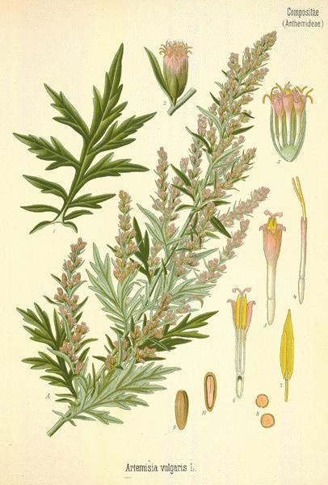

**MUGWORT**

“universal herb for protection and prophecy”

**Names**: Mugwort, Wild Wormwood, St. John’s Plant

**Scientific** **Name**: Artemisia Vulgaris

**Parts** **Used**: whole dried plant (leaves, flowers, root)

**Actions**: bitter, stimulant, nervine, tonic, emmenagogue, diaphoretic, diuretic, hemostatic, antispasmodic, sedative, anti-parasitic

**Uses**: lucid dreaming, epilepsy, fits, palsy, fevers, sealing injured blood vessels, digestive gas/bloating, stimulate and ease menstruation, expel parasites, soothes the nervous system, extends REM sleep, reduce the effects of smoking, liver cleansing, culinary herb

**Constituents**: Volatile oil (thujone, borneol, cineole, pinene), sesquiterpene lactones, flavonoids, coumarins, bitter principle, tannins, over 100 other constituents

**Harvest**: Leaves- August, Roots- Autumn

**Taste**: bitter & aromatic

**Medicinal Preparations**

**Tincture**: Cover four ounces of fresh herb with 1 pint 100 proof alcohol, vodka, gin or brandy. Cover and keep in a dark place, shaking several times per day for two weeks.

**Juice**: fevers

**Infusion**- drunk before divination rituals, induce lucid dreams, deep sleep…stomach pains and stimulates appetite

**Dried** **Leaf**- placed underneath pillow for deeper sleep and more lucid dreaming, can be smoked for spiritual purposes

**Good** **to** **combine** **with**:

Pennyroyal & Southernwood- emmenagogue

**Environment**: Waste ground, roadsides, railroads, fallow agricultural land with a lot of nitrogen still in it, sandy, open ground, prefers lime-rich soils.

**Identification**: *Artemisia vulgaris:* Perennial weed with persistent rhizomes, may reach five feet tall, often reddish-brown in color, and become woody with age. Leaves two to four inches long, one to three inches wide, simple, alternate, deeply lobed, and have a distinctive aroma.   Leaves on the upper portions of the plant are more deeply lobed and may lack petioles.  Leaf undersides are covered with soft, white to gray hairs, while upper leaf surfaces may be smooth to slightly hairy. Flowers are inconspicuous occurring in clusters at the top of the plants.  Individual heads are very small and on short stalks. Mugwort looks similar the garden chrysanthemum as well as ragweed seedlings, which lack the distinctive aroma typical of Mugwort.

**Magical** **Uses**: Linked to the moon, believed to ward off fatigue, sunstroke, wild beasts and evil spirits, leaves rubbed on the body before sleep would prevent dreaming about the dead, protection for travelers, invocation of dreams

Was used in brewing beer before hops were used

**Contra**-**indications**: pregnancy

**Sources**:

<https://thenaturopathicherbalist.com/2015/09/13/artemisia-vulgaris/>

http://www.botanical.com/botanical/mgmh/m/mugwor61.html

<http://happyherbcompany.com/mugwort>

<http://www.eattheweeds.com/mugwort/>