**MONOGRAPH**

**By: Michelle Jones**

**Common Name: Mullein**

**Botanical Name: Verbascum thapsus**

**Also known as:** bunny's ear, flannel leaf,

candlewick plant, hag taper, Aaron’s rod, Adam’s flannel, beggar’s blanket and flannel, beggar’s stalk, big taper, blanket herb and leaf, bullock’s lungwort, clot, clown’s lungwort, cow’s lungwort, cuddy’s lungs, devil’s tobacco, duffle feltwort, fluff weed, graveyard candles, great mullein, Jacob’s staff, Our lady’s flannel, Quaker rouge, velvet dock, wild ice leaf, wooly mullein.

**Family:** Scrophulariaceae (Figwort Family)

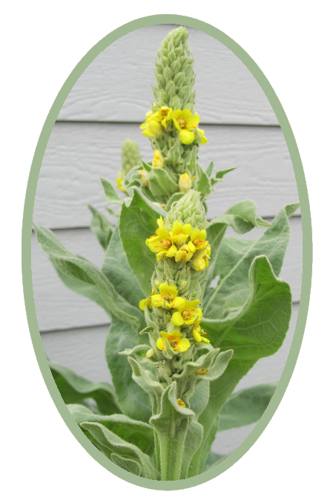

**Parts used:** Leaves, flowers, roots and seeds

Tinctures, Decoction, Infused Oil

**Uses:**

**Respiratory –** Mullein is used to treat cough, whooping cough, tuberculosis, bronchitis, hoarseness, pneumonia, earaches, colds, chills, flu, swine flu, fever, allergies, tonsillitis, sore throat and asthma.

**Expectorant-** Mullein helps to clear the lungs of mucous. Mullein has demulcent properties.

It relieves mucous membranes that are inflamed by forming a soothing film over them. It is traditionally used to clear the lungs of congestions and treat coughs.

**Analgesic –** Mullein flower infused oil is useful for treating ear infection in combination with garlic. The mullein flowers treat the pain and the garlic kills the infection. It is also used as a mild sedative.  
**Emollient -** Mullein has emollient properties, which soften and protect skin. It has been used traditionally to treat burns and bruises. Mullein is applied to the [skin](http://www.webmd.com/skin-problems-and-treatments/picture-of-the-skin) for wounds, burns, [hemorrhoids](http://www.webmd.com/vitamins-supplements/ingredientmono-572-mullein.aspx?activeingredientid=572&activeingredientname=mullein), [bruises](http://www.webmd.com/vitamins-supplements/ingredientmono-572-mullein.aspx?activeingredientid=572&activeingredientname=mullein), [frostbite](http://www.webmd.com/a-to-z-guides/frostbite), and skin infections ([cellulitis](http://www.webmd.com/skin-problems-and-treatments/guide/cellulitis)). The leaves are used topically to soften and protect the skin.

**Astringent** – Mullein’s combination of demulcent and astringent properties makes it a valuable treatment for diarrhea.

**Bone Alignment:** Mullein can be used to facilitate proper bone and spinal alignment. According to Matthew Wood, “It has a moistening, lubricating effect on the synovial membranes… so that it is hydrating to the spine and joints. It is often indicated in back injuries. People think they are untreatable and incurable, but an increase the synovial fluids will make the spine more pliable and comfortable. The vertebra will slip back into place more readily, pain and inflammation will decrease and the condition will get better."  
**Lymphatic:** Mullein is also an excellent remedy for the lymphatic system. It can be applied as a compress to any instance of glandular swelling. The use of Mullein flower tincture to relieve swellings is also due to its lymphatic actions, and among the various parts that can be used, it offers the most pain relieving qualities.

**Diuretic –** Mullein has been used as a diuretic to increase urine output.  
**Bitter –** Mullein leaf is bitter and assists in food digestion and absorption of nutrients. Mullein also helps to treat gastrointestinal bleeding.

**Other –** It can be used to treat ear mites in animals. A tincture of Mullein, 8-10 drops repeated frequently, has proved beneficial for migraine or sick headache of long standing.

Gargling the decoction is used to treat toothache. Other uses include [colic](http://www.webmd.com/parenting/baby/understanding-colic-basics), gastrointestinal bleeding, [joint pain](http://www.webmd.com/pain-management/guide/joint-pain), and [gout](http://www.webmd.com/vitamins-supplements/ingredientmono-572-mullein.aspx?activeingredientid=572&activeingredientname=mullein).

**Actions:** Astringent, bitter, anti-inflammatory, antimicrobial, expectorant, respiratory, diuretic and analgesic.

* **Leaf**: expectorant, anti-tussive, demulcent, antispasmodic, astringent, vulnerary, counter-irritant (topical), lymphatic
* **Flower**: demulcent, expectorant, anti-tussive, antispasmodic, astringent, antimicrobial, diuretic, diaphoretic, anodyne
* **Root**: anodyne, antispasmodic, sedative, styptic, vulnerary
* **Seed**: nervine, nephrotonic (kidney trophorestorative)

**Constituents:**

The leaves are nearly odorless and have a mucilaginous and bitter taste. They contain gum as their principal constituent, together with 1 to 2 per cent of resin, divisible into two parts, one soluble in ether, the other not; a readily soluble amaroid; a little tannin and a trace of volatile oil.

The flowers contain gum, resin, a yellow coloring principle, a green fatty matter (a sort of chlorophyll), a glucoside, an acrid, fatty matter; free acid and phosphoric acid; uncrystallizable sugar; some mineral salts, the bases of which are potassia and lime, and a small amount of yellowish volatile oil. They should yield not more than 6 per cent of ash. Their odour is peculiar and agreeable: their taste mucilaginous.

**Tincture:** Leaves and flowers.

1:2 Tincture: 40 drops - 5x’s per day.

**Capsules:** Leaf

Dried Powder: 500 mg 1-3x per day.

* **Decoction: 6:1 -** 6 parts leaves and flowers to one cup of water. Strain through cheesecloth to separate the tiny hairs on the leaves that are irritating.

**Harvest:** Mullein leaves are best harvested in the summer of the second year as the plant is growing its stalk. Bundle and hang the leaves upside down to dry. Harvest the buds and flowers when in bloom (Usually between July and September) and use them fresh or dried.

**Taste:** Bitter (leaf) and sweet (flower).

**Energetics:** Leaf: mildly cooling. Flower: neutral to mildly warming.

**Psychology:**  Good for people with the need for alignment. Useful for someone who is scattered all over the place, and needs to focus and direct their energies.

**Combines:** plantain, lobelia, wild lettuce, solomon’s seal, goldenseal, horsetail.

**Contra-indications:** None have been identified.

**Where it grows:**  Great Mullein, is a widely distributed plant, being found all over Europe and in temperate Asia as far as the Himalayas, and in North America is exceedingly abundant as a naturalized weed in the Eastern States. It is found throughout Britain (except in the extreme north of Scotland) and also in Ireland and the Channel Islands, on hedge-banks, by roadsides and on waste ground, more especially on gravel, sand or chalk. It flowers during July and August.

**Folklore:**

A couple of folk names for mullein have more intriguing associations. “Candlewick plant” refers to the old practice of using the dried down of mullein leaves and stems to make lamp wicks. Folklore reports that mullein stems once were dipped in tallow to make torches either used by witches or used to repel them, hence the name “hag taper.” The custom of using mullein for torches dates back at least to Roman times.

**Citations:**

<http://www.botanical.com/botanical/mgmh/m/mulgre63.html>

<http://www.motherearthliving.com/plant-profile/herb-to-know-mullein-verbascum-thapsus.aspx?PageId=2#ArticleContent>

<http://www.herbcraft.org/mullein.html>

<http://www.thebrothersmedia.net/living-well/2015/03/mullein-effects.html>

http://herbsandowls.com/mullein-medicinal-uses-preparations/