**Plantain, *Plantago major***

**Name**

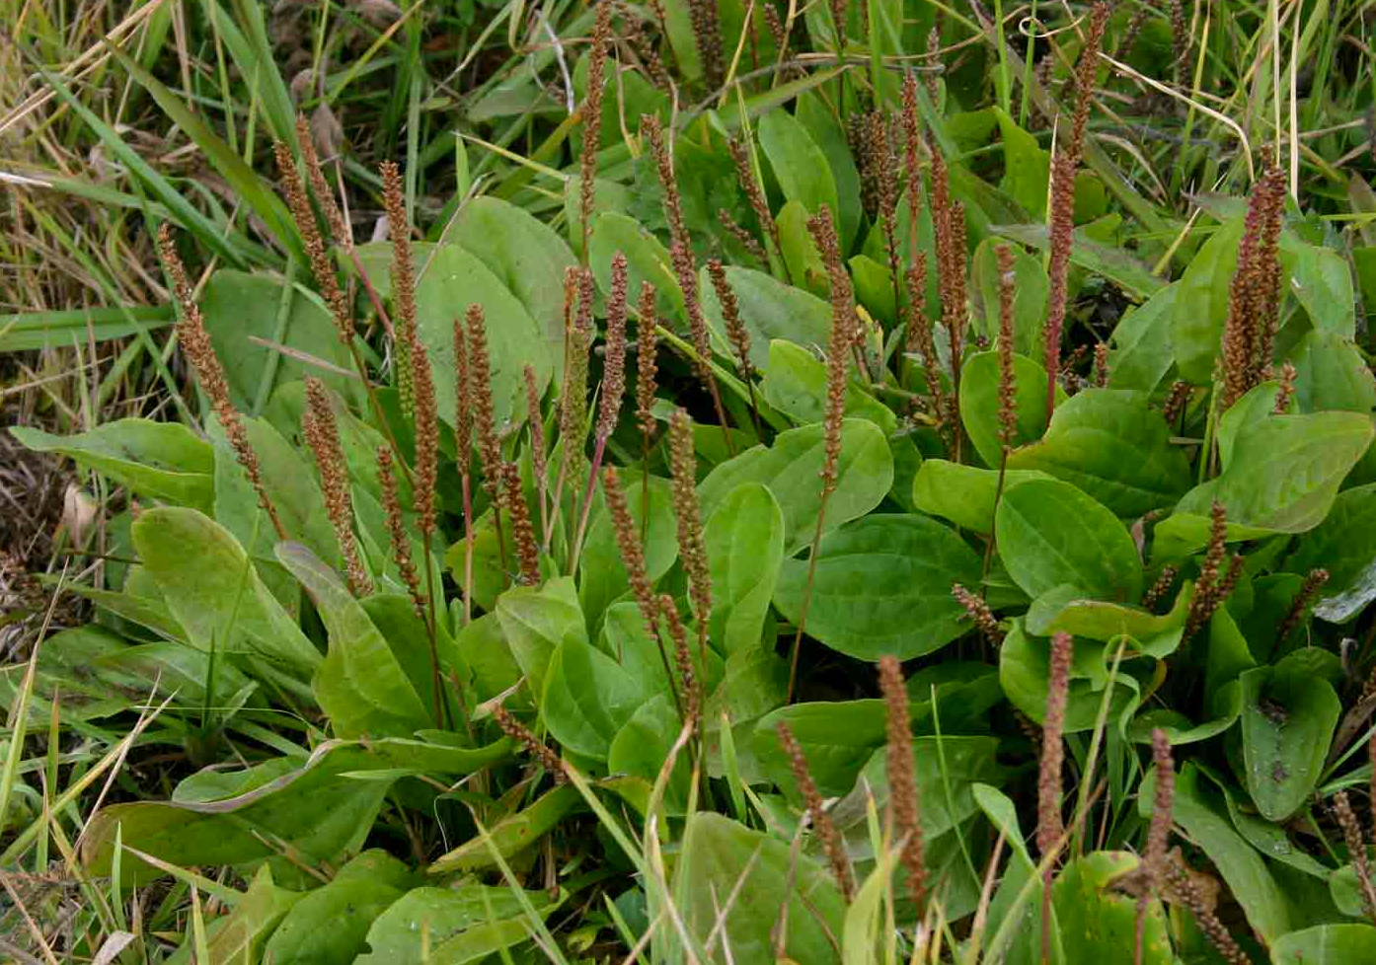Broadleaf plantain, Common Plantain, Cuckoo's Bread, Englishman's Foot Greater Plantain, Iron leaf1, Plantago major, Plaster leaf1, Rat-tail plantain, Ripple Grass, Slanlus, Snakeweed, Waybread, Waybroad, White Man's foot

**Description**

Often considered a weed in North America, plantain is a 2 to 12-inch high plant with parallel veined leaves of an ovate-elliptical shape.1 Arranged in a circular pattern, the leaves are 5 to 7 inches long.

The roots are thick, extensive, and fibrous. “Flowers are borne in spikes on one to many leafless stalks. These Flowers “are numerous, small, 2 to 4 mm in diameter, and green- white.”2

Initially native to Europe as well as northern and central Asia, this perennial plant is now found throughout the world. Plantain can grow in sun, shade, and most soil conditions—indeed, it is often found in marginal areas with disturbed soil. Several of the plant’s nicknames allude to its proliferation. Spread by the travels of colonists to North America, Native Americans there called it Englishman’s Foot or Whiteman’s foot. Other names such as “plaster leaf”, “slanlus” (plant of healing), and “snakeweed” (snakebite treatment) attest to plantain’s medicinal uses.

**Parts Used:** Roots, leaves, flower spikes3

**Uses:**

Note: Approved by the German Commission E (FDA Equivalent) for internal use

**Skin conditions**

* Used for a wide range of skin conditions including stings (bee, wasp, nettle), bruises, burns, poison ivy, wound healing, and as a hemostatic. May also be used as a skin softener.

*Leaves (crushed or poultice) or ointment*

* At the most basic level, for skin conditions including bee stings, crush leaves and apply.
* May be used3 to 4 times a day.

*Infusion from leaves*

* Use as a wash for skin issues including “sunburn, windburn, rashes, or wounds”5

*Herbally infused oil5*

* Also used for skin softening, soothing, and healing.

**Throat inflammation, cough, upper respiratory issues**

* May use as a tincture or a tea from the leaves

**Documented/published traditional uses throughout the world4**

*Respiratory organs*

Antitussive, asthma, bronchitis, colds, ear ache, expectorant, pulmonary diseases, throat inflammation

*Digestive organs*

Cholera, constipation, diarrhea, dysentery, gastritis and colitis, gum inflammation, oral wounds, stomachache, stomach cramps, stomatitis, ulcer

*Urogenital system*

Abortifacient, contraceptive, inhibit menstrual period, kidney stones, menstrual disorders, pregnancy and childbirth renal bladder ailments, urinary tract infections, uterine problems, vaginitis

*Heart and circulation*

Astringent effect, blood rectifier, diabetes, diuretic, edema, hemorrhoids, hypertension

*Sense organs*

Eye infections, eye problems

*Nerve system*

Analgesic, antipyretic (fever reducing), hypnotic, nervous shock, physical weakness, stimulant, toothache

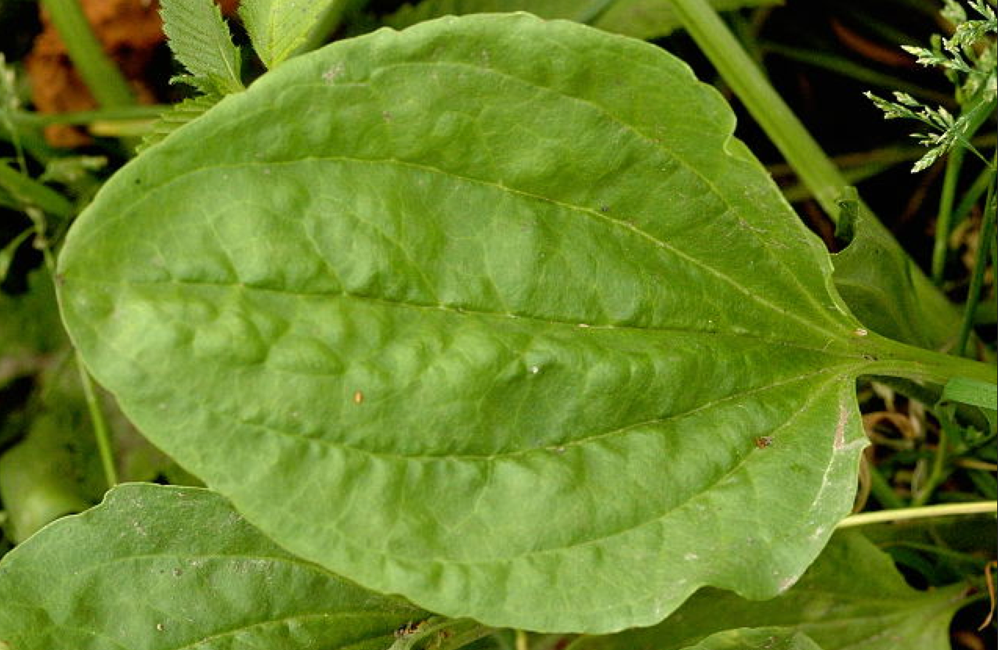

*Antineoplastic*

Tumors

*Parasitic infections*

Anthelmintic, antimalarial, parasites

*Skeleton*

For bone fractures

*Antidote*

Snake poison

**Actions**: anti-inflammatory (demulcent), analgesic, antitussive (suppresses coughing), antioxidant, diuretic, cooling, emollient (soothes skin)

**Constituents**:4 Caffeic acid, fatty acids, glycosides, Vitamins A, C, K (shoots), beta-carotene, calcium, carotenoids, flavonoids, polysaccharides.

**Harvest**: “Anytime from early spring until frost.”5 Be cautious not to pick from polluted areas.

**Taste**: Bland, mucilaginous.

**Contra-indications:** Contraindicated for pregnancy, lactation, and those with intestinal obstruction.6

**Interesting Notes**:

* From Romeo and Juliet, Act I, Scene II from the period 1592– 1609:4
  + Romeo: Your plantain leaf is excellent for that.
  + Benvoleo: For what, I pray thee?
  + Romeo: For your broken shin.
* Traditionally used by the Vikings and Greeks for wound healing.
* In a 1980 letter published in the New England Journal of Medicine, a doctor wrote:
  + “A group of 10 people – all sensitive to poison ivy – were treated with plantain last summer. The cessation of itching in all cases was rapid. The treatment was repeated up to four times in some cases, but the itching stopped in all cases, and the dermatitis did not spread to other parts of the body.”

1 Nature Gate – Plantago Major, <http://www.luontoportti.com/suomi/en/kukkakasvit/greater-plantain>

2 common plantain, Plantago major. Alaska Natural Heritage Program. University of Alaska, Anchorage.

http://aknhp.uaa.alaska.edu/wp-content/uploads/2013/01/Plantago_major_BIO_PLMA2.pdf

3 Plantain, Common, http://www.botanical.com/botanical/mgmh/p/placom43.html

4 Samuelsen, Anne Berit. "The traditional uses, chemical constituents and biological activities of Plantago major L. A review." Journal of ethnopharmacology 71.1 (2000): 1-21.

5 Plaintain, <http://www.prairielandherbs.com/plantain.htm>

6 Plantago major. http://medicinalplants.us/plantago-major#Contraindications

7 Duckett, Serge. "Plantain leaf for poison ivy." *The New England journal of medicine* 303.10 (1980): 583.

**Images**

Page 1: http://www.uniprot.org/taxonomy/29818

Page 2: https://exploringhealth.wordpress.com/2008/09/04/herbal-tutor-plantain/