**Rosemary**

“dew of the sea”

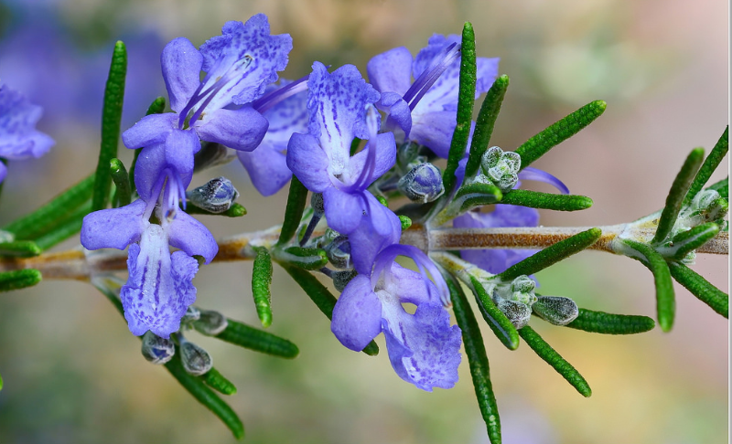

**Scientific** **Name**: Rosmarinus officinalis

**Parts** **Used**: Leaves (fresh or dry)

**Constituents**: iron, calcium, vitamin B6, antioxidants, essential oils, flavonoids, rosmarinic acid and other phenolic acids

**Actions**: vulnerary, anti-inflammatory, analgesic, nervine, diaphoretic, aromatic, carminative, anticancer, astringent, cholagogue, circulation, diuretic, muscle relaxant, stimulant, stomachic, antiviral, tonic, cordial

**Uses**: enhances memory and concentration, improves digestion, reduces inflammation, prevents brain aging, cancer fighting, protects eyesight, immune enhancing, pain reducing, reduces anxiety, protects against DNA damage, helps with arthritis, hair and skin treatment, headache relief, culinary uses

**Taste**: pungent, astringent, bitter

**Medicinal** **Preparations**

*Oil*- external use for eczema, arthritis, healing of wounds

*Infusion*- for hair treatments, headaches, indigestion, etc

*Essential* *oil*- rub on temples for memory/concentration boost

**Combines** **well** **with**: St. John’s Wort for headaches, Nettle for dandruff

**Botany:** Native to the Mediterranean area, rosemary now grows widely in other parts of the world. It thrives in a warm and sunny climate. The plant takes its name from rosmarinus, a Latin term meaning "sea dew." It is an upright evergreen shrub that can grow to a height of 6 and a half feet. The woody rootstock bears rigid branches with fissured bark. The long, needle-like leaves are dark green on top and pale beneath. Both the fresh and dried leaves are aromatic. The small flowers are pale blue. The leaves and parts of the flowers contain volatile oil.

**Spiritually-** wards off evil spirits, associated with Aphrodite

**Contraindications**- not for pregnant women in high doses

http://www.witchipedia.com/herb:rosemary

http://umm.edu/health/medical/altmed/herb/rosemary

<http://www.anniesremedy.com/herb_detail51.php>

<http://naturalsociety.com/rosemary-benefits-health-growing-own-medicine/>

http://www.medicalnewstoday.com/articles/266370.php