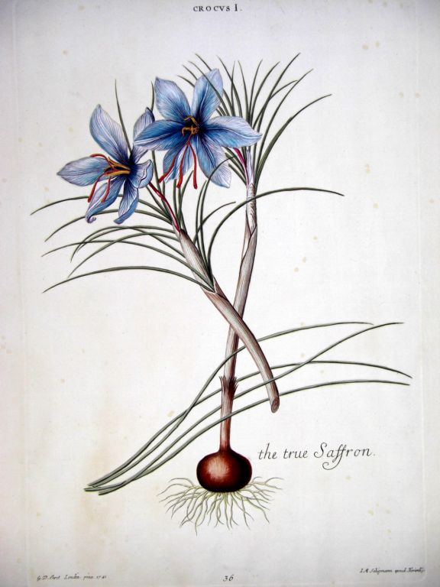

*Saffron*

Monograph by: Christianna Ferri

**Name:** Autumn Crocus, Azafrán, Azafron, Croci Stigma, Crocus Cultivé, Crocus sativus, Indian Saffron, Kashmira, Kesar, Kumkuma, Saffron Crocus, Safran, Safran Cultivé, Safran Espagnol, Safran des Indes, Safran Véritable, Spanish Saffron, True Saffron, Zafran

**Scientific name:** Crocus sativus L.

**Action:** Powerful antioxidant**,** as well as safranal which is another ingredient in Saffron which produces an aroma that improves the availability of serotonin in the nervous system which is how it helps with depression

**Parts used:** Stigma of the flower, flower petals, stamens, leaves

**Uses:** Depression,Alzheimer’s disease, Amnesia, Macular degeneration, Retinitis pigmentosa, weight loss, cancer, menstrual relief

**Native to:** Southwest Asia and some areas of Europe

**Taste:**  It’s hard to pinpoint exactly with Saffron tastes like. Some say it tastes bitter. Some also say it has a faint honey taste, and others say it tastes like the sea.

**Contradictions:** Safety while breastfeeding and during pregnancy have not been investigated.Traditionally, extremely high doses were used to induce an abortion but it is not known if normal doses cause the uterus to contract

**When to harvest:**  The fall

References:

1. <http://www.botanical-online.com/english/saffron.htm>
2. <http://www.naturafoundation.co.uk/monografie/crocus_sativus.html\>
3. <http://gourmet.lovetoknow.com/What_Does_Saffron_Taste_Like>
4. <http://www.herbwisdom.com/herb-saffron.html>