MONOGRAPH

by Michelle Jones

Common Name: Schisandra

Botanical Name: Schisandra chinensis

AKA: Wu Wei Zi (Five Flavored Berry)

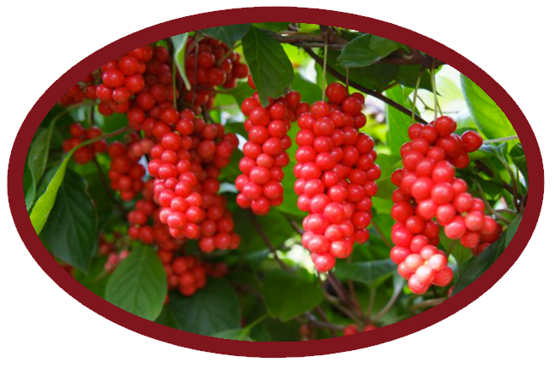

The berry of Schisandra is also called Wu Wei Zi (five flavored berry) because it is sweet, sour, salty, bitter and pungent.

**Parts used:** Berry

Tinctures, Decoctions, Capsules.

**Uses:**

Adaptogen– Schisandra has an effect on the central nervous, sympathetic, endocrine, immune, respiratory, cardiovascular and gastrointestinal systems. It balances the sympathetic and parasympathetic nervous systems. Research has shown that its adaptogenic qualities help the body to fight disease and adapt to stresses from physical, mental, chemical, and environmental sources. Schisandra reduces stress, improves mental health, promotes endurance, coordination and concentration, prevents mental fatigue, and increases accuracy and quality of work. It is used to improve performance in athletes. Its immune strengthening qualities afford a stress-protective effect against a broad spectrum of harmful factors including heat shock, skin burn, cooling, frostbite, immobilization, swimming under load in an atmosphere with decreased air pressure, aseptic inflammation, irradiation, and heavy metal intoxication.

Longevity and vitality **-** Schisandra is an herb and supplement that prevents early aging and increases lifespan.

The berries are rich in antioxidants and they also have an anti-inflammatory effect in the body. Both of these actions help to improve cellular function and promote a longer lifespan. In traditional Chinese medicine the ability of Schisandra to promote longevity and vitality is attributed to its relationship with the three primary life energies of qi, jeng, and shen.

Astringent **-** It tonifies and protects the heart, liver and lungs. Schisandra treats chronic cough and diarrhea.

Alterative **-** Schisandra is a blood purifier known to safely remove toxins from the tissues and blood without any negative side effects.

Cardiac Tonic **-** Schisandra lowers blood pressure, acts as a vasodilator (causing blood vessels to dilate), improves blood circulation, improves heart function, treats palpitations and promotes health of blood vessels.

Respiratory **–** Schisandra stimulates the respiratory system. As a result, it is antitussive and expectorant. It tones the lungs. Schisandra has been shown to stimulate breathing. Schisandra is used to treat stress induced Asthma.

Hepatic – It promotes healing of a damaged liver, protects the liver and treats Hepatitis. Schisandra improves the overall functioning of the liver by stimulating the growth of new hepatocytes (liver cells) and increase glutathione, which is an essential liver antioxidant. It also normalizes blood sugar.

Nervine– Schisandra soothes the nerves and exerts an effect on the central nervous system. It balances the sympathetic and parasympathetic nervous systems. It affects both the excitatory and inhibitory processes of cerebral cortex to bring balance.

Aphrodisiac – It is a sexual tonic. This is likely because it improves blood flow. Schisandra has long been used to treat impotence.

Hormone Regulator – It reduces the levels of stress hormones in the blood and supports proper endocrine function

Oxytocics **–** Schisandra strengthens uterine contractions and has an effect on uterus myotonic (neuromuscular) activity.

Anti-inflammatory **–** It exerts significant protective antioxidant and anti-inflammatory effects on the body.

Stimulant **–**Schisandra stimulates all body systems. It produces stimulation to all levels of the central nervous system.

Hypnotic – It treats disturbed dreams and insomnia

Antidepressant - Schisandra calms the mind, boosts mood, relieves anxiety and treats irritability.

Antispasmodic **–** It has an effect on the nervous system, which affects the muscles.

Antitussive **–** Schisandra treats chronic cough and wheezing.

Cholagogue **–** It increases the flow of bile.

Diuretic **–** Schisandra is administered as a diuretic to detox the kidneys.

Hypotensive- It normalizes blood pressure, by either lowing high levels or raising low levels.

Expectorant **-** Schisandra is an expectorant, promoting the clearing of lung mucus.

Anti-oxidant **–** Schisandra contains antioxidants that can protect against cancer or even kill cancer cells. Research into the anti-cancer properties of Schisandra has so far been limited to a few studies, with promising results.

In one particular study, a substance found in Schisandra, called Schisandran C, was found to stop the growth of cancer cells in laboratory testing.

Bitter **–** It assists in food digestion and absorption of nutrients.

Antimicrobial **-** It inhibits Staphylococcus aureus, Klebsiella pneumoniae, Salmonella enterica, Pseudomonas aeruginosa, and more.

Other **-** Schisandra balances the moisture in the body by either helping it to retain moisture or drying up excess fluids. It is used to treat night sweats. It improves eyesight, including night vision.

**Actions:** Adaptogen, bitter, astringent,alterative, cardiac tonic, hepatic, nervine, aphrodisiac, hormone regulator, oxytocics, anti-inflammatory, stimulant, expectorant, hypnotic, antidepressant, antispasmodic, antitussive, cholagogue, diuretic, hypotensive, anti-oxidant, anti-microbial.

**Constituents:** Schisandra is rich in organic acids, vitamins, flavonoids, phytosterols, and lignans. Its chemical constituents include the [lignans](https://en.wikipedia.org/wiki/Lignan) [schisandrin](https://en.wikipedia.org/wiki/Schisandrin), [deoxyschisandrin](https://en.wikipedia.org/w/index.php?title=Deoxyschisandrin&action=edit&redlink=1), [gomisins](https://en.wikipedia.org/w/index.php?title=Gomisins&action=edit&redlink=1), and [pregomisin](https://en.wikipedia.org/wiki/Pregomisin), which are found in the seeds of the fruit. Other chemical constituents include [schisandrin B](https://en.wikipedia.org/w/index.php?title=Schisandrin_B&action=edit&redlink=1), schisandran C, γ-[terpinene](https://en.wikipedia.org/wiki/Terpinene), [bisabolene](https://en.wikipedia.org/wiki/Bisabolene) (+)-[gomisin K2](https://en.wikipedia.org/w/index.php?title=Gomisin_K2&action=edit&redlink=1), [gomisin S](https://en.wikipedia.org/w/index.php?title=Gomisin_S&action=edit&redlink=1), [pregomisin](https://en.wikipedia.org/wiki/Pregomisin), [schisantherin A](https://en.wikipedia.org/w/index.php?title=Schisantherin_A&action=edit&redlink=1), [schicantherin B](https://en.wikipedia.org/w/index.php?title=Schicantherin_B&action=edit&redlink=1), [angeloylgomisin Q](https://en.wikipedia.org/w/index.php?title=Angeloylgomisin_Q&action=edit&redlink=1), and [rubrildilactione](https://en.wikipedia.org/w/index.php?title=Rubrildilactione&action=edit&redlink=1).

**Tincture:** Dried berries soaked overnight before preparation.

1:4 Tincture: 25-35 drops 3x’s per day.

Dried fruit extract: In a 1:6 w/v ratio against liquid (95% ethanol) and administered at 20-30 drops daily.

**Capsules:**

Dried Powder: 3-9 grams per day.

4:1 Dried Decoction: 1-3 grams per day with meals.

Decoction:Dried fruit extract in a 1:20 w/v ratio against water, 150mL drank twice a day with meals.

**Harvest:** Harvest at the end of July and the beginning of August.

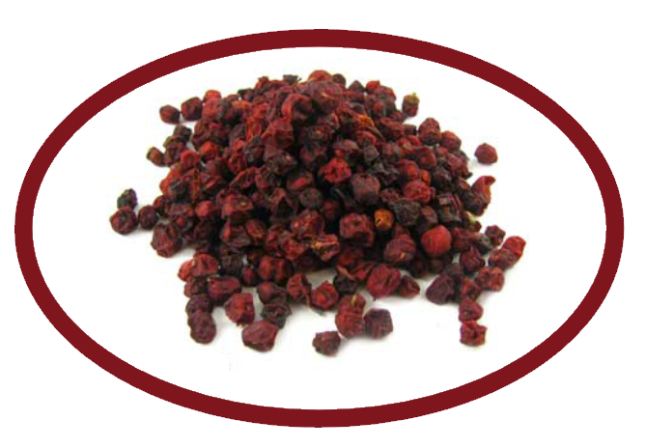

**Taste:** Warming. Sweet, sour, salty, bitter and pungent.

**Psychology:** Flower Essence: Quiet the spirit, calm the heart. Schisandra Flower Essence helps you feel stability through the process of change. It strengthens and encourages when you feel anxious or fearful about growing and revealing your true self. Schisandra teaches moderation to those committed to a path of growth who tend to overextend themselves. This energy may not be as useful for those who are somewhat disembodied.

**Combines:** Milky oat seed, skullcap, ashwagandha root, ginseng root, ophiopogon root, goji berry.

**Constitution:** Is good for all constitutions. Schisandra can be both stimulating and relaxing depending upon a person’s constitution. It is a good adaptogen for people who tend to run on the dry side, since it helps the body retain moisture.

**Pulse:** Fast paced, non resistant?

**Tongue:** Dry, cracked?

**Contra-indications:** Use with caution if pregnant. Do not use if you have Epilepsy or increased intracranial pressure. May increase stomach acidity and potentiate barbiturates.

**Where it grows:** Schisandra is the berry of a climbing vine native to northeast China ([Manchuria](https://en.wikipedia.org/wiki/Manchuria)) and parts of Russia. It is cultivated in long rows.

**Citations:**

Medicine Hunter <http://www.medicinehunter.com/schisandra>

<https://en.wikipedia.org/wiki/Schisandra_chinensis>

<https://www.amazon.com/gp/product/1575666170/ref=ox_sc_act_image_1?ie=UTF8&psc=1&smid=ATVPDKIKX0DER>

[The One Earth Herbal Sourcebook: Everything You Need to Know About Chinese, Western, and Ayurvedic Herbal Treatments](https://www.amazon.com/gp/product/1575666170/ref=ox_sc_act_title_1?ie=UTF8&psc=1&smid=ATVPDKIKX0DER) by Alan Keith

[https://books.google.com/books?id=PWz6ZxInpUoC&pg=PA196&lpg=PA196&dq=how+pulse+reacts+to+Schisandra&source=bl&ots=XZz4Ydknmh&sig=lvu5Bj6GtzvdN7sHzouxm8L_sVk&hl=en&sa=X&ved=0ahUKEwjpuezsq6rMAhVKOj4KHalbAGoQ6AEIRDAH#v=onepage&q=how%20pulse%20reacts%20to%20Schisandra&f=false](https://books.google.com/books?id=PWz6ZxInpUoC&pg=PA196&lpg=PA196&dq=how+pulse+reacts+to+Schisandra&source=bl&ots=XZz4Ydknmh&sig=lvu5Bj6GtzvdN7sHzouxm8L_sVk&hl=en&sa=X&ved=0ahUKEwjpuezsq6rMAhVKOj4KHalbAGoQ6AEIRDAH)

<http://floraofasia.com/schisandra/>

<http://www.deliciousobsessions.com/2013/08/adaptogens-herbs-for-vitality-schisandra-berries/>

<http://modernherbalmedicine.com/articles/adaptogens-to-the-rescue.html>

<http://www.chineseherbshealing.com/schizandra-berry/>

<https://www.healthysmoothiehq.com/schizandra-berry>