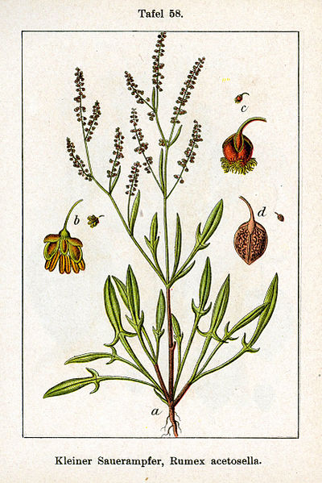

*Sheep sorrel is an herb that many Americans consider to be just a common weed. However, its medicinal uses have been known for quite some time. In fact, it has recently received extra attention for its use in a common cancer tea. Historically, sheep sorrel has been used to treat a variety of issues from inflammation and diarrhea to scurvy and cancer. What’s interesting about this herb is that every single part of the plant can be used medicinally.*

Sheep Sorrel

*Stephanie Ragusa*

**Name:** Rumex Acetosella, Red sorrel, Field sorrel, Field weed, Oseille

**Parts Used:** Aerial parts, roots

**Constituents:** Glycosides, hyperoside, emodin, rhein, oxalates, tannins

Vitamins: A, B Complex, C, D, E, K

**Uses:**  Kidney detoxification, helps reduce fevers, diarrhea, scurvy, ingredient in cancer treatment and prevention formulas

**Actions:** Antiscurbutic, depurative, diaphoretic/sudorific, diuretic, febrifuge, refrigerant, styptic

**Taste**: bitter, sour, lemon-like

**Preparations:**

*Decoction of roots h**elps with jaundice.*

*Decoction of the flowers helps heal and soothe ulcers of the body and bowels and when gargled, heal mouth sores*

*Tincture should be made from fresh leaves*

*Teas/Infusions are traditionally made using dries leaves*

*Juice may be extracted from fresh plants for use in urinary and kidney diseases*

*Poultice made from sheep sorrel is reported to have a drawing effect on tumors or cysts.*

*Topical Wash can be used to treat skin problems such as herpes, eczema and itchy rashes including poison ivy and hives*

**Distribution:** Native to the southwestern Mediterranean region, including southwestern and Atlantic Europe, common in North America

**Combines:** Sheep sorrel is famously combined with turkey rhubarb, burdock root and slippery elm bark to create Essiac formula - a controversial cancer treatment

**Constitution:** Sorrel is prevalent in all hot diseases, cools any inflammation and heat of blood in choleric, or sickness and fainting, arising from heat, and to refresh the overspent spirits

**Harvest**: Leaves and stems in spring and summer, roots in fall

**Contraindication**: Not for long term use. Should be avoided by those with arthritis, gout or kidney stones because it contains oxalic acid.