**Shepherd’s Purse**

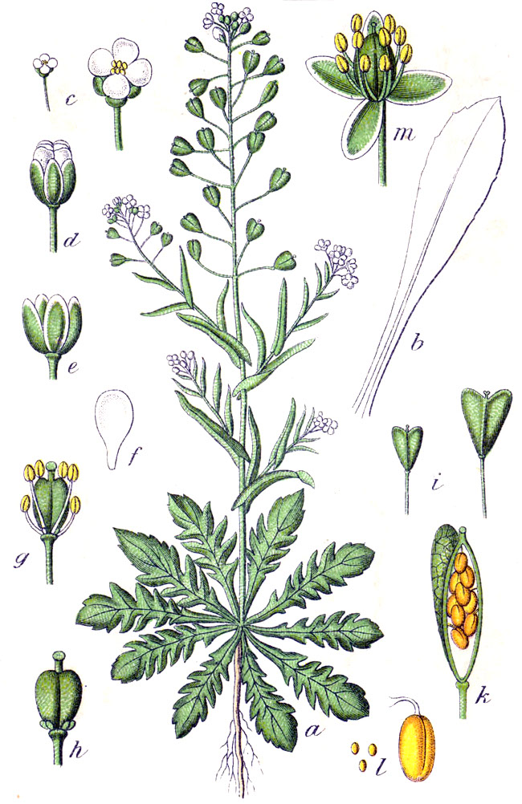

**Name:** Shepherd’s Purse, *Capsella bursa-pastoris.* Also referred to as Shepherd's Bag, Shepherd's Scrip, Shepherd's Sprout, Lady's Purse, Witches' Pouches, Rattle Pouches, Pickpurse, Casewort, Case-weed, Pick-Pocket, Pick-Purse, Blindweed, Pepper-and-Salt, Poor Man's Parmacettie, Sanguinary, Mother's Heart, Clappedepouch (*Irish*), Bourse de pasteur (*French*) and Hirtentasche (*German*).

Family: Brassicaceae

**Parts Used:** Whole plant - The whole plant is used, can be dried and usually used as an infusion, tincture, tea and even juice.

**Native To:** A native of Europe and thought to be found where Europeans settled. Found globally in areas such as North America, Europe, North Africa and some parts of Asia (such as China).

**Uses:** Medicinal, food source and ceremonial.

* Stops hemorrhaging (tyramine and other amines in plant are thought to provide this action) - internal and external bleeding. “A tea made from the dried herb is considered to be a sovereign remedy against of all kinds hemorrhages– the stomach, the lungs, the uterus and more especially the kidneys.”
* The plant is thought to contain a protein that is similar to oxytocin in that it can produce uterine contractions - helpful during childbirth but also post-birth to help reduce bleeding and return uterus to its original size.
* May help hemorrhoids.
* Bladder prolapse. May be helpful with bladder infections.
* Can resolve blood in urine.
* “A vasodilator, and also hastens coagulation and constrict[s] blood vessels.”
* Can be applied to skin to stop nosebleeds, cuts and superficial burns.
* Can help with fluid loss and aid in conditions resulting in diarrhea.
* Premenstrual problems, long periods, and menstrual [cramps](http://www.webmd.com/pain-management/muscle-spasms-cramps-charley-horse). Can be used to aid with heavy menstrual periods, especially those influenced by fibroids and endometriosis.
* “Circulatory problems including mild [heart failure](http://www.webmd.com/heart-disease/heart-failure/default.htm), [low blood pressure](http://www.webmd.com/heart/understanding-low-blood-pressure-basics), and nervous [heart](http://www.webmd.com/heart-disease/rm-quiz-know-heart) complaints.”
* Ceremonially used in some native american birth practices. Fresh or dried shepherd’s purse is placed in bath water for births.
* “Remedy for cancer – it contains fumaric acid which has markedly reduced growth and viability of Ehrlich tumor in mice.”
* “The seed, when placed in water, attracts mosquitoes. It has a gummy substance that binds the insect's mouth to the seed. The seed also releases a substance toxic to the larvae. ½ kilo of seed is said to be able to kill 10 million larvae.”

**Actions:** [Anti-cancer](http://www.anniesremedy.com/chart.php?prop_ID=107), a[ntiscorbutic](http://www.anniesremedy.com/chart.php?prop_ID=61), a[stringent](http://www.anniesremedy.com/chart.php?prop_ID=11), d[iuretic](http://www.anniesremedy.com/chart.php?prop_ID=20), e[mmenagogue](http://www.anniesremedy.com/chart.php?prop_ID=21), f[ebrifuge](http://www.anniesremedy.com/chart.php?prop_ID=23), haemostatic, h[ypotensive](http://www.anniesremedy.com/chart.php?prop_ID=29), oxytocic, refrigerant, stimulant, s[typtic](http://www.anniesremedy.com/chart.php?prop_ID=65), vasoconstrictor, vasodilator and vulnerary.

“Anti-inflammatory, diuretic and contractile effects on smooth muscle.”

**Constituents:** Choline, acetylcholine and tyramine, saponins, mustard oil, flavonoids. Bursinic acid (so named by French chemist Bombelon). Bursinic acid is an organic acid. Bombelon also noted an alkaloid and tannate resembling sulphocyansinapine. “A peculiar sulphuretted volatile oil, closely similar to, if not identical with oil of mustard, as well as a fixed oil, have been determined and 6 per cent of a soft resin.”

Leaves are rich in vitamins A, B and C. Leaves taste best if harvested before plant flowers.

Seed pods can be used as seasoning (peppery taste).

**Tincture and Capsules (Dosage):** “Decoction, 2 fluid ounces 3 times daily between meals. Fluid extract, 1 teaspoonful (1/8 of decoction). Infusion, 1 cupful. Powder, 1-4 grams. Tincture, ½ -1 fluid teaspoon (30-60 drops).”

“Control bleeding after completing a miscarriage, should be 10-20 drops of the tincture, and 20-40 drops for postpartum hemorrhage.”1

“For bleeding take half a teaspoon of [tincture] 3 times per day until the bleeding stops and then discontinue.” 2

“For prolapse, 5 drops [of tincture] 3 times per day in a little water. Continue taking for a few days after everything has moved back into place.” 2

**Harvest:** Best if harvested in summer for tincture. Can be harvested all year round.

**Taste:** Seeds taste peppery. In Japan shepherd’s purse is used to flavor rice. 2

**Flower Essence:** My research uncovered 2 very different flower essence descriptions for shepherd’s purse:

“Personal power - shepherd's purse is for the person who gives too much of themselves, especially their creative talents, to other people or to causes. Shepherd's purse teaches these souls to conserve the energy necessary for their soul journey. Maintaining a healthier expenditure of energy makes room for new creative talents to emerge that are of true benefit to the community.”

“Fertility, supporting feminine cycles. Shepherd’s purse flower essence is related to the soul quality of fertility and feminine energy. It is useful for soothing the fear and negative emotions associated with various phases of the menstrual cycle.”

**Combines:** Hawthorn and lime blossom (for high blood pressure). 5 parts hawthorn, 3 parts lime blossom and 2 parts shepherd’s purse. 2

Blue cohosh and capsella (postpartum bleeding).

**Pulses:** “To check bleeding, shepherd’s Purse tincture works best in a pulse dosing pattern. That means you take it frequently in smaller doses. I usually recommend 1 dropperful (1mL or 30 drops of the tincture) every 10 minutes until bleeding slows or stops (usually within an hour). Then you can do it every hour or two to maintain the results if you still require it. For uterine bleeding from fibroids or a heavy period you may start with this pulse dosing pattern for an hour and then take 1 dropperful 4 times a day for the rest of your period.”3

**Contra-indications:**

Kidney Stones - “Shepherd's purse contains chemical compounds called oxalates, which can form [kidney](http://www.webmd.com/urinary-incontinence-oab/picture-of-the-kidneys) stones (nephrolithiasis).. If you have had [kidney stones](http://www.webmd.com/kidney-stones/ss/slideshow-kidney-stones-overview) in the past, it’s best to avoid using shepherd's purse.”

[Thyroid](http://www.webmd.com/women/ss/slideshow-thyroid-symptoms-and-solutions) Conditions - “Shepherd's purse might interfere with treatment for [thyroid](http://www.webmd.com/women/rm-quiz-thyroid-problem) conditions.”

Surgery - “Shepherd's purse can affect the central [nervous system](http://www.webmd.com/brain/default.htm). There is a concern that it might slow down the central nervous system’s activity too much when combined with anesthesia and other [medications](http://www.webmd.com/drugs/index-drugs.aspx) used during and after surgery. Stop using shepherd's purse at least 2 weeks before a scheduled surgery.”

1 http://www.herballegacy.com/Ray_Dosages.html

2 Bruton-Seal, Julie and Seal, Matthew. Backyard Medicine: Harvest and Make Your Own Herbal Remedies. New York, New York. 2009.

3 https://theradiclereview.com/tag/shepherds-purse-tincture/