**Slippery Elm**

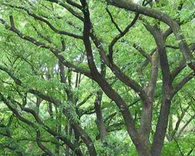**Name**

Slippery elm, Ulmus Rubra, Ulmus Rubra Muhl, Ulmus fulva (obsolete) 1,red elm, gray elm, soft elm, moose elm, Indian elm

**Description**

Known for its “slippery” inner bark, this is a medium-sized tree that grows in eastern North America. May reach 200 years of age and 40 meters (132 feet in height). Grows in a wide range of climates and conditions. 2

Slippery elm leaves are asymmetrical, “usually broadest below or near the middle, tapering abruptly into a long narrow point. The base of the leaf is rounded and strongly uneven, with a double row of coarse teeth along the margin. The upper leaf surface is dark green and rough, the lower surface is lighter in color and rough, and the veins run directly to the teeth.”3

**Parts Used:** “Slippery” Inner Bark

**Uses:**

Soothes and protects irritated mucous membranes

* Decoction/Tea
  + Stomach and intestinal ulcers, colitis, diarrhea, laryngitis, reflux
* Powdered bark for
  + In a drink, including cold water
  + Poultices (external application)
    - Wounds, burns, boils, psoriasis, and other skin conditions
* Lozenges for sore throats

Known Native American usage1

* For infected and swollen glands, in combination with other plants. Eye wash for sore eyes. (Iroquois Indians)
* Poultice to heal sores on the body. (Menomini and Meskwaki)
* Tea to ease childbirth. !See warning at bottom!. (Meskwaki women)
* Treat sore threats. (Ojibwe, also known as Chippewa)
* Decoction as a laxative. (Dakota, Omaha-Ponca, and other tribes)

Animal usage

* British Columbia, for ruminants experiencing diarrhea or blood in stool.4

**Actions**: Demulcent (anti-inflammatory), anti-tumor5, anti-oxidant5, antitussive (suppresses coughing), digestive tonic, diuretic, emollient (soothes skin), laxative (purgative, aperient)

**Constituents**:6

**Mucilage**

* Uronic acid (36%): pentose, hexose)
* Methylpentose (25%): (rhamnose, galactose)

**Other**

* Tannins (<= 3%), Oxalate acid, Flavanoids, Phytosterols, Salicyclic Acid, Capric Acid, Caprylic acid, Decanoic acid

**Tincture**: Extremely water-soluble. Not often used as a tincture.

**Capsules**: Usually used as a decoction or as powder in water.

**Harvest**: Takes 10+ years to reach harvestable age. Spring or fall seasons from large branches or the trunk. Removing only segments of the bark allows the tree to sustain itself. However, there is an issue of “poaching” where the bark is fully stripped and the tree is left to die.7

Note: Due to disease and over-harvesting, slippery elm is currently considered “at-risk.” A substitute is marshmallow root.

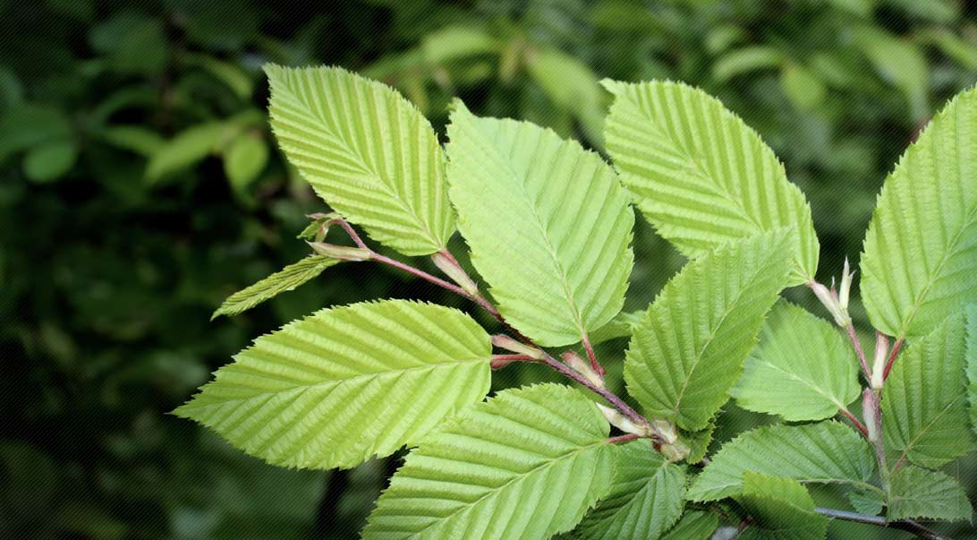

**Taste**: Neutral, pleasant.

Psychology:

Flower essence:

Combines:

Constitution:

Pulse:

Tongue:

**Contra-indications:** Slippery elm is contraindicated for pregnant women.8,9

**Interesting Notes**:

* “Field surgeons of the American Revolutionary Army used a poultice of the inner bark as a primary treatment for gunshot wounds.”10
* In 1987, the Northern Journal of Applied Forestry noted that deer were stripping the bark from trees—endangering the trees. This bark stripping was restricted to slippery elms. Scientists did not know the cause but it is associated with an overpopulation of deer. (Could the deer be using it to soothe the digestive tract—or other issues.)11

1 USDA National Resources Conservation Service. http://www.plants.usda.gov/plantguide/pdf/cs_ulru.pdf

2 <https://www.na.fs.fed.us/pubs/silvics_manual/volume_2/ulmus/rubra.htm>

3 <https://www.extension.iastate.edu/forestry/iowa_trees/trees/slippery_elm.html>

4 Lanes, C., Turner, N., Brauer, G., Lourenco, G., & Georges, K. (2006). Ethnoveterinary medicines used for ruminants in British Columbia, Canada. Journal

5 Leonard, S. S., Keil, D., Mehlman, T., Proper, S., Shi, X., & Harris, G. K. (2006). Essiac tea: Scavenging of reactive oxygen species and effects on DNA damage. Journal of Ethnopharmacology, 103(2), 288–296. http://doi.org/10.1016/j.jep.2005.09.013

>6 Watts, C. R. (2012). Slippery elm, its biochemistry, and use as a complementary and alternative treatment for laryngeal Irritation. *Journal of Investigational Biochemistry*, *1*(1), 17-23.

7 Thieves Swipe Tree Bark for Thriving Herbal Market. New York Times, August 13, 2006. http://www.nytimes.com/2006/08/13/us/13herbal.html

8 Brown, A. C., Hairfield, M., Richards, D. G., McMillin, D. L., Mein, E. a, & Nelson, C. D. (2004). Medical nutrition therapy as a potential complementary treatment for psoriasis--five case reports. Alternative Medicine Review : A Journal of Clinical Therapeutic, 9(3), 297–307. Retrieved from <http://www.altmedrev.com/publications/9/3/297.pdf>

9 Ehrlich, S. D. (2014). Slippery elm. Retrieved May 15, 2016, from http://umm.edu/health/medical/altmed/herb/slippery-elm

10 Slippery Elm monograph. Steven Foster. http://www.stevenfoster.com/education/monograph/Ulmus_rubra.html

11 Bark Stripping by White-Tailed Deer in West Virginia. http://www.ingentaconnect.com/content/saf/njaf/1987/00000004/00000002/art00015

**Images**

top picture: <http://www.slipperyelmbarktea.com/images/portfolio/img1.jpg>

leaves: http://www.herbco.com/c-242-slippery-elm-bark.aspx