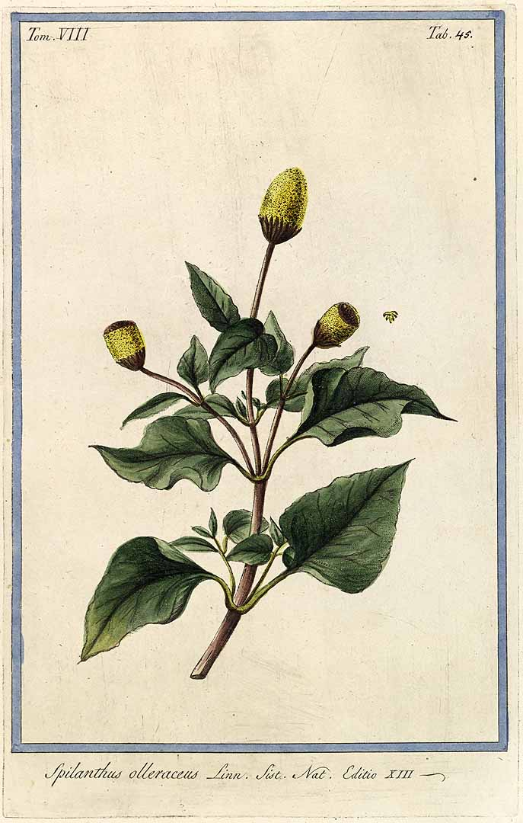

*Top of Form*

*Spilanthes Acmella*

Monograph by: Christianna Ferri

**Name**: Acmella oleracea, toothache plant, peak-a-boo plant, spot plant, prickelblume, alphabet plant, jambu, Australian cress, Brazil cress

**Parts used:** root, stem, leaf, flower (strongest part of the plant)

**Properties:** numbing when the leaves and flowers are chewed (when chewed helps with the relief of tooth ache)

**Uses:** alleviate pain of toothache, helps with nausea, helps with gum and dental issues. Flowers and leaves are similar to Echinacea and non toxic. Helps to enhance the immune system and improve digestion. Also, due to its muscle relaxing effects, an extract of the plant has been used in some high end facial creams because of its natural “Botox” effect

**Taste:** Flower bud has a grassy taste followed by a strong tingling or numbing sensation followed by a cooling sensation in the throat

**Native to:** Brazil and Africa. It is a perennial in warmer climates but may be grown as an annual in temperate regions

**When to harvest:** leaf and buds may be harvested on an ongoing basis. Commercial harvest or for a good stock of tincture for the winter, it is best to harvest at the end of the summer

**Tincture:** 30-40 drops three to five times a day

**Contradictions:** None noted, but is listed as a purgative so a large amount could cause vomiting

**References:**

1. <http://www.anniesremedy.com/herb_detail512.php>
2. <http://www.seedaholic.com/spilanthes-acmella-toothache-plant.html>
3. <https://en.wikipedia.org/wiki/Acmella_oleracea>
4. [www.doc-development-durable.org/file/culture-plantes-ailmentaires/fiches_plantes/cresson-de-para/spilanthes%20acmella.pdf](http://www.doc-development-durable.org/file/culture-plantes-ailmentaires/fiches_plantes/cresson-de-para/spilanthes%20acmella.pdf)