**Yellow Dock, *Rumex crispus***

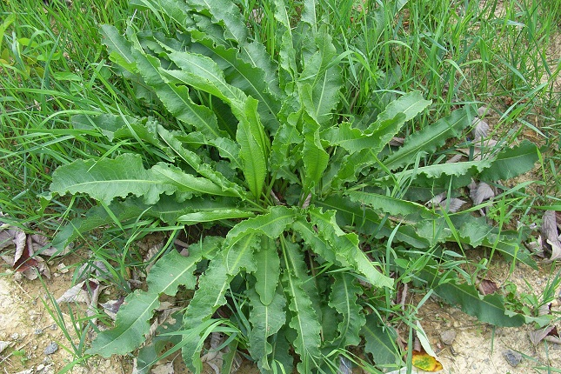**Name**

curled dock, curly dock, garden patience1, K^tlahtesus’ (pronounced “LadaySoSay”) 1, narrow dock1, sour dock1

**Description**

Yellow dock is a perennial that prefers damp locations including “disturbed soil, waste areas, roadsides, fields/meadows, shorelines, and forest edges.”2 Known for its long smooth leaves with “waved” edges, this plant is notable for its yellow roots, including a large taproot.

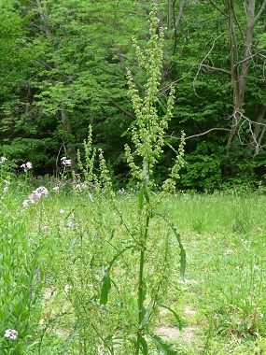

When blossoming, the flower stalk may reach nearly 1m high2 and is distinct for small flowers and triangular seeds growing in clusters. The flowers are actually colored sepals – not real flower petals.1

Yellow dock plant may be found throughout North and South America. Brought to the Americas from Europe, it may still be found there as well as Northern Africa and India.

Yellow dock is also known as a snakebite remedy—making it a particularly power medicinal plant.

**Parts Used:** Primarily roots, also leaves and seeds

**Uses:**

Yellow dock is particularly good for problems involving the liver and most often used as part of an herbal formula.

***Gastrointestinal***

* Constipation, diarrhea, and hemorrhoids.
  + Tincture, capsules, or decoction of the root. 3
  + For constipation, a decoction using fresh leaves is still used as one of the primary treatments in the Nkonkobe Municipality of South Africa (population approx. 130k).5
  + The seeds may be used for diarrhea 3 and dysentery.7

***Liver***

* Tonic that helps cleanse the liver and stimulate bile production.

***Lungs***

* Bleeding of the lungs3
* Cough
  + Before the plant flowers, a homeopathic tincture may be made to help a “irritable tickling cough of the upper air-tubes and the throat.”7

***Source of Iron, Vitamin A and Vitamin C***

* In early spring and autumn, the leaves may be eaten as a source of iron, vitamin A, and vitamin C.3 Use sparingly because of high oxalate content.

***Skin***

* Several forms of the root in may be may be used on “sores, ulcers, wounds and various other skin problems.” 3
  + These forms include: poultice, salve, or dried powder3

**Women’s Health**

* As part of a formula, yellow dock can “regulate menstrual blood when there is a tendency toward early flooding or slow, heavy and delayed menstruation.” 9

***Cancer***

* Published lab studies in 2012 showed yellow dock root to contain potent anti-oxidant and anti-cancer properties. 6 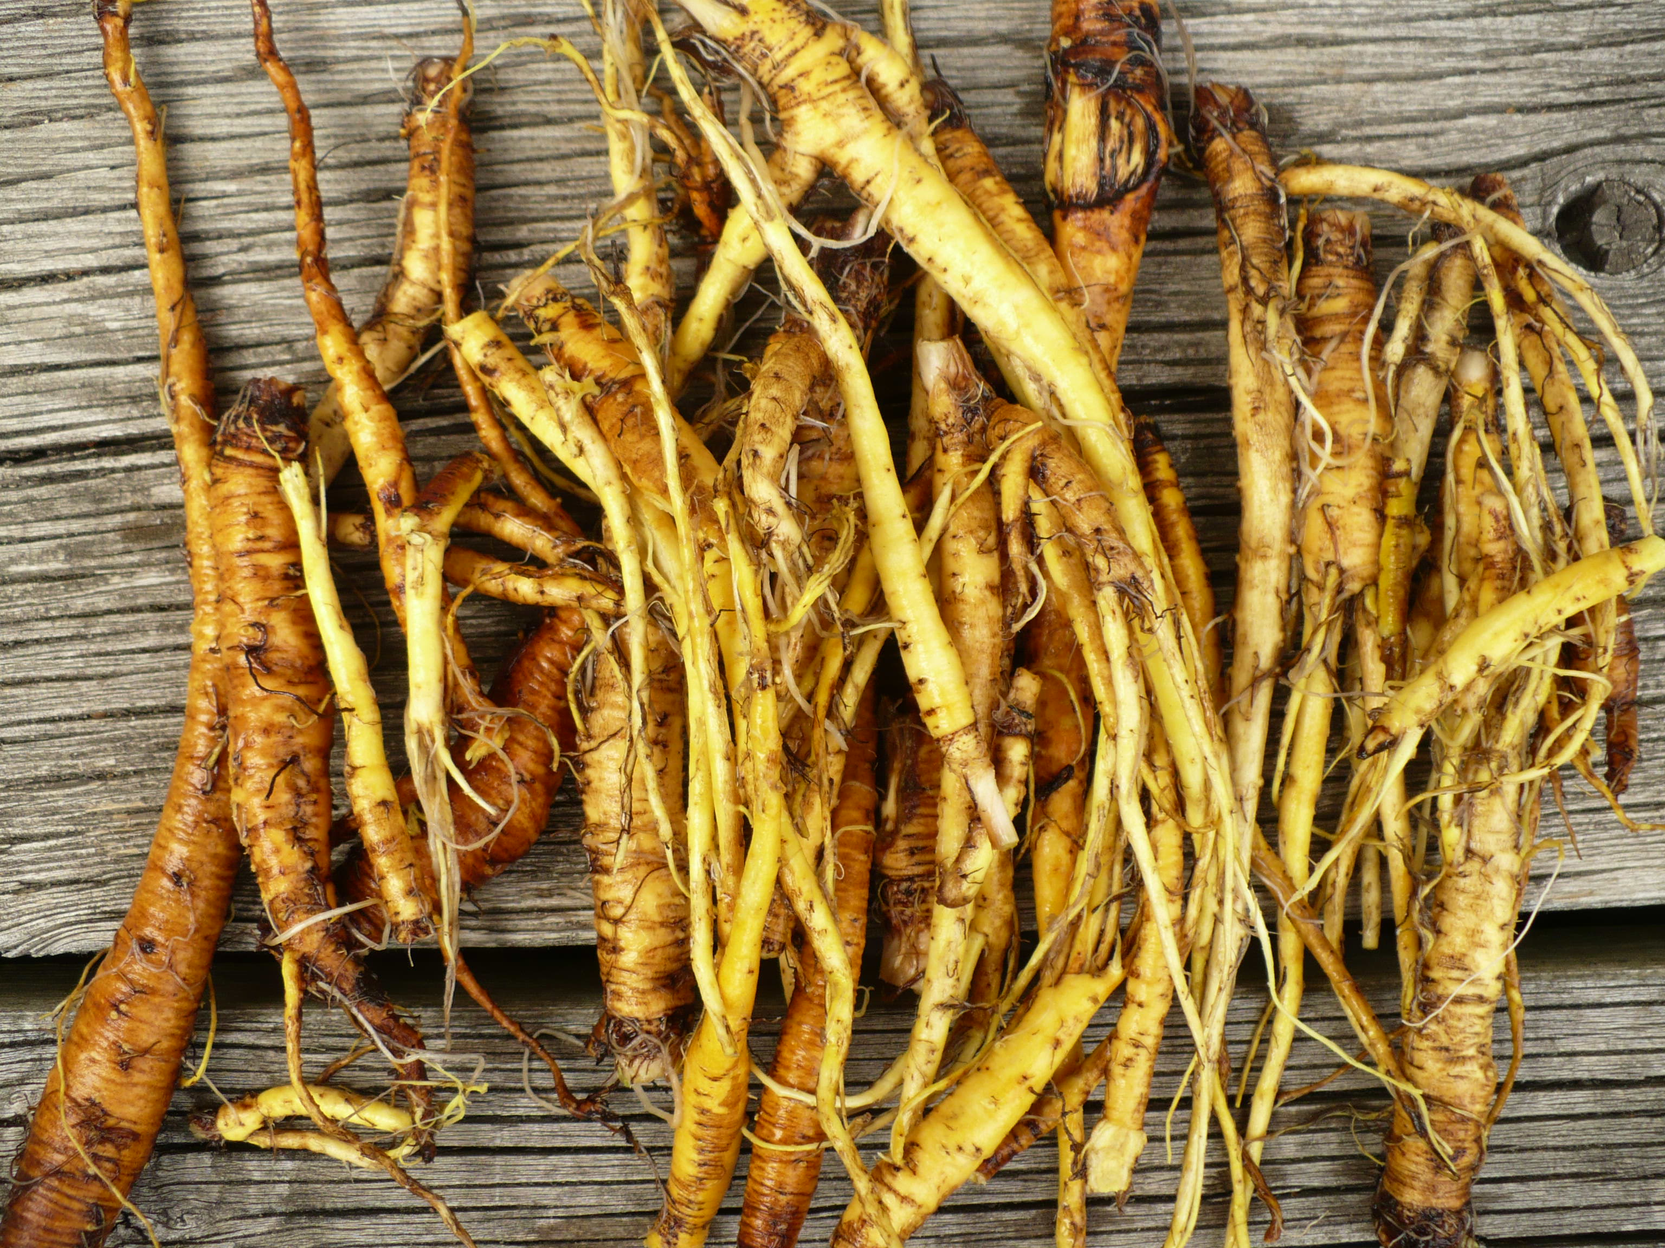

**Actions**3: alterative, antiscorbutic, astringent, cholagogue, depurative, laxative

**Often Used With:** Red Clover, Burdock, Cleavers, and Barberry

**Constituents**1:quinines, carotenoids, phenols, tannins, triterpenoids, flavonoids, anthraquinones, emodin, quercetin

**Harvest**:

* **Leaves:** Use young leaves, preferably before stems have developed.3
* **Roots**: Late summer or early fall.4

**Contra-indications:**

* Not recommended for pregnant women due to the laxative effects.3
* Excess use has been linked to gastric disturbance, nausea and dermatitis.3
* The leaves contain high levels of oxalates and should be used with moderation.

**Interesting Notes**:

In the late 1800s, Dr. Morse's Compound Syrup of Yellow Dock Root was a product produced in Providence, RI. Advertisements promised that it was “the best Blood Purifier Ever Prepared. Cures all Humors, Dyspepsia, Billiousness, Constipation, Piles, Headache, Liver and Kidney Diseases and is unsurpassed as an appetizer.8

**References**

1 The Benefits of The Use Of Yellow Dock In Herbal Preparations. Jankowski, Julie. June 2013. <http://www.seminar.schoolofnaturalhealing.com/sites/seminar.schoolofnaturalhealing.com/files/Yellow%20Dock%20-%20Julie%20Jankowski.pdf>

2 <https://en.wikipedia.org/wiki/Rumex_crispus>

3 Pareek, Archana, and Ashwani Kumar. "Rumex crispus L.–A plant of traditional value." Drug Discovery 9.20 (2014): 20-23. http://citeseerx.ist.psu.edu/viewdoc/download?doi=10.1.1.640.9581&rep=rep1&type=pdf

4 <http://www.methowvalleyherbs.com/2012/03/yellow-dock-pesky-weed-as-food-medicine.html>

5 Wintola, O. A., and A. J. Afolayan. "Ethnobotanical survey of plants used for the treatment of constipation within Nkonkobe Municipality of South Africa." African Journal of Biotechnology 9.45 (2010): 7767-7770.

6 Shiwani, Supriya, Naresh Kumar Singh, and Myeong Hyeon Wang. "Carbohydrase inhibition and anti-cancerous and free radical scavenging properties along with DNA and protein protection ability of methanolic root extracts of Rumex crispus." Nutrition research and practice 6.5 (2012): 389-395.

7 Grieve, M. Yellow Dock. Botanical.com: A Modern Herbal. <http://www.botanical.com/botanical/mgmh/d/docks-15.html#yel>

8 East Carolina University. Digital Collections: https://digital.lib.ecu.edu/21002

9 Yellow Dock: Super Cleanser. http://herbalisl.blogspot.com/2010/03/yellow-dock-super-cleanser.html

**Images**

Page 1, Image 1: <http://www.tipdisease.com/2015/09/yellow-dock-rumex-crispus-overview.html>

Page 1, Image 2: http://www.ediblewildfood.com/yellow-dock.aspx

Page 2, Image 1: http://urbol.com/yellow-dock-root/

Page 2, Image 2: https://digital.lib.ecu.edu/21002