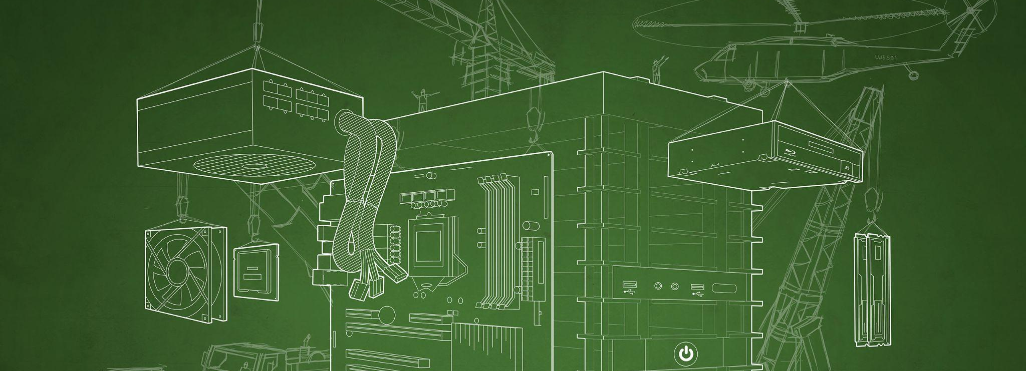
Nemotron learns to review code

depthfirst | Early RL step 5 to final step 200

Demo Overview
Final RL earned more credit for known software defects. Three trace pairs show two misses becoming matches and one equally successful run using fewer tokens. Early step 5 was already trained. The untouched-model comparison is pending.
Mean reward 0.169 → 0.263 Full credit 10/80 → 20/80
20 held-out cases, four attempts per checkpoint. Reward is graded credit, not accuracy.

Key Visuals
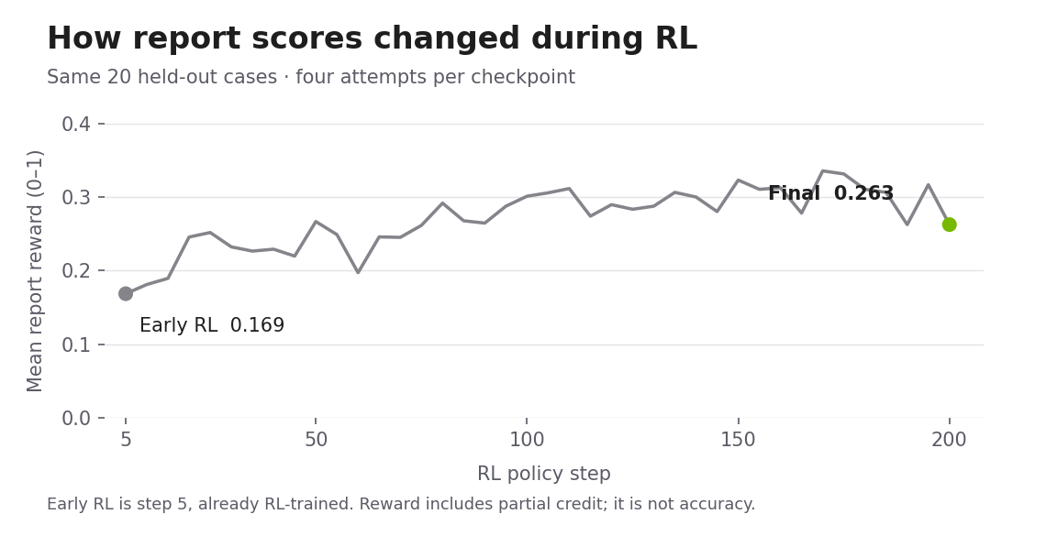

Key Points
The 95% reward-change interval [−0.009, +0.213] includes zero. Cases with positive reward fell from 9/20 to 7/20. Incomplete attempts fell from 18 to 6, reported separately.
- Inspect both traces side by side. Open the interactive demo

Demo Presentation Script
Three minutes. Start with the score and its limits, then open the three paired examples. Each comparison shows what both runs read and what each reported.
On screen | Open | Talking points
A server contacts the wrong systems | Icon fetching example  View both runs | Early RL reported a different XML issue. Final RL identified the risky icon fetch, and the checker matched it to the known defect.
A permission boundary is missing | Access control example  View both runs | Final RL identifies the known permission problem after the selected early run missed it. This is a report match, not a demonstrated attack.
The same issue with less effort | Token efficiency example  View both runs | Both runs match the same object-property defect. Illustrative detector cost falls from $0.020219 to $0.002572, about 87.3% lower.

References and Background
Original trace exports and model weights
Interactive results and paired traces
JSON trace folder on GitHub
RL final adapter on Hugging Face
Results and questions on GitHub

Demo Details

NVIDIA Technologies
- NVIDIA Nemotron 3.5 Lightning 30B A3B BF16 base model.
- Final step 200 RL policy, exported as a 3.59 GB LoRA adapter. It requires the base model. Download access is manually approved on Hugging Face; inference is untested.

Software and Services
- depthfirst source-review workflow; Tinker checkpoint export; Hugging Face model hosting. The interactive site uses the cloned Amelia UI source.

Target Audience
- Visitors interested in model training, software quality and how agent behavior changes. No security background is needed to follow the paired examples.

Setup and Installation
The booth demo displays recorded runs. Opening the site does not launch scanning, training or attacks.

Required Equipment and Software
- A laptop or desktop, a current browser, and an internet connection.
- For an offline fallback, keep this PDF open and save the JSON trace exports locally.

Repo Location
RL presentation branch on GitHub

Installation
No installation is needed for the hosted presentation. Model serving is separate and has not been validated for this exported adapter.

Startup
Open the demo. Show the graph, read the uncertainty note, then open the three paired cases. Links to model weights and trace JSON remain available for follow-up.

Measurement Notes
The cost illustration uses $0.039 per million input tokens and $0.18 per million output plus reasoning tokens, with no cache discount. It includes detector tokens only and excludes judges, training and infrastructure. It is not an invoice.
OpenRouter price scenario

